DEV Refesh

SE01 – TOC

RFC – DWMK910030

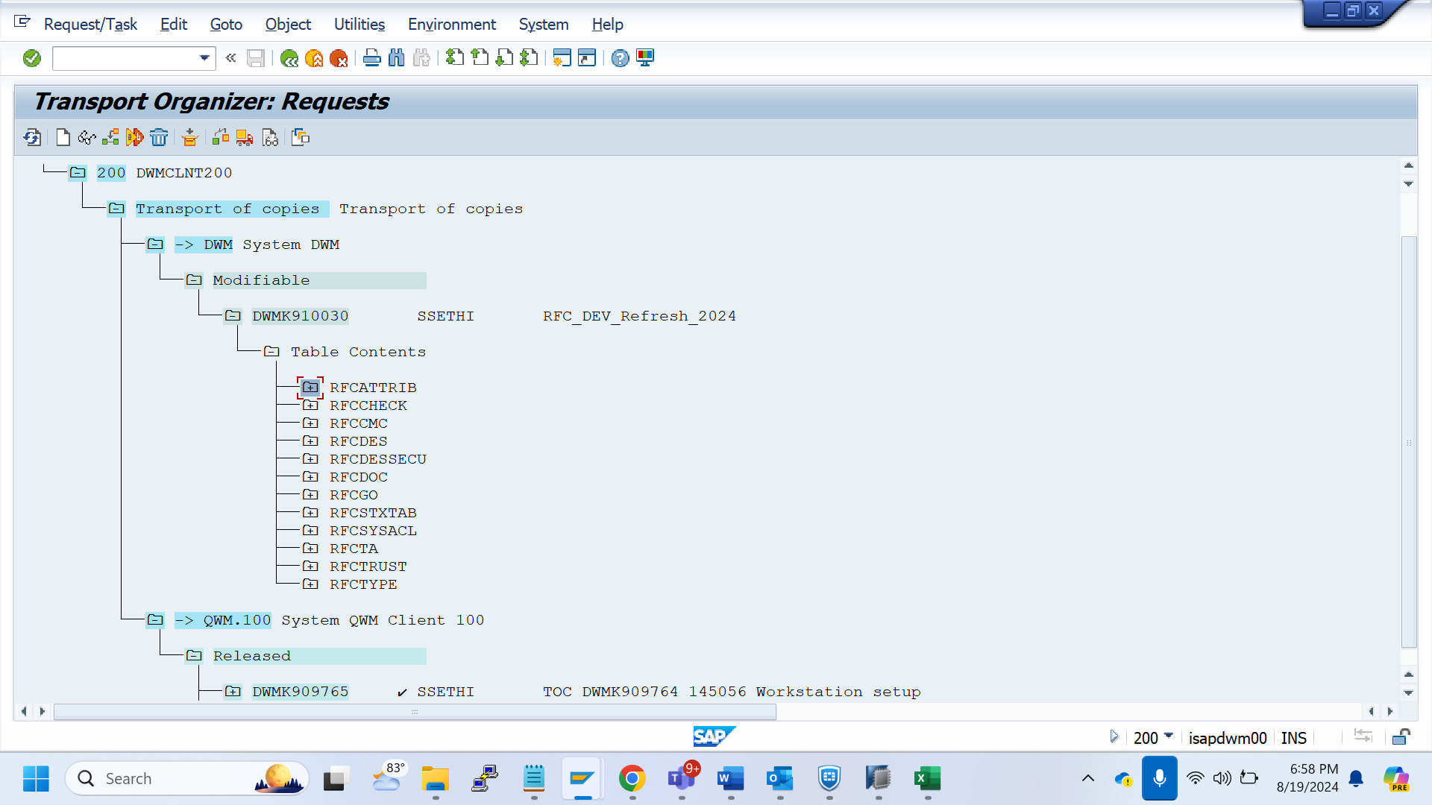

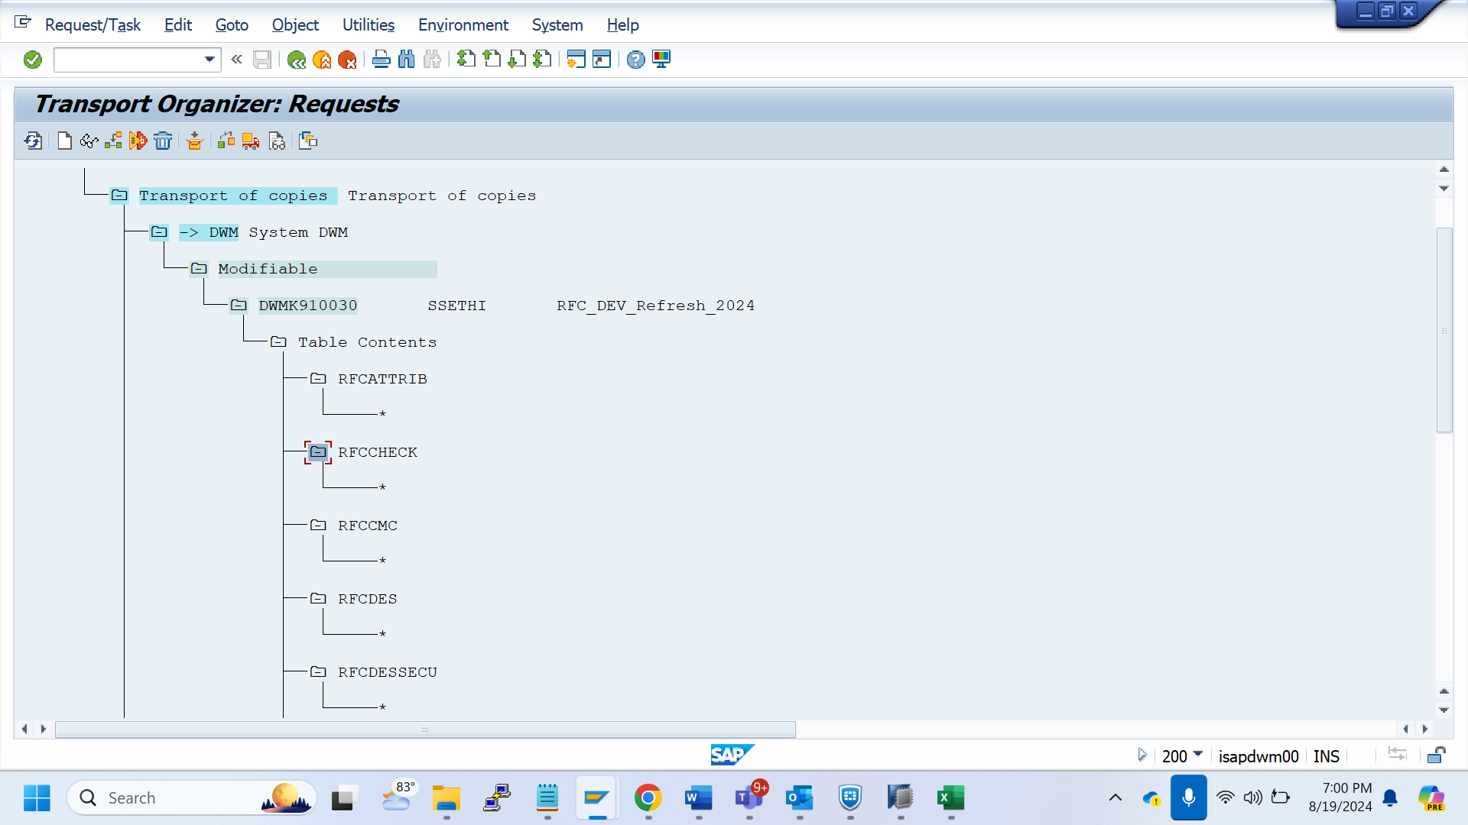

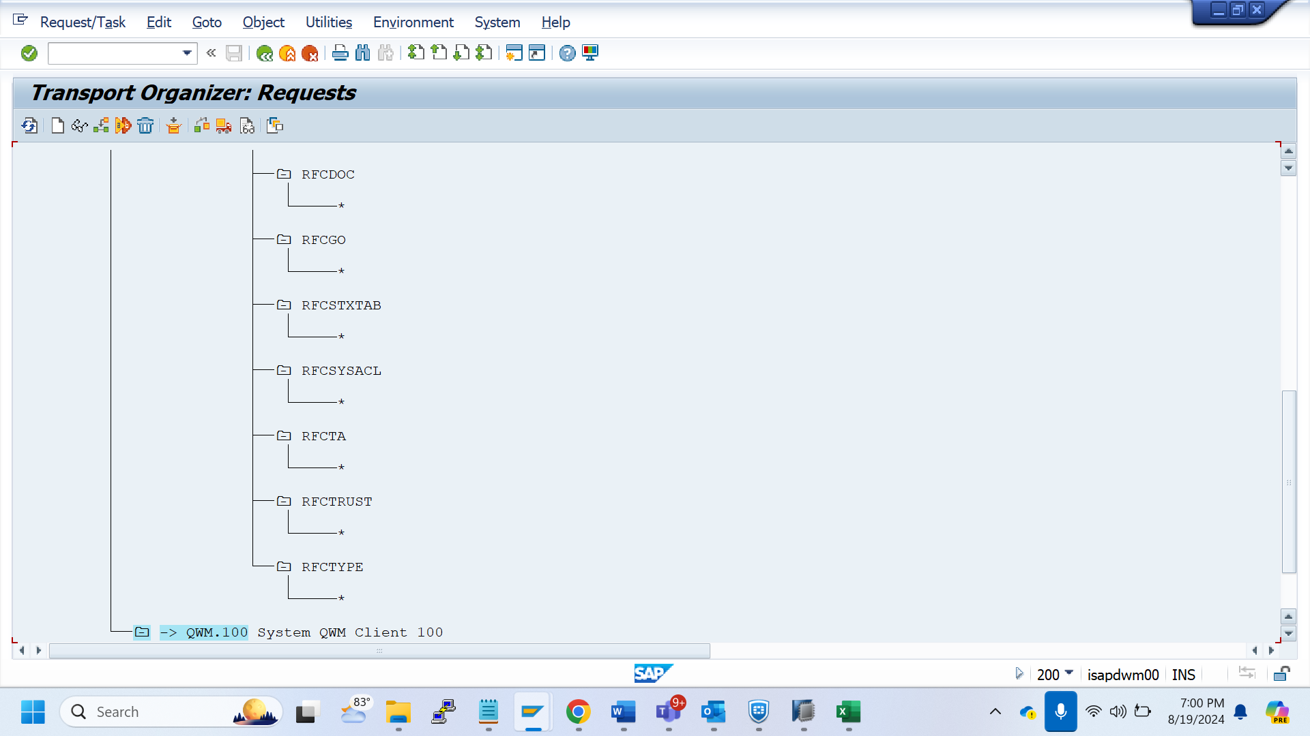

Partner Profile - DWMK910031

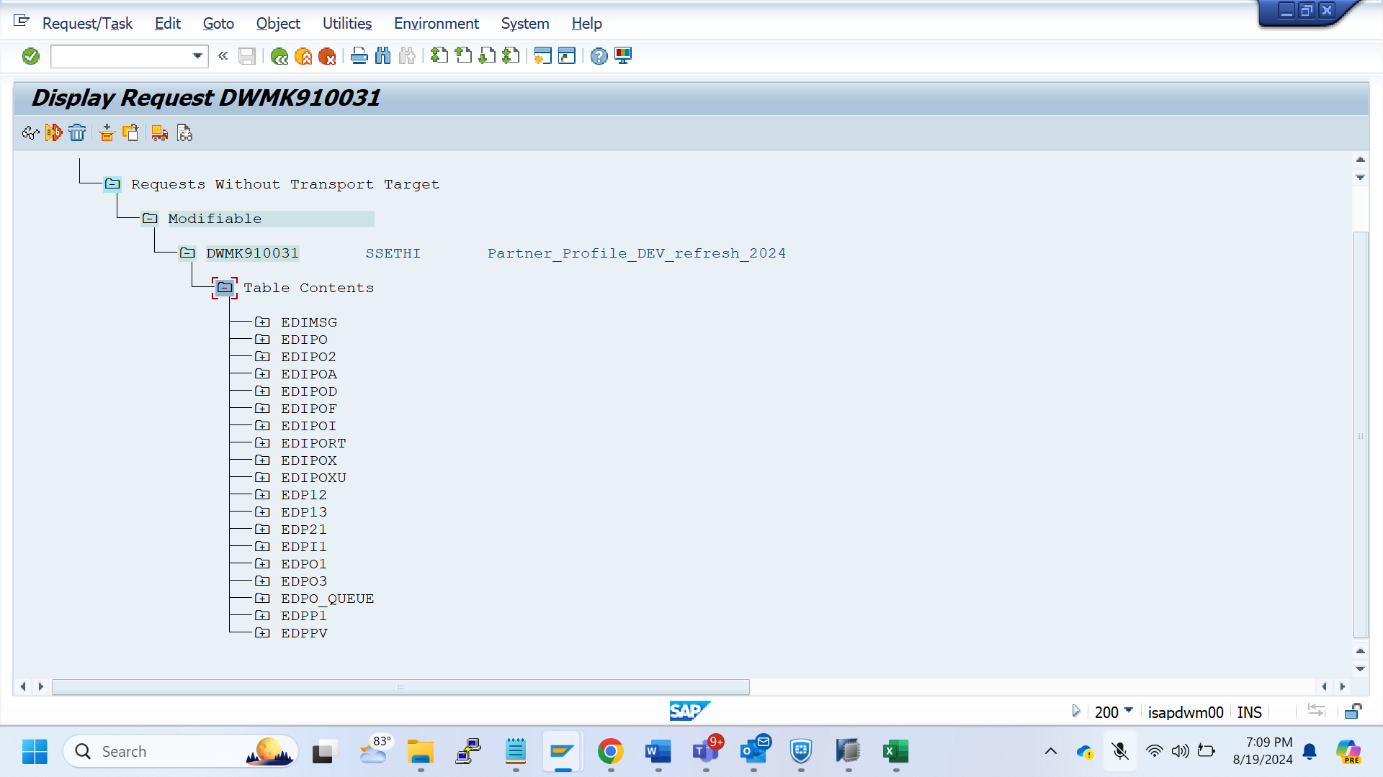

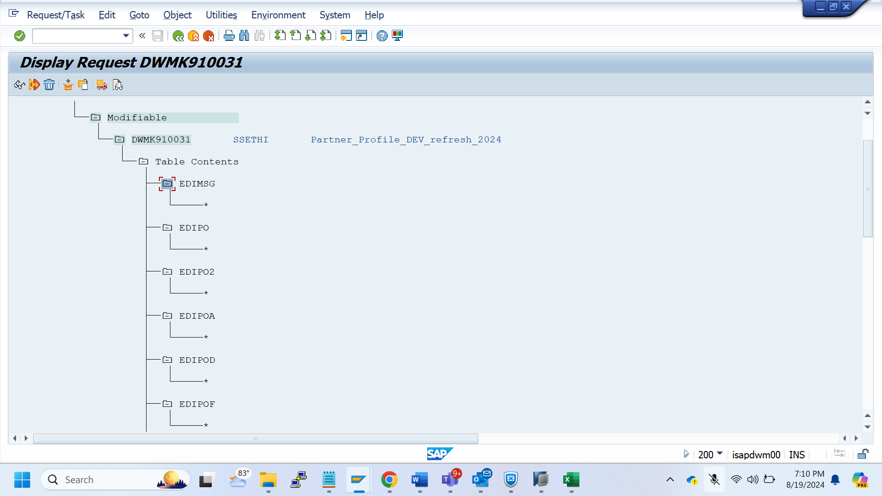

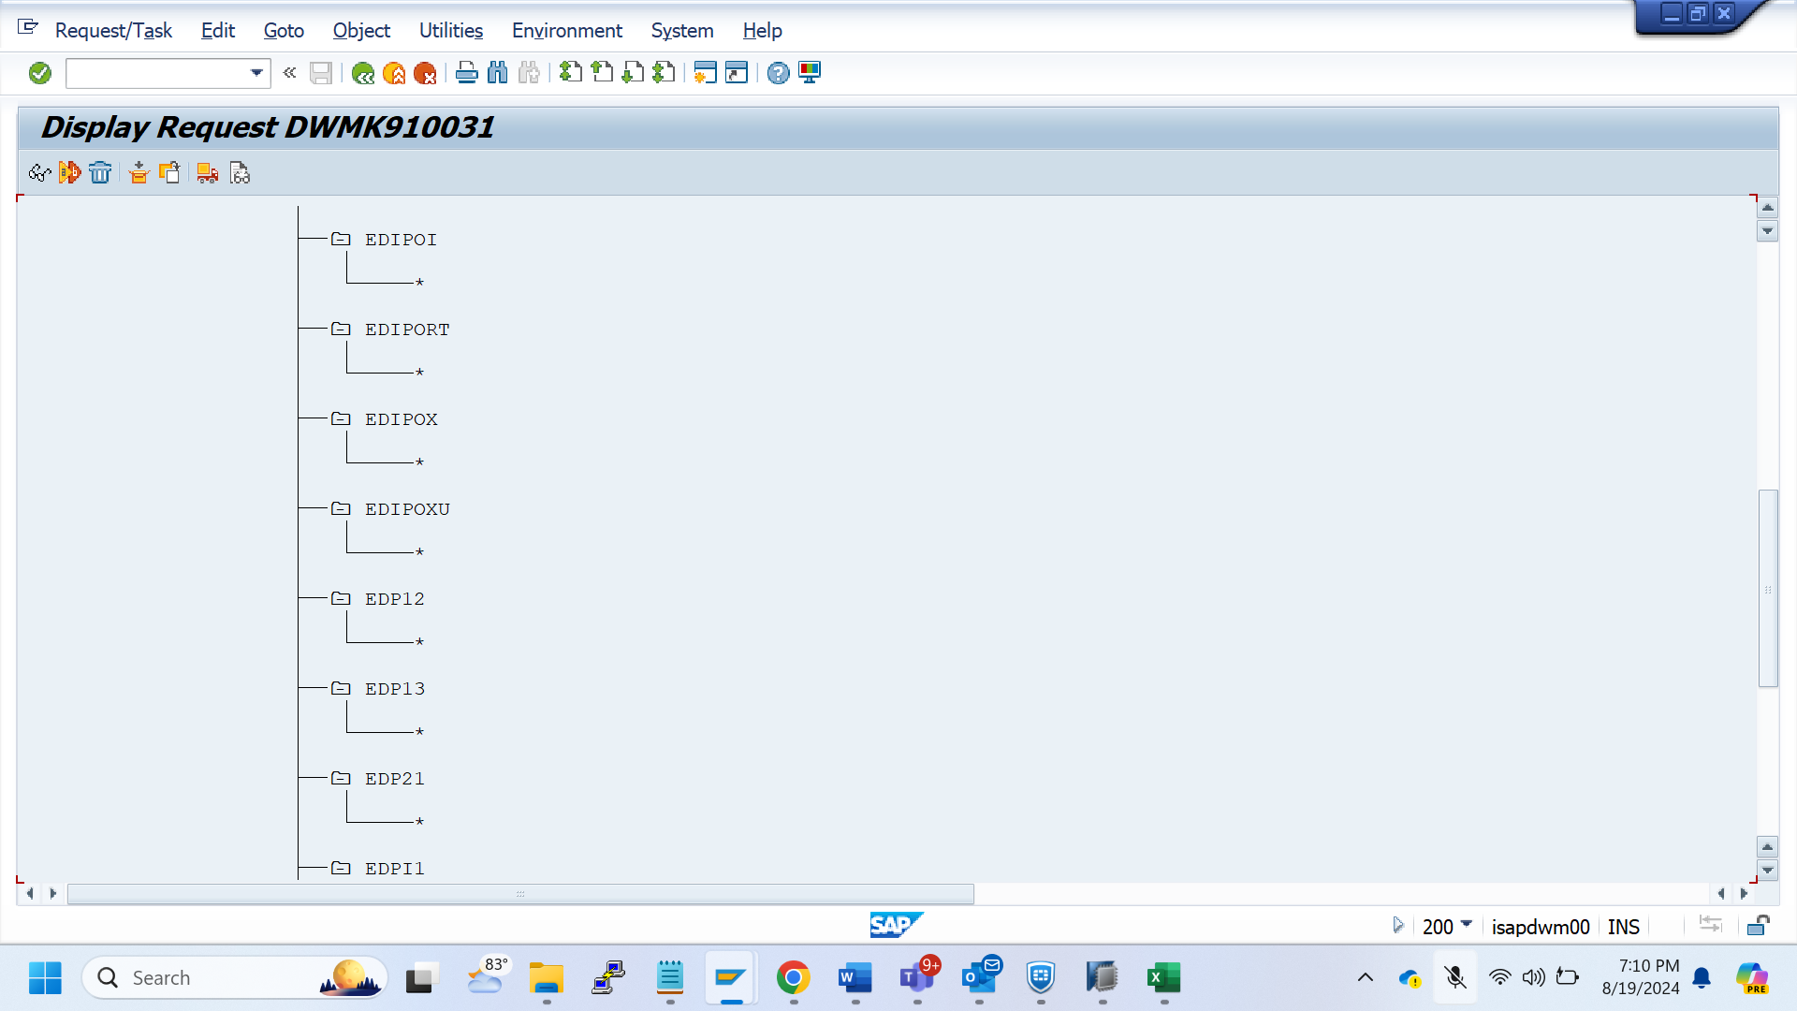

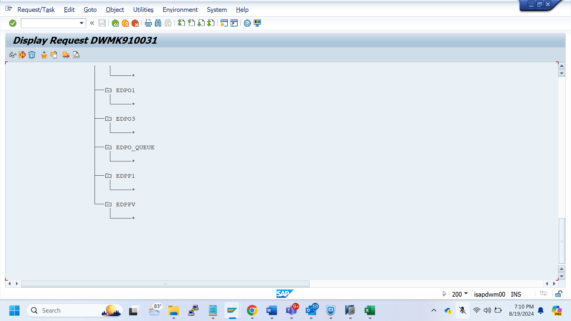

BD64 Transport - DWMK910032

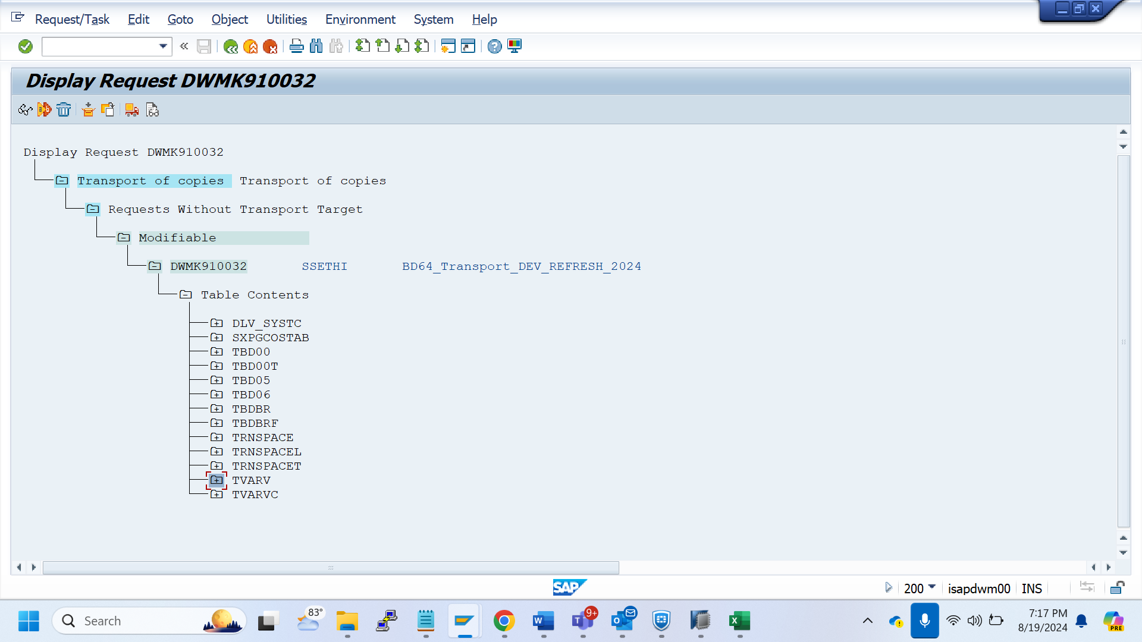

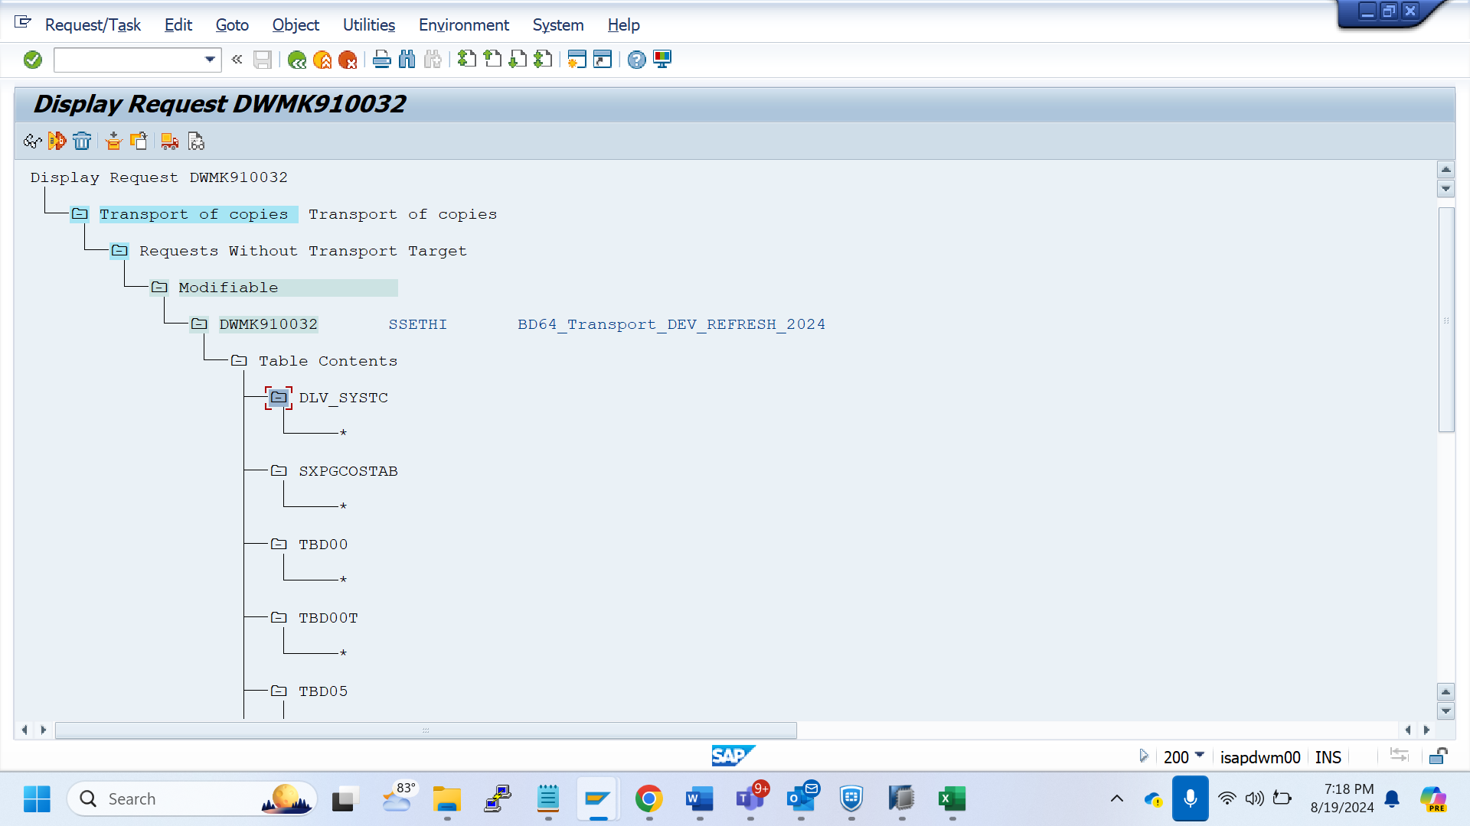

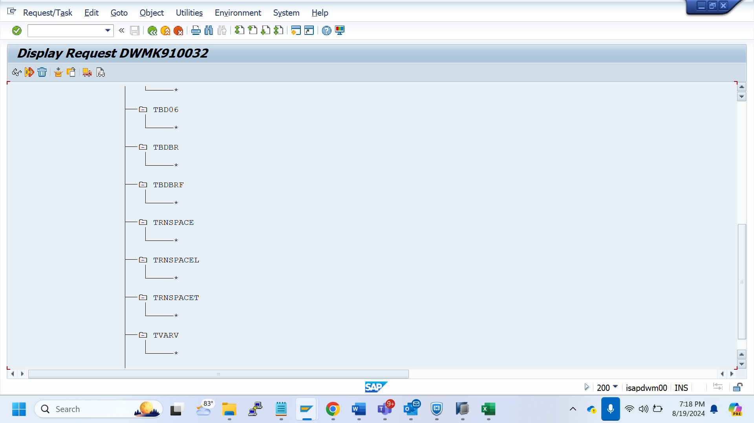

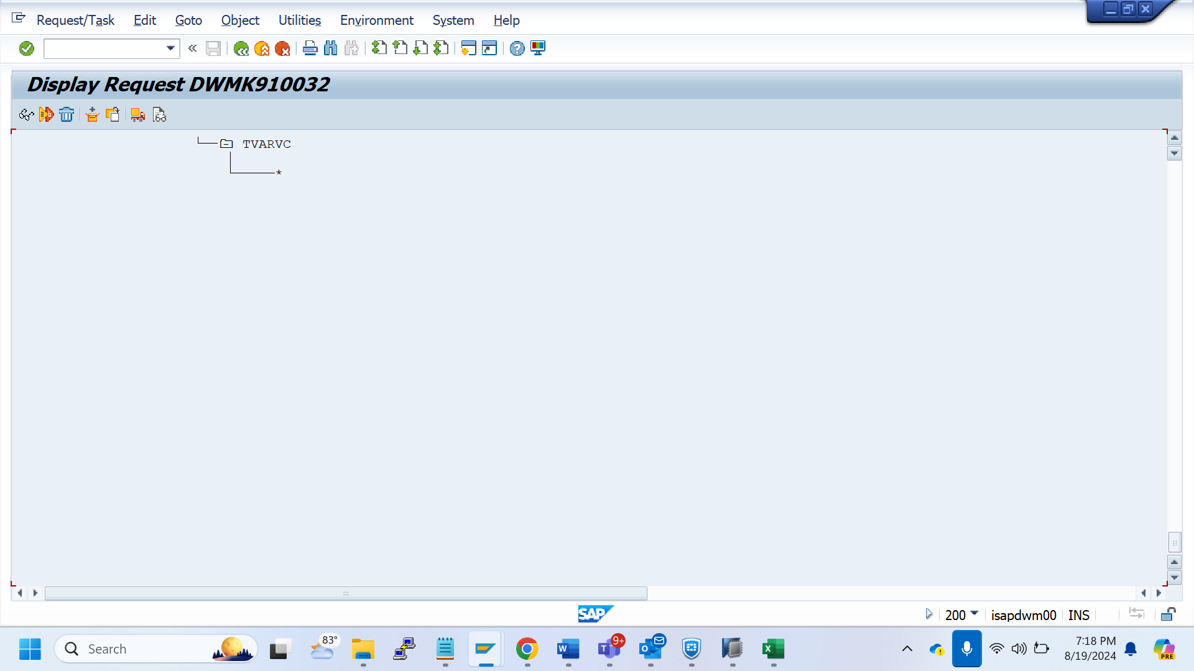

File tcode Transport - DWMK910033

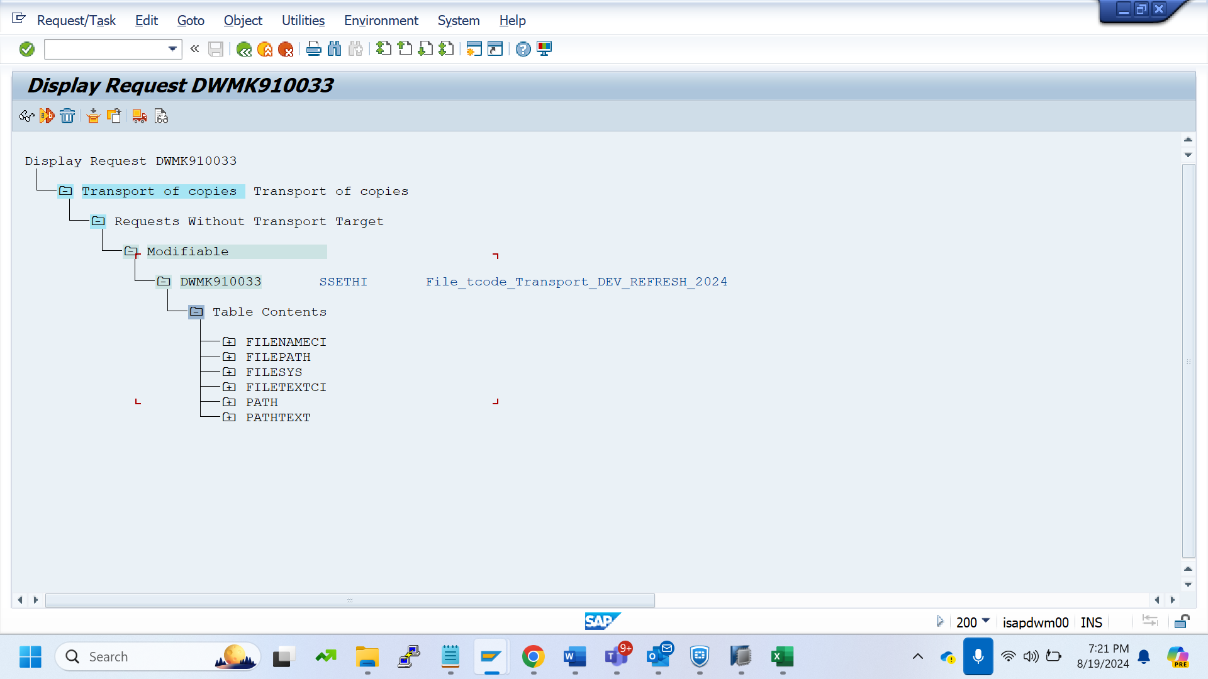

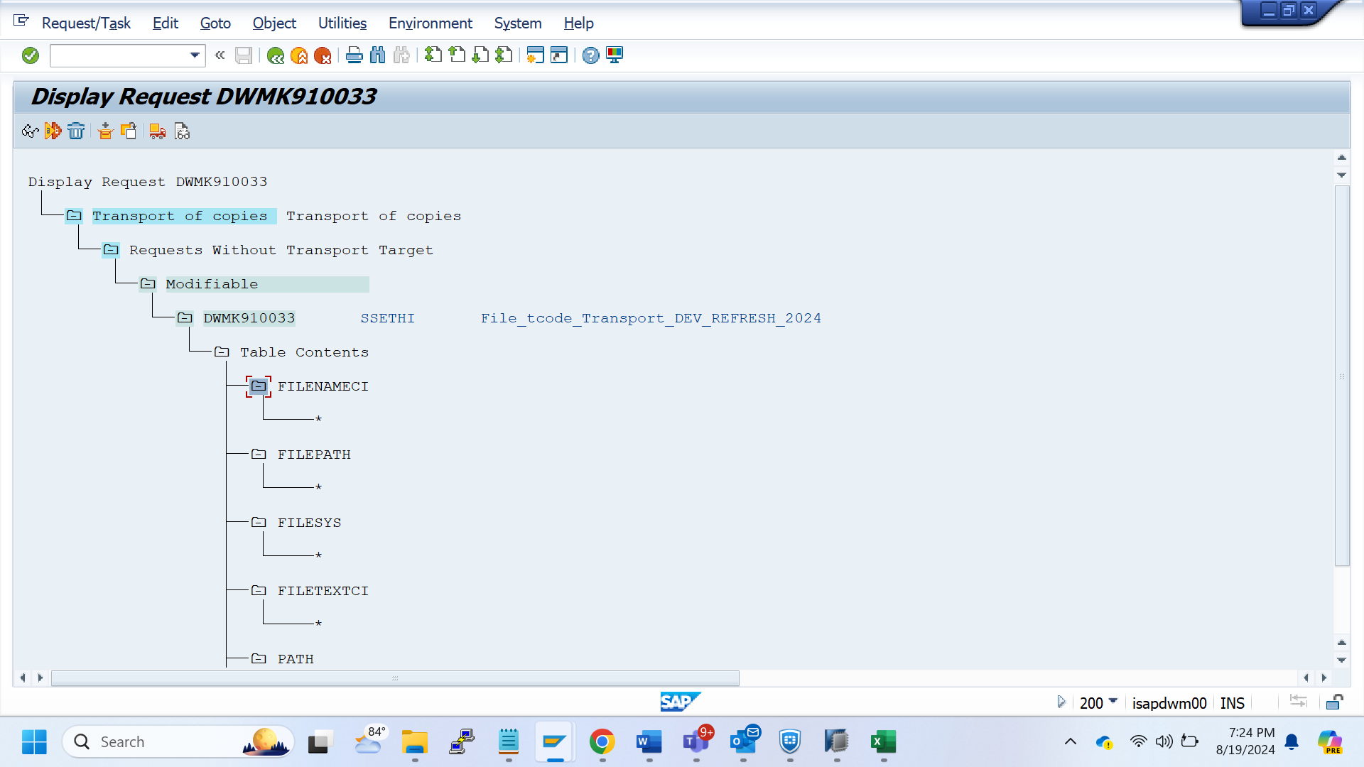

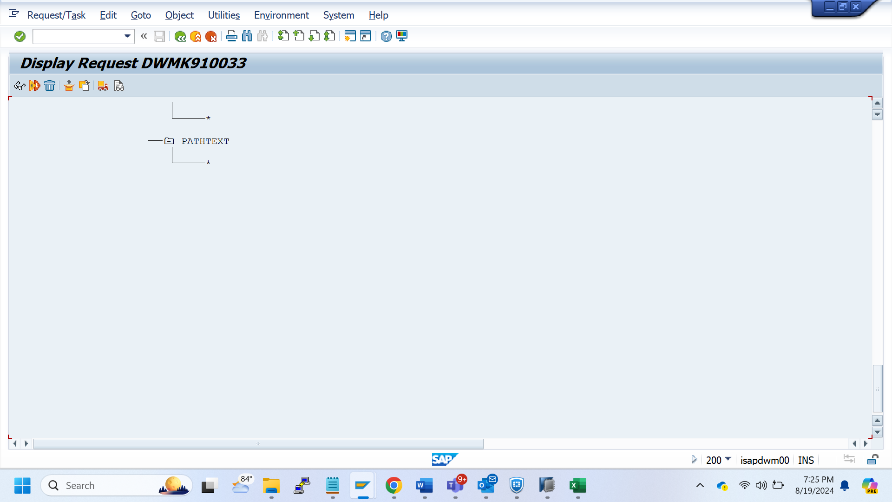

STRUST - DWMK910034

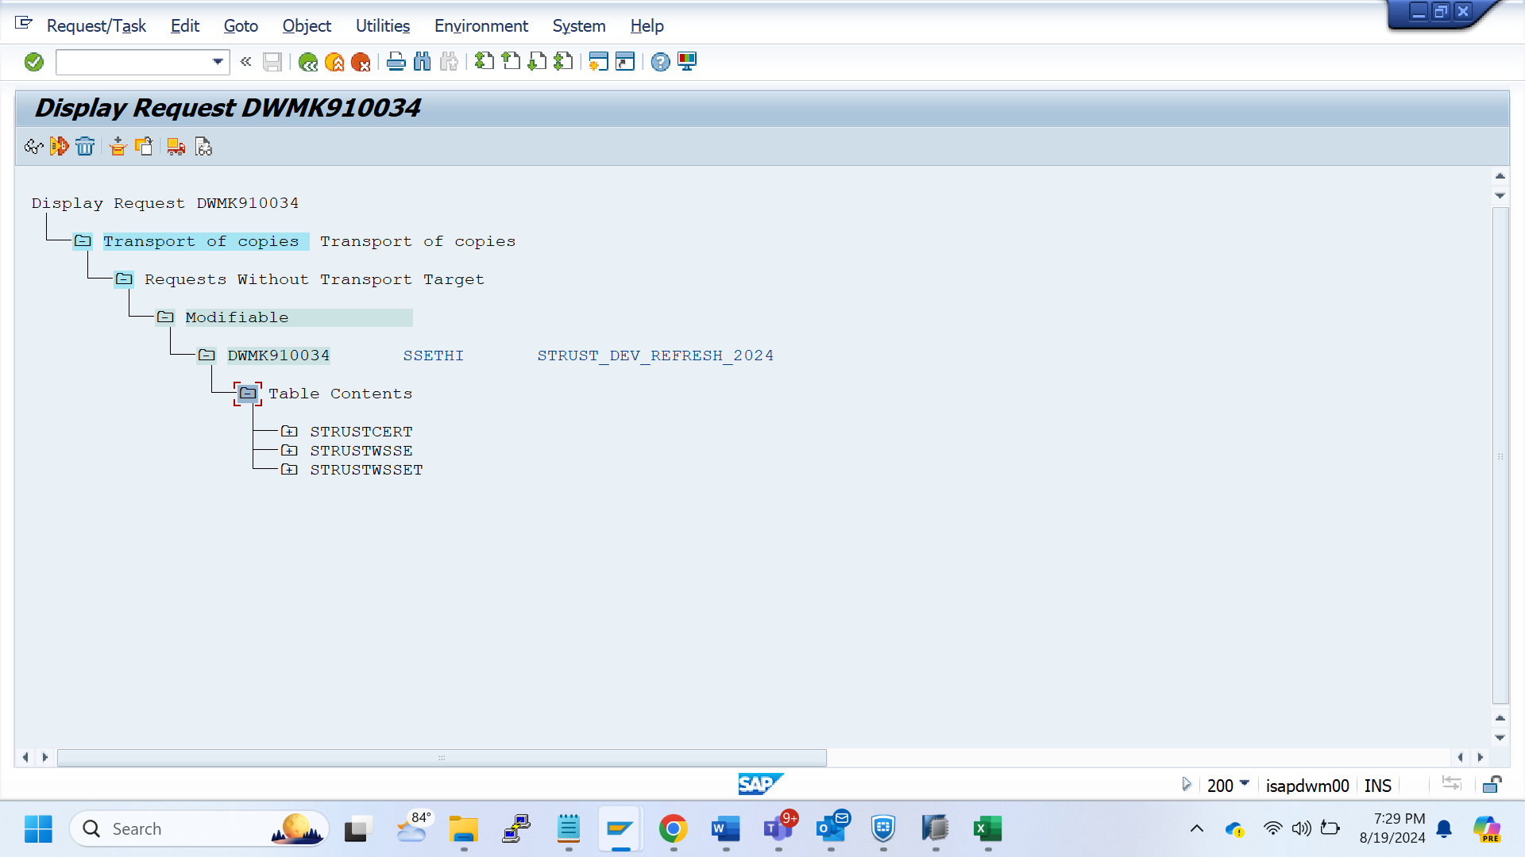

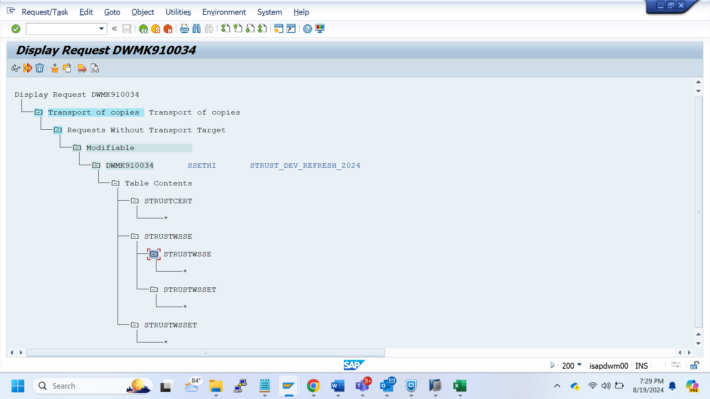

table export of Logical systems - DWMK910035

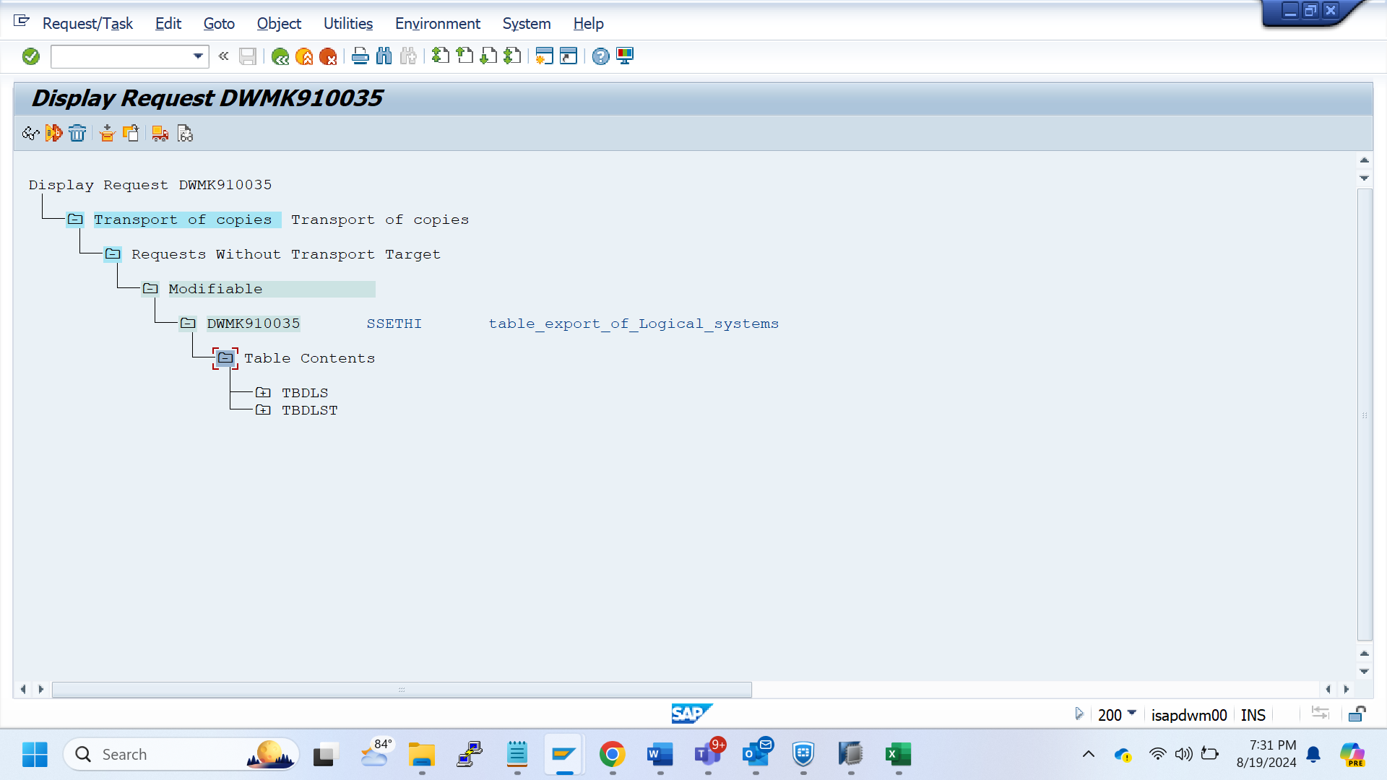

**DBCO - DWMK910036**

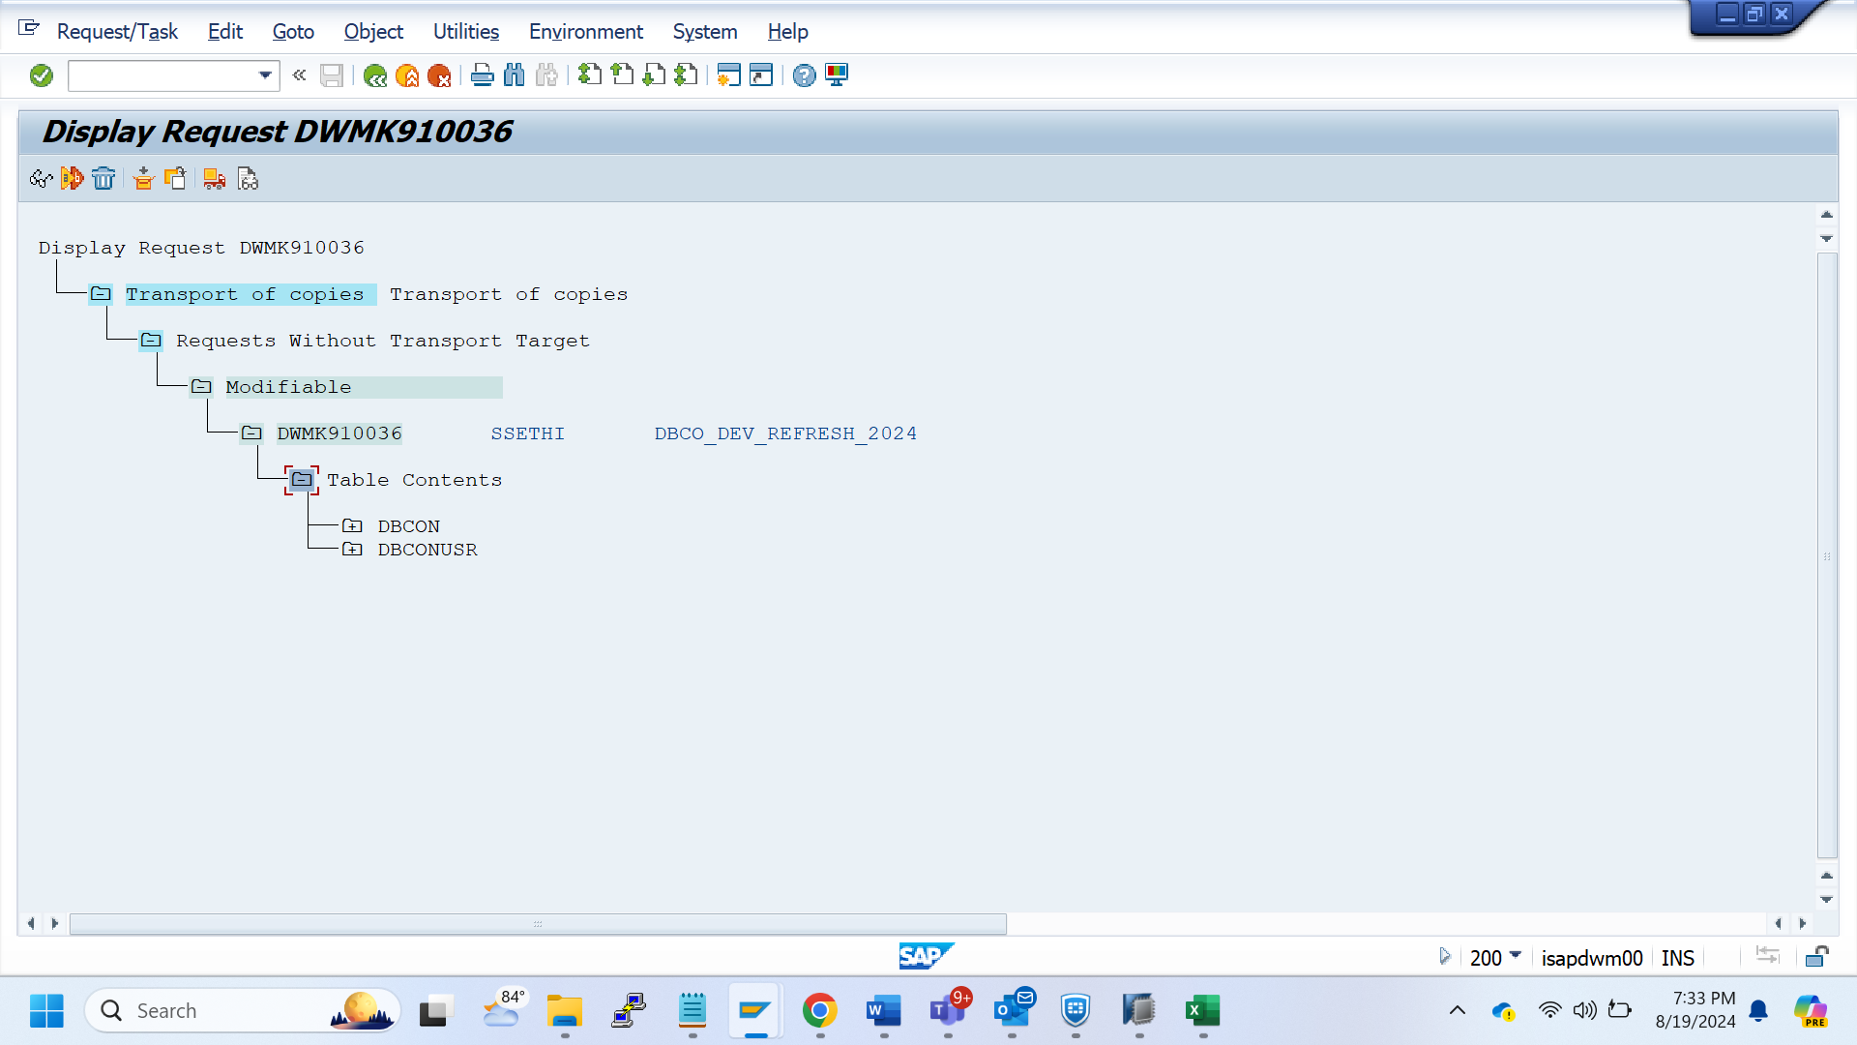

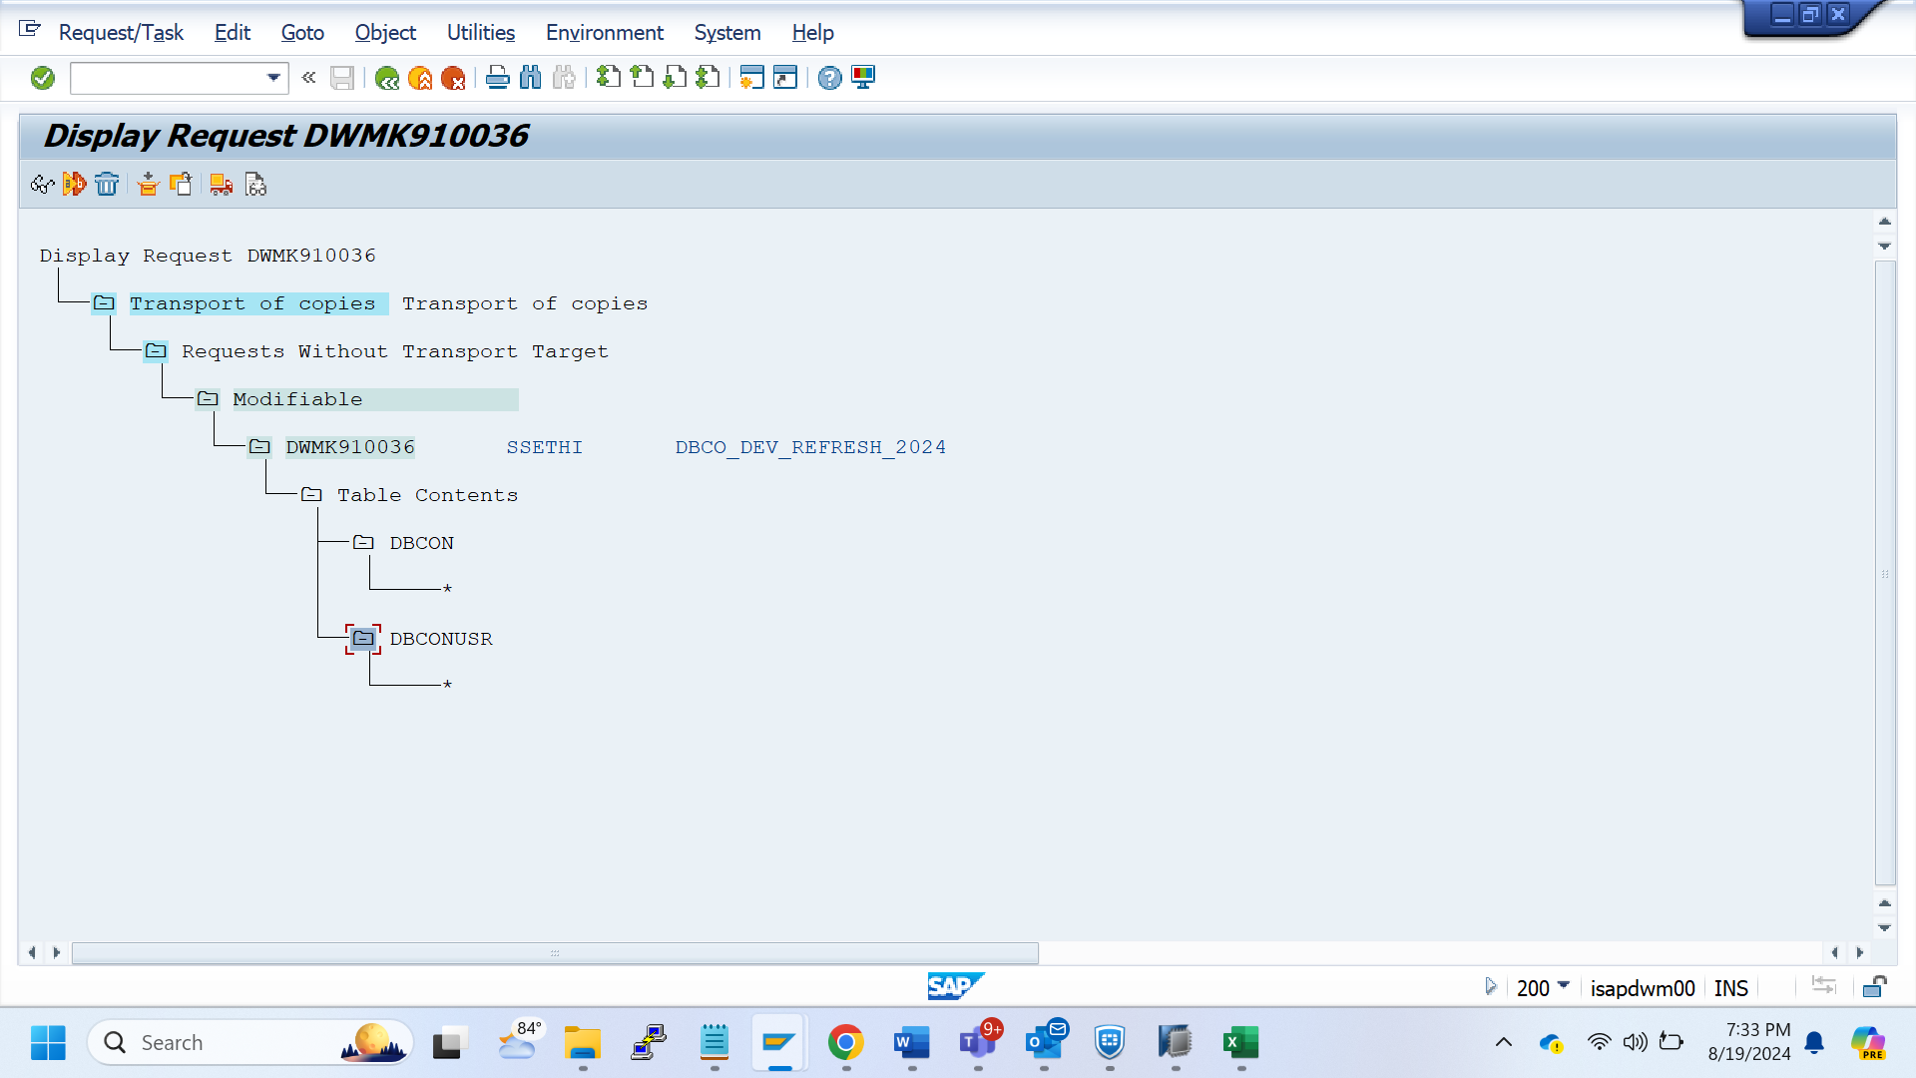

Secstore table - DWMK910037

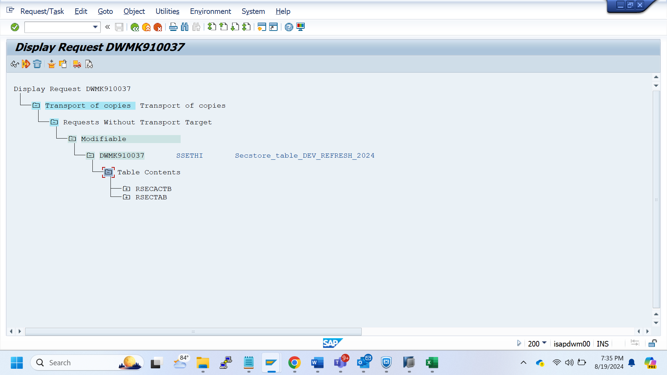

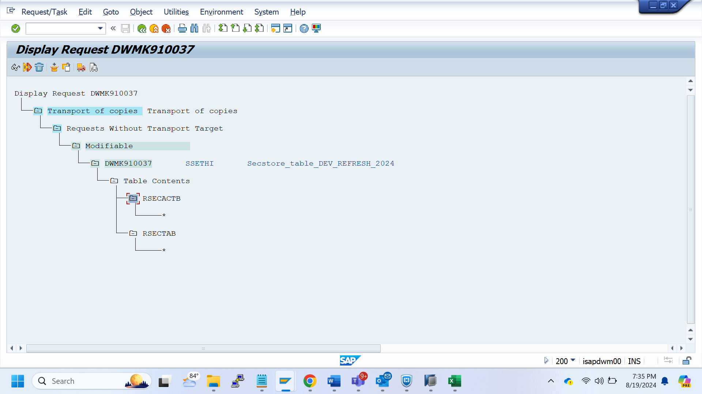

SAP instance/SMLG/RZ12/operation mode/Trusted system - DWMK910038

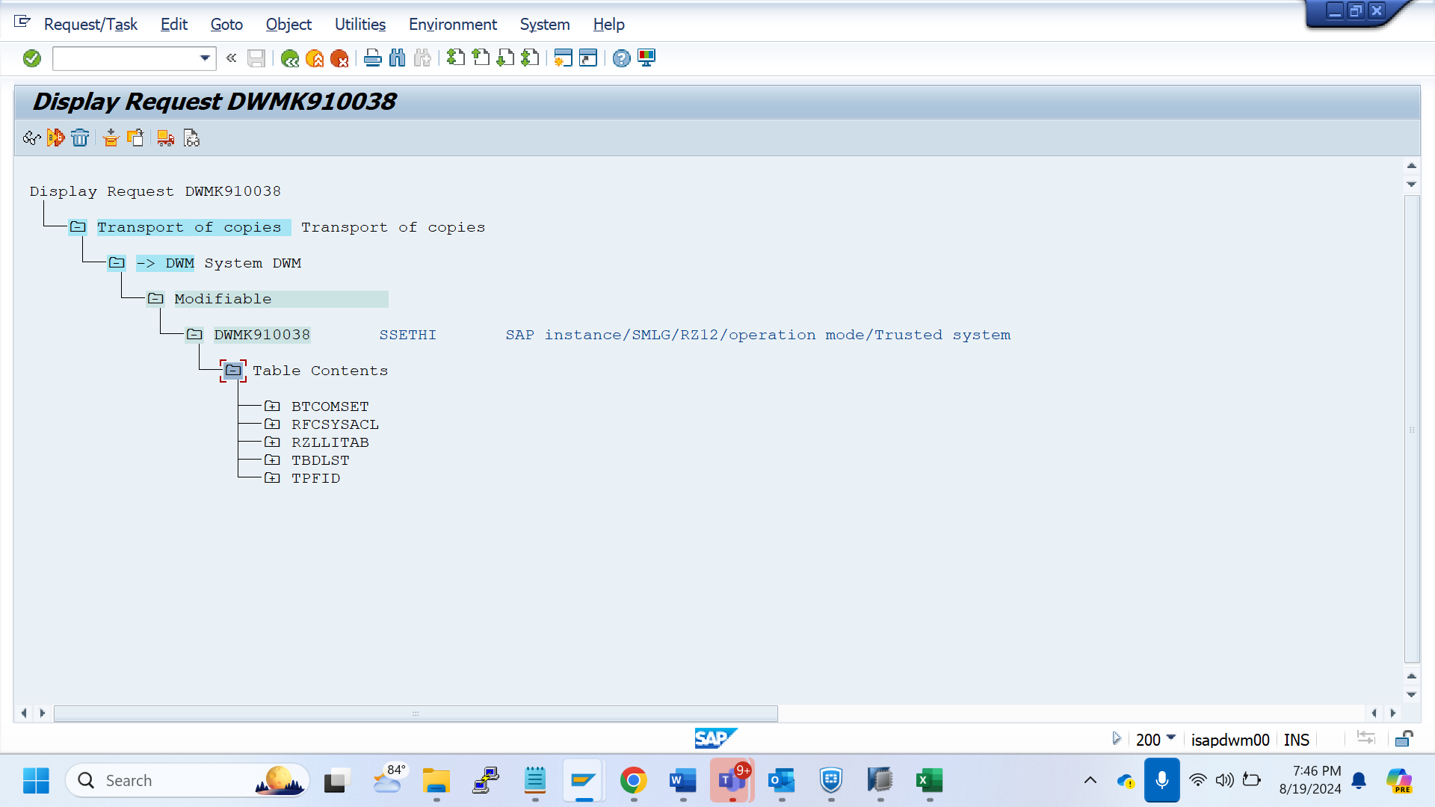

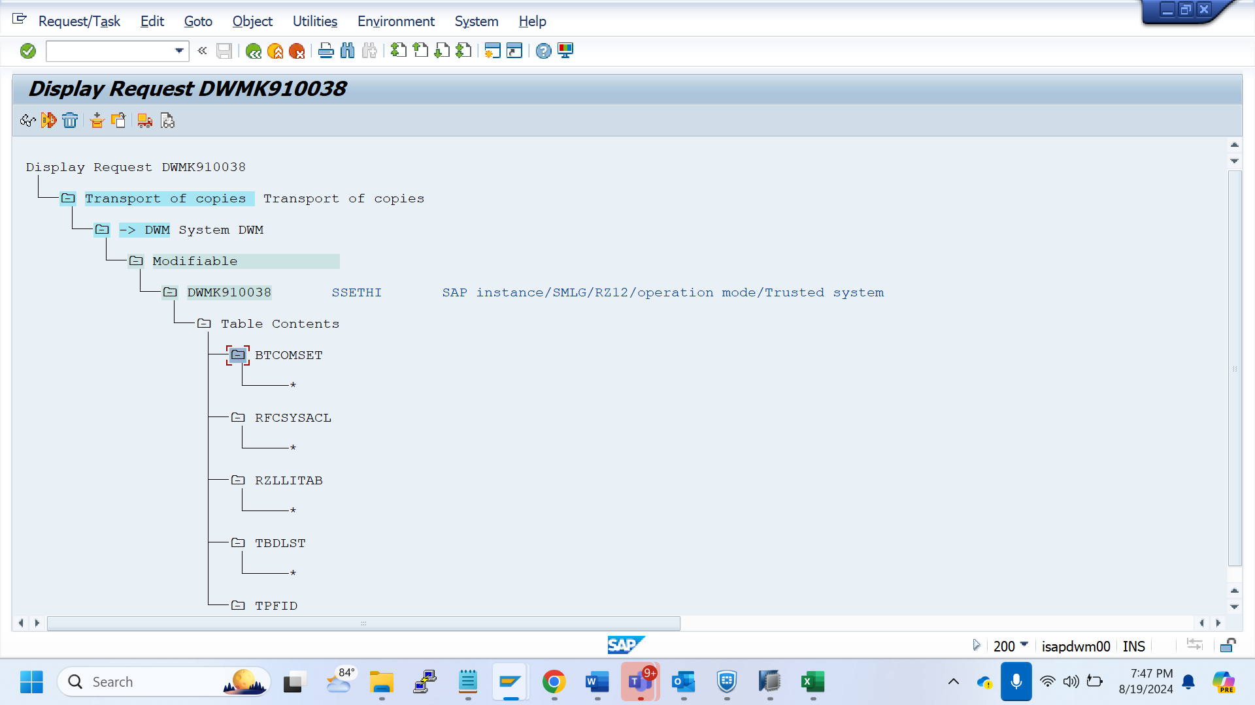

SCOT/ SOST - DWMK910039

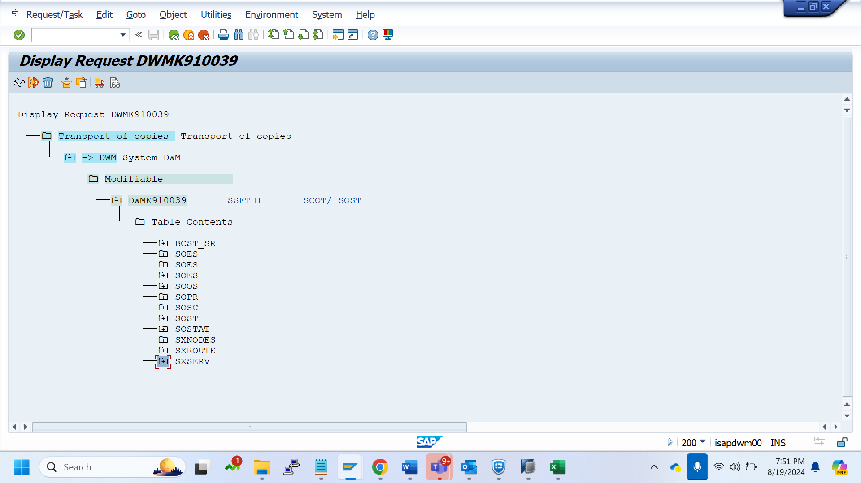

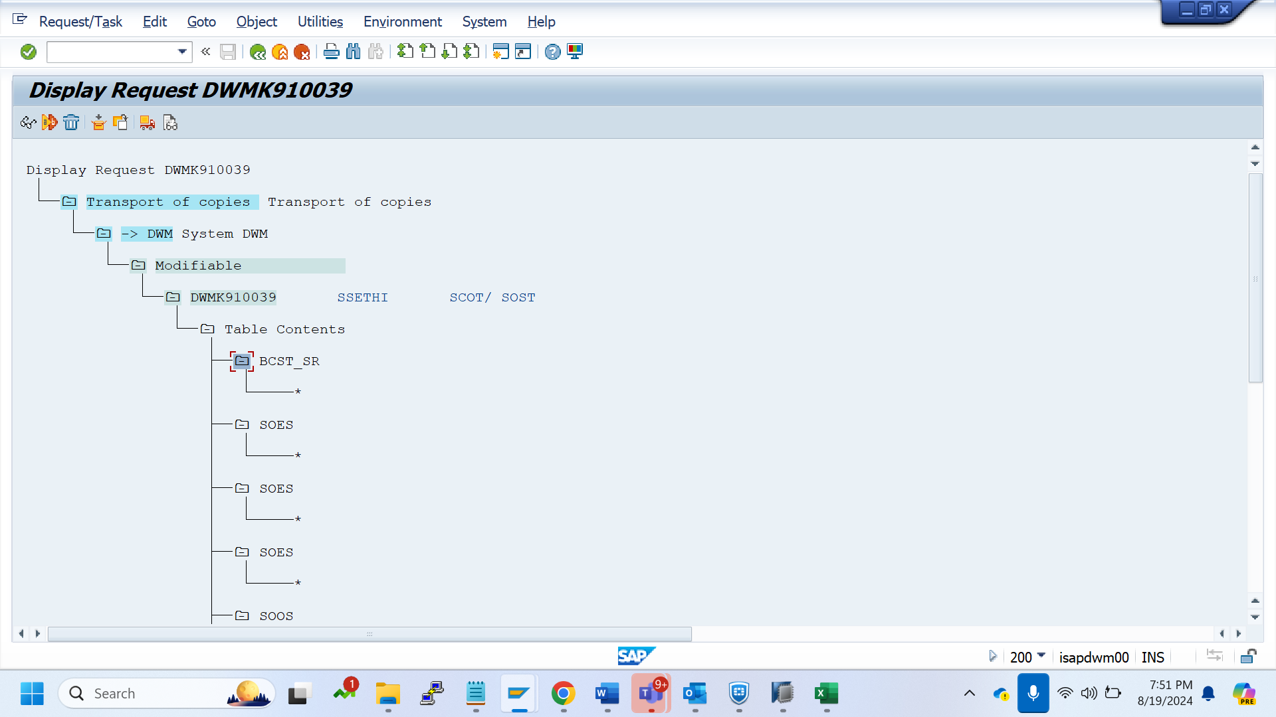

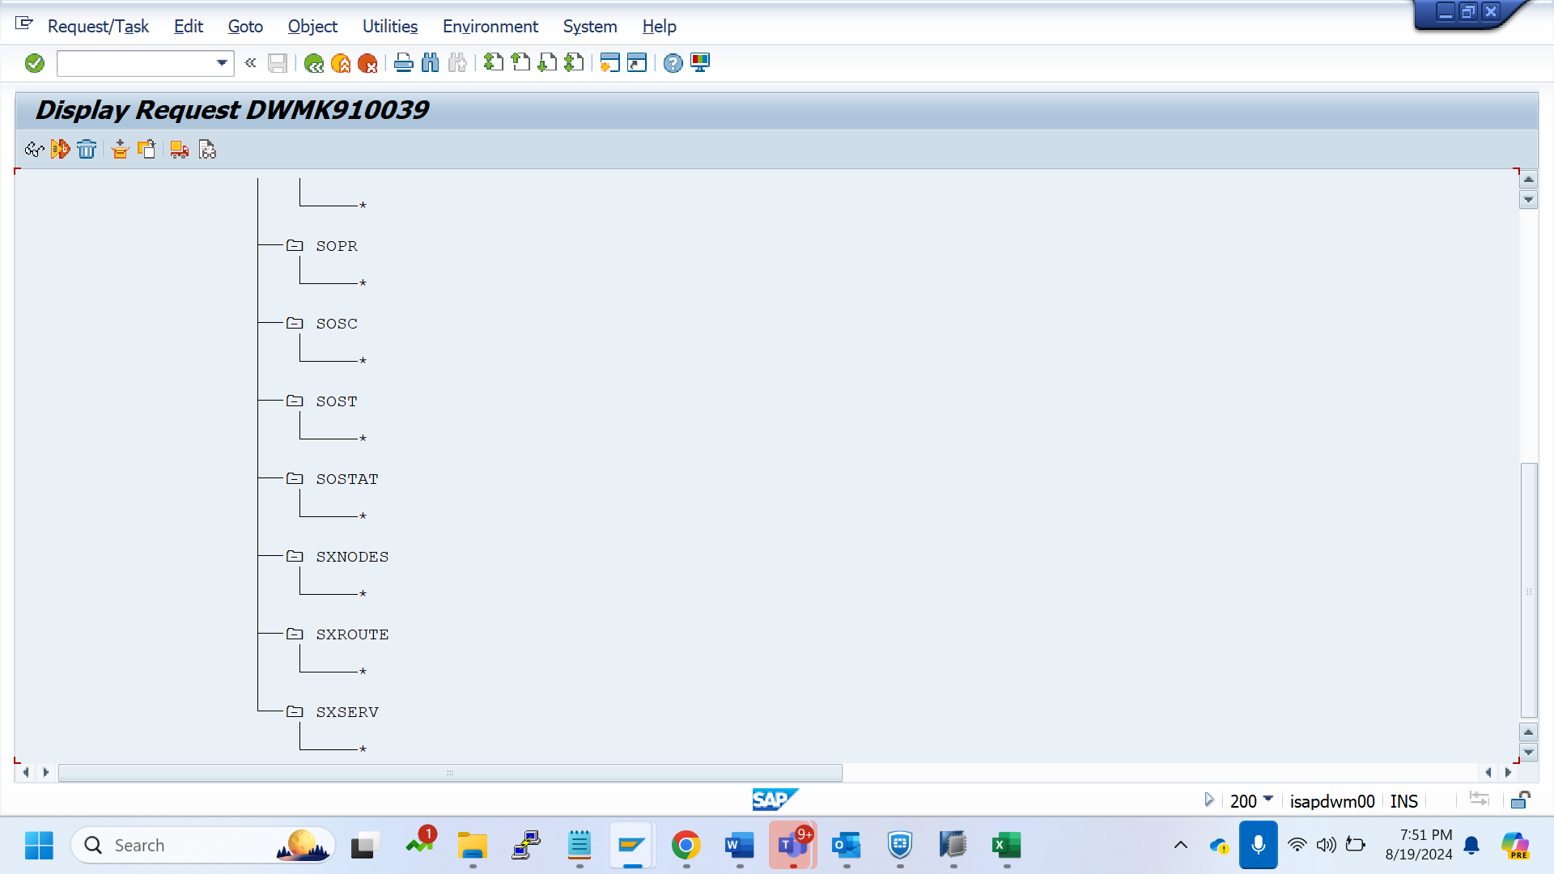

export all SICF services - DWMK910040

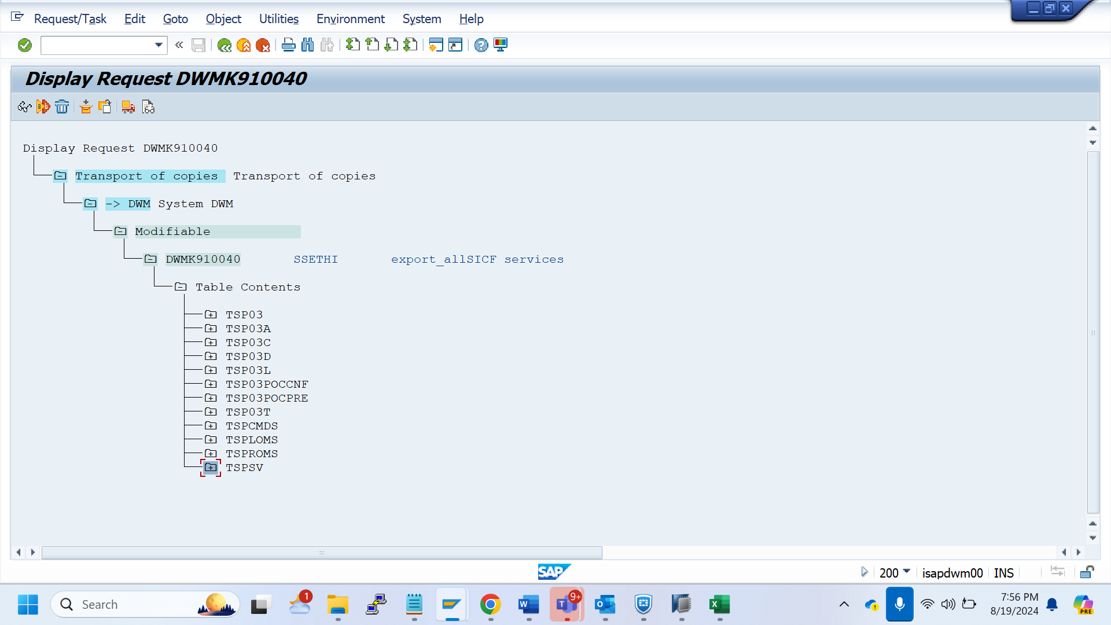

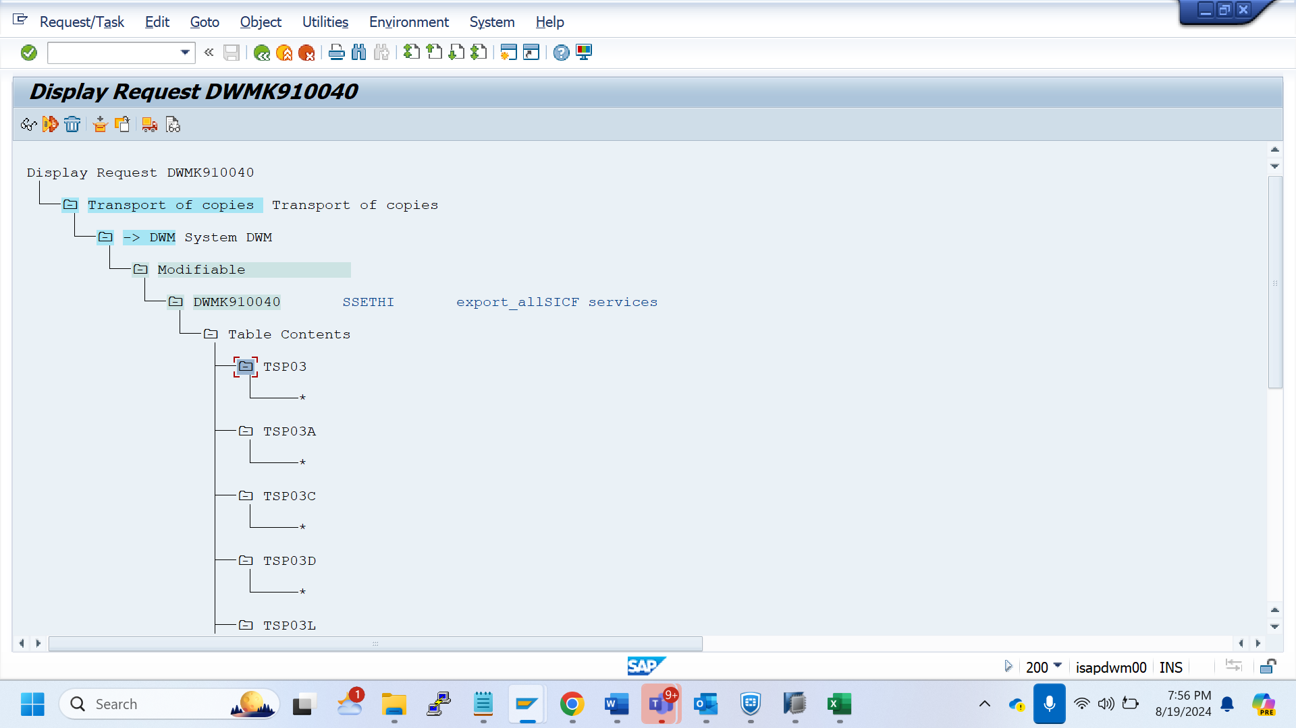

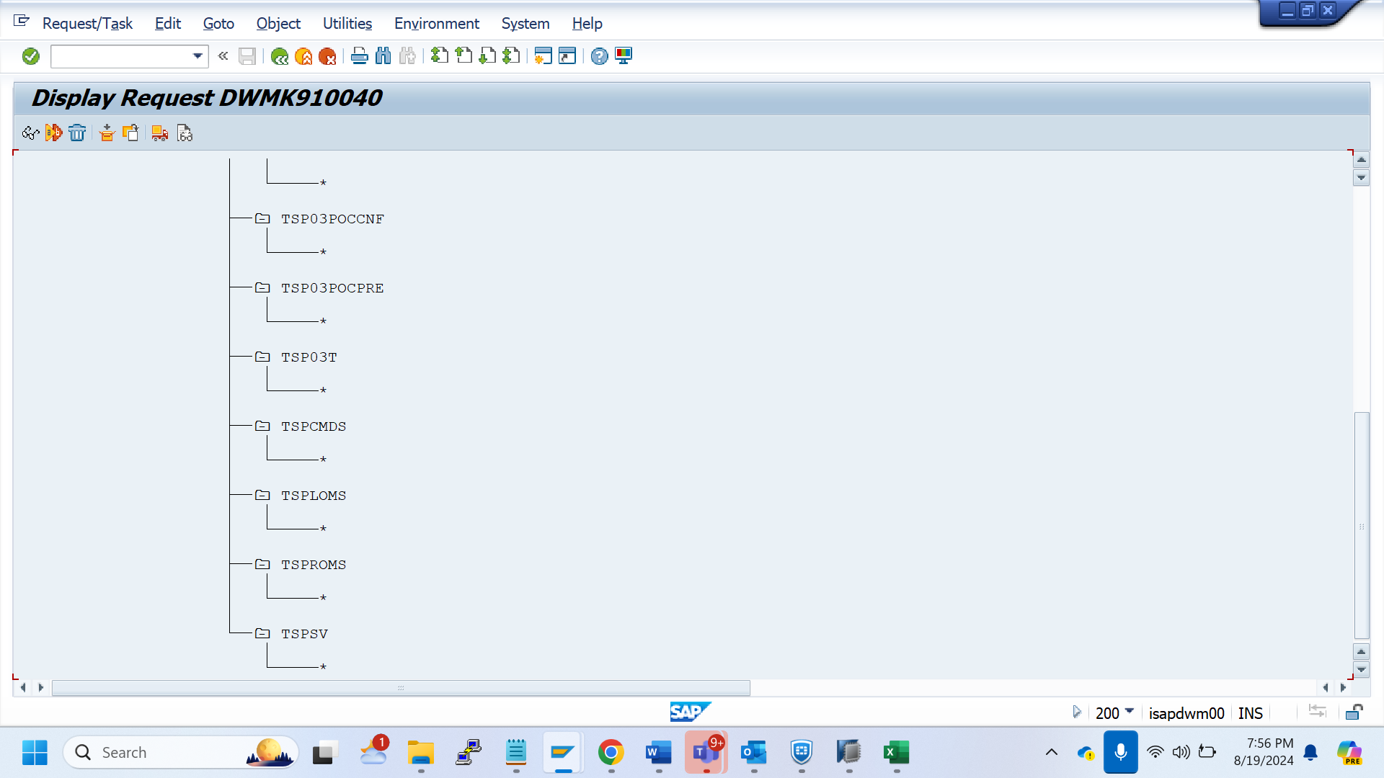

Extra Tables - DWMK910041

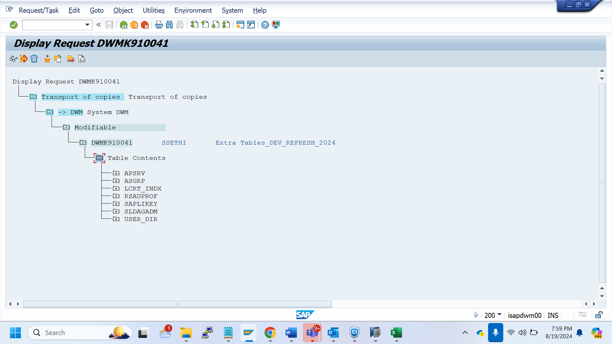

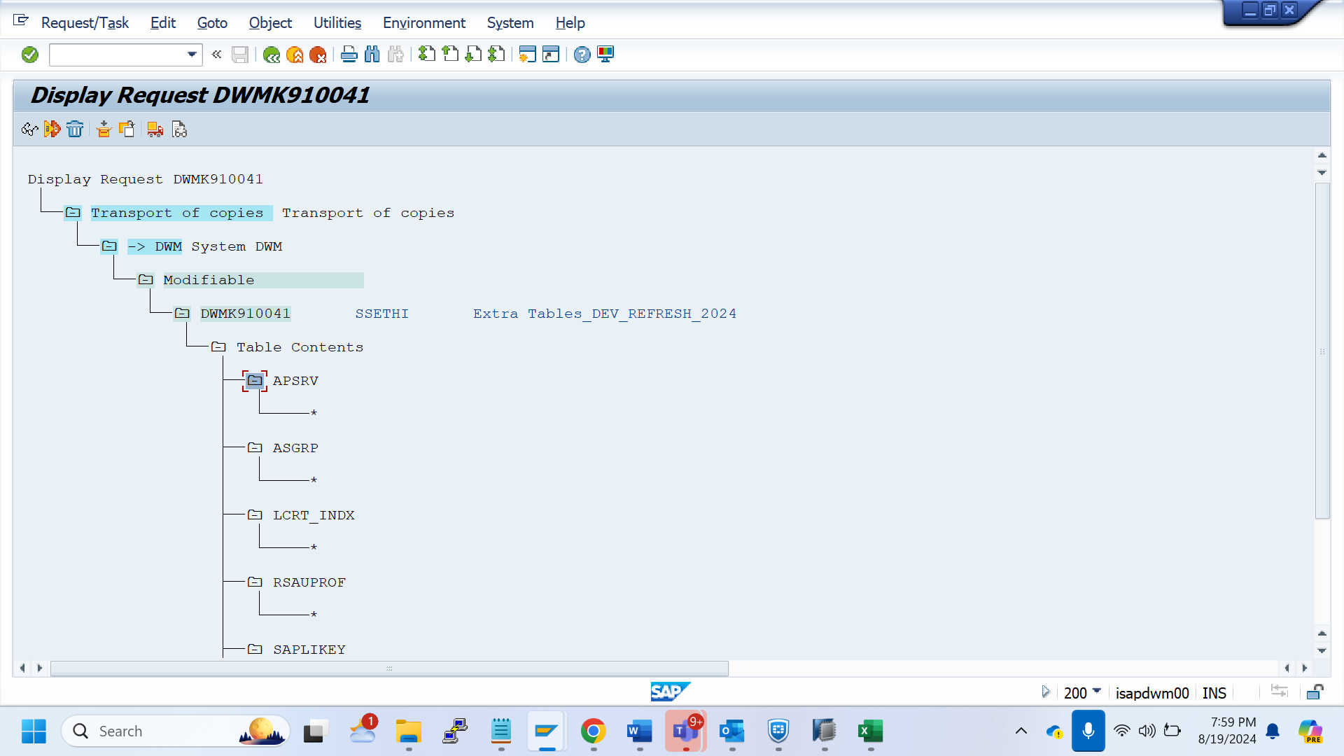

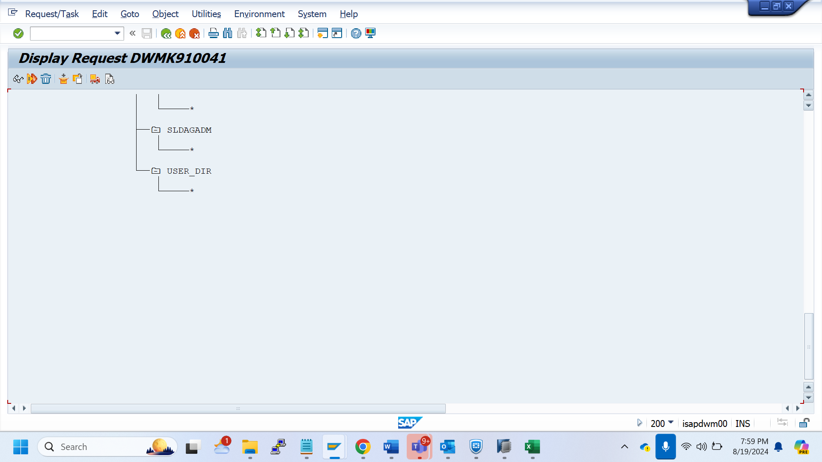

Batch Jobs - DWMK910042

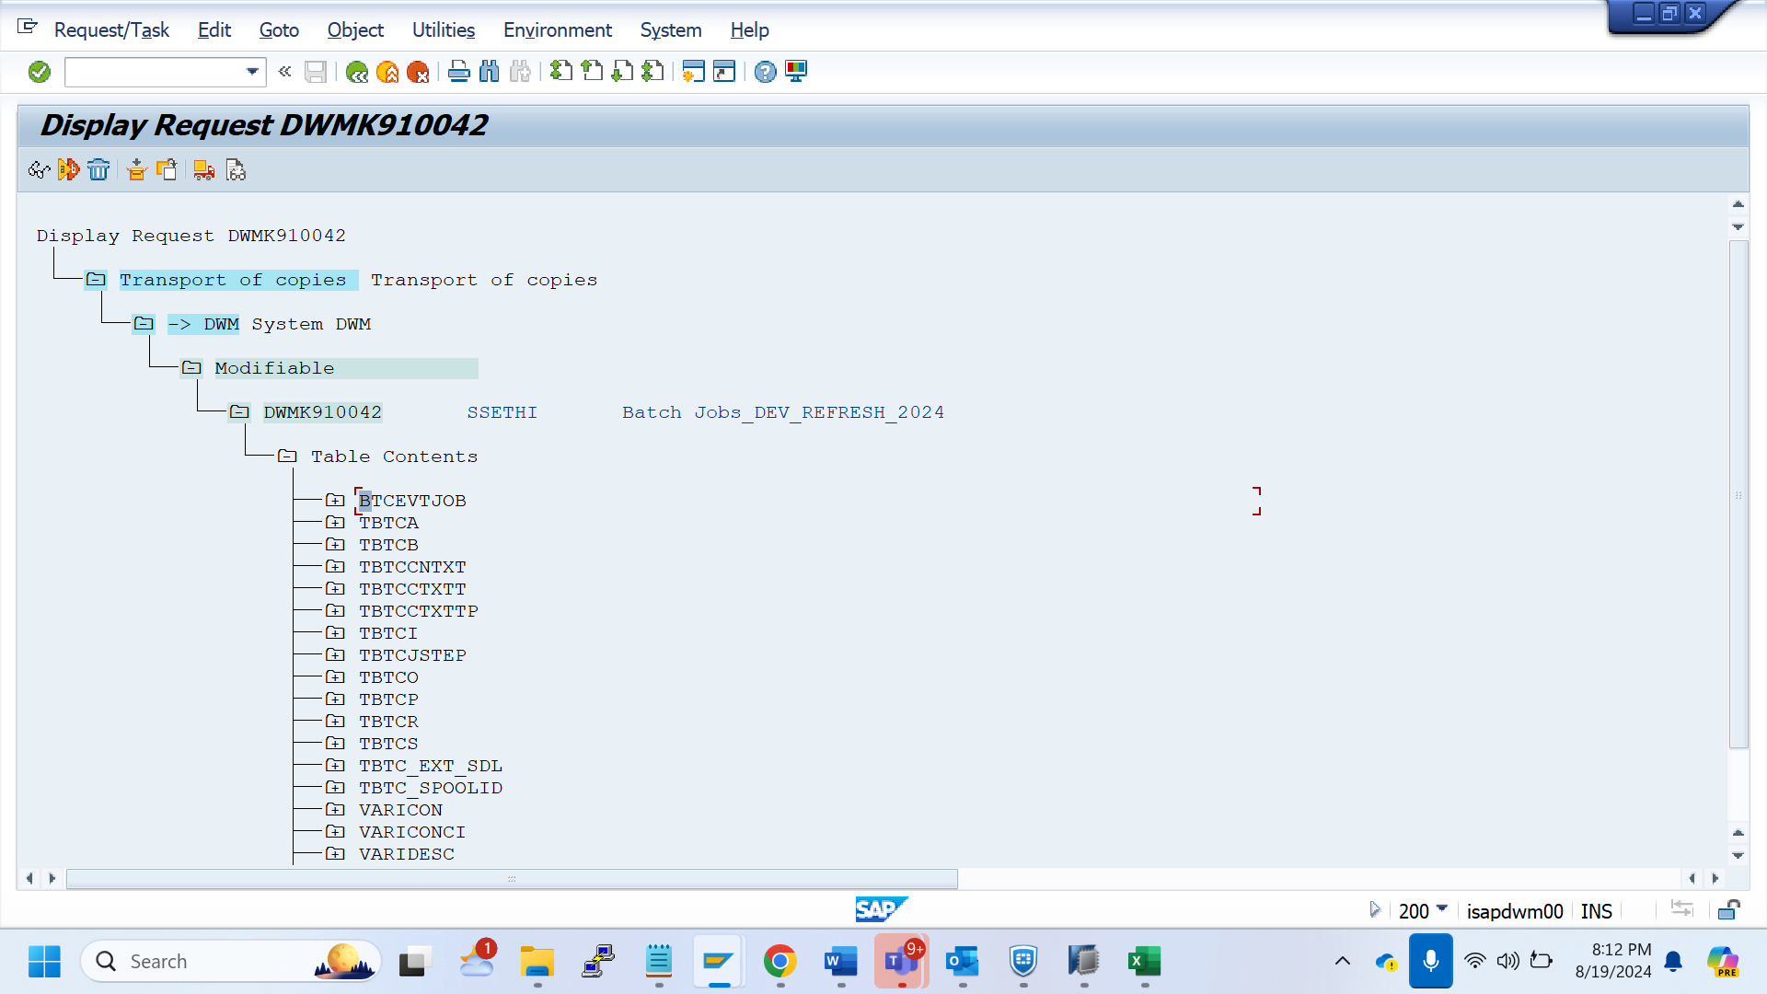

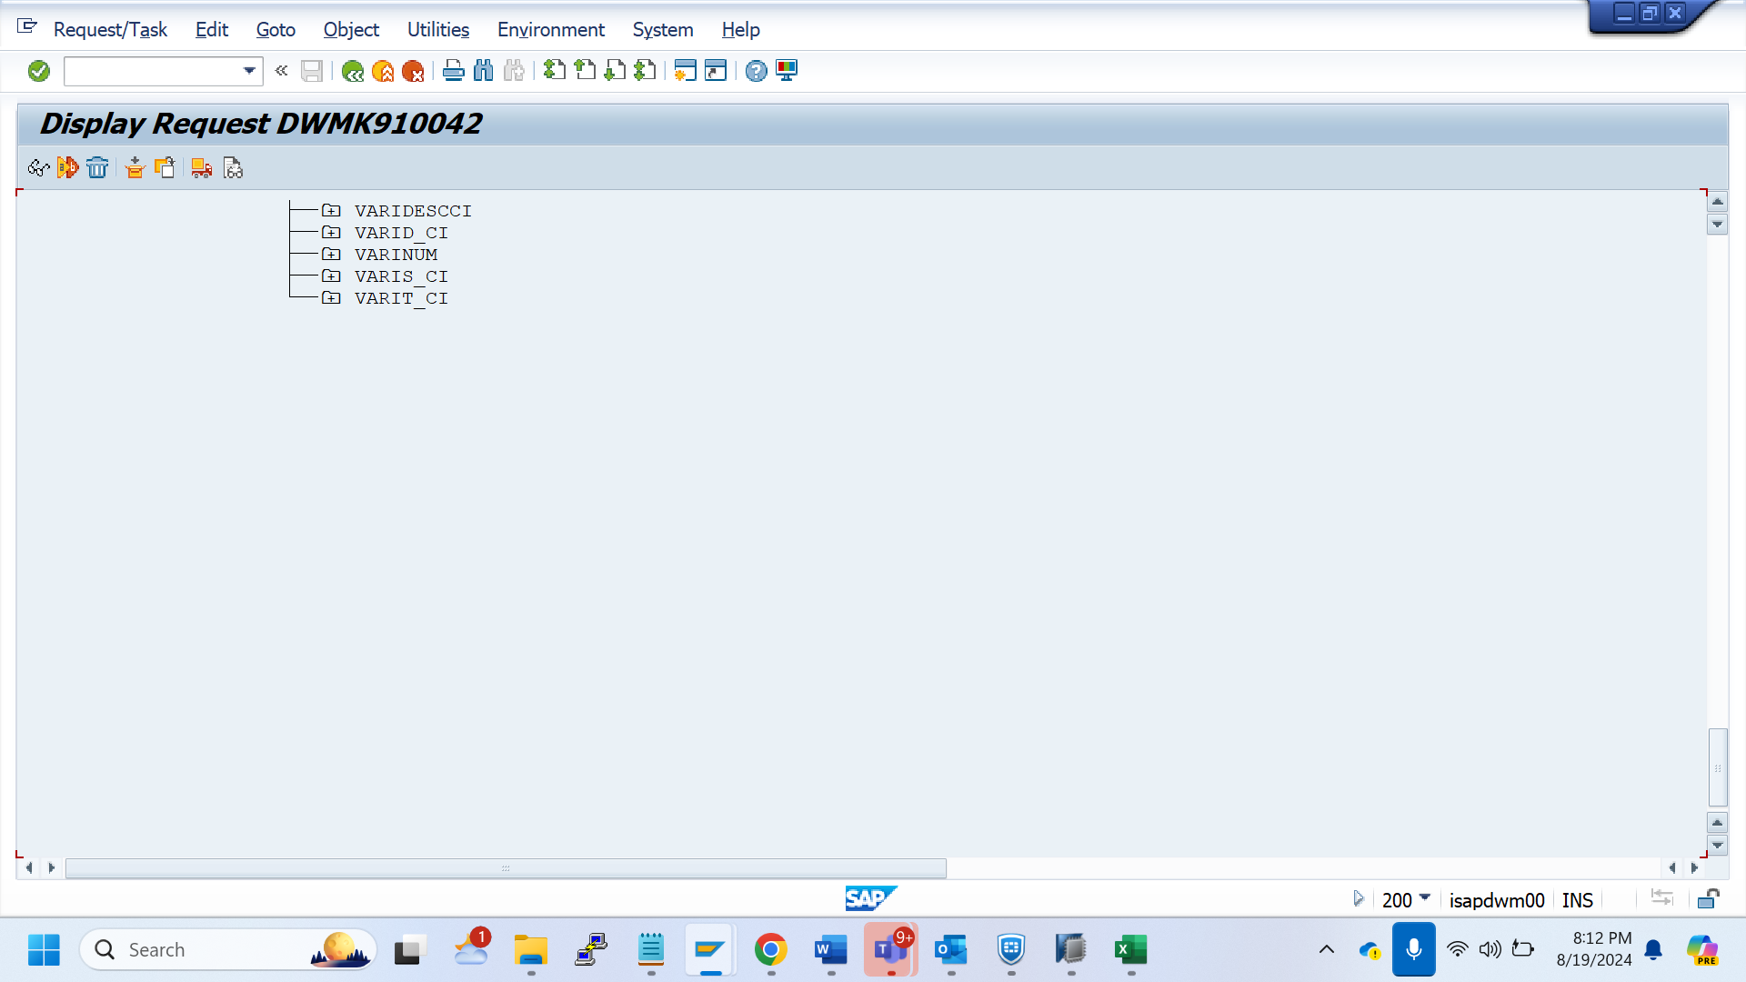

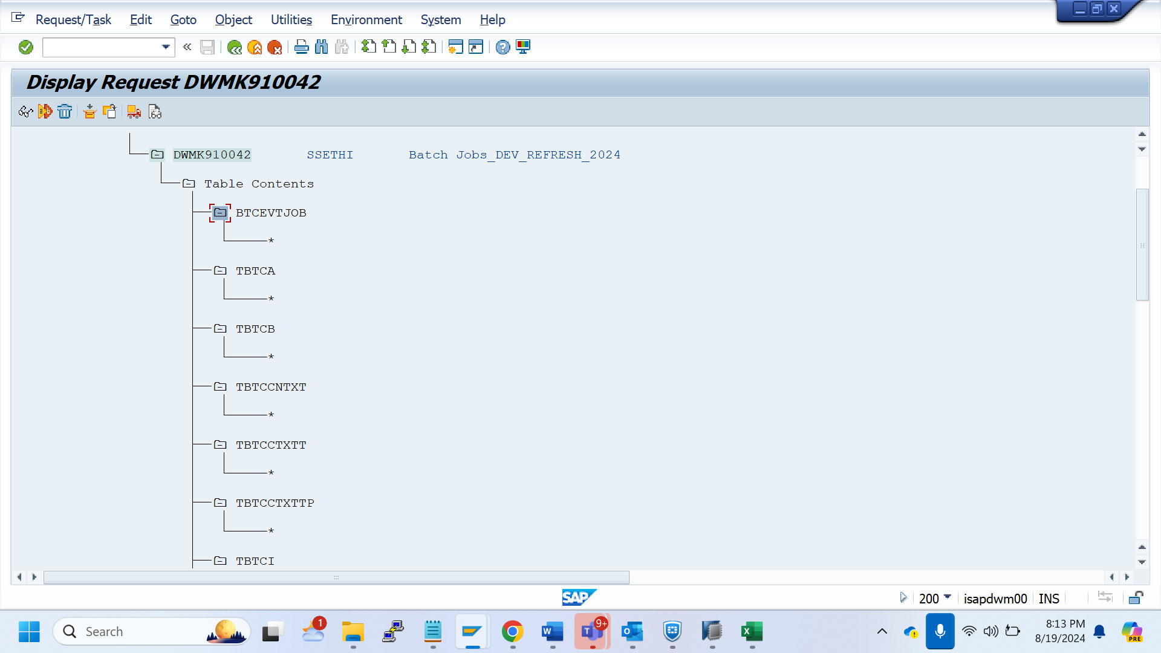

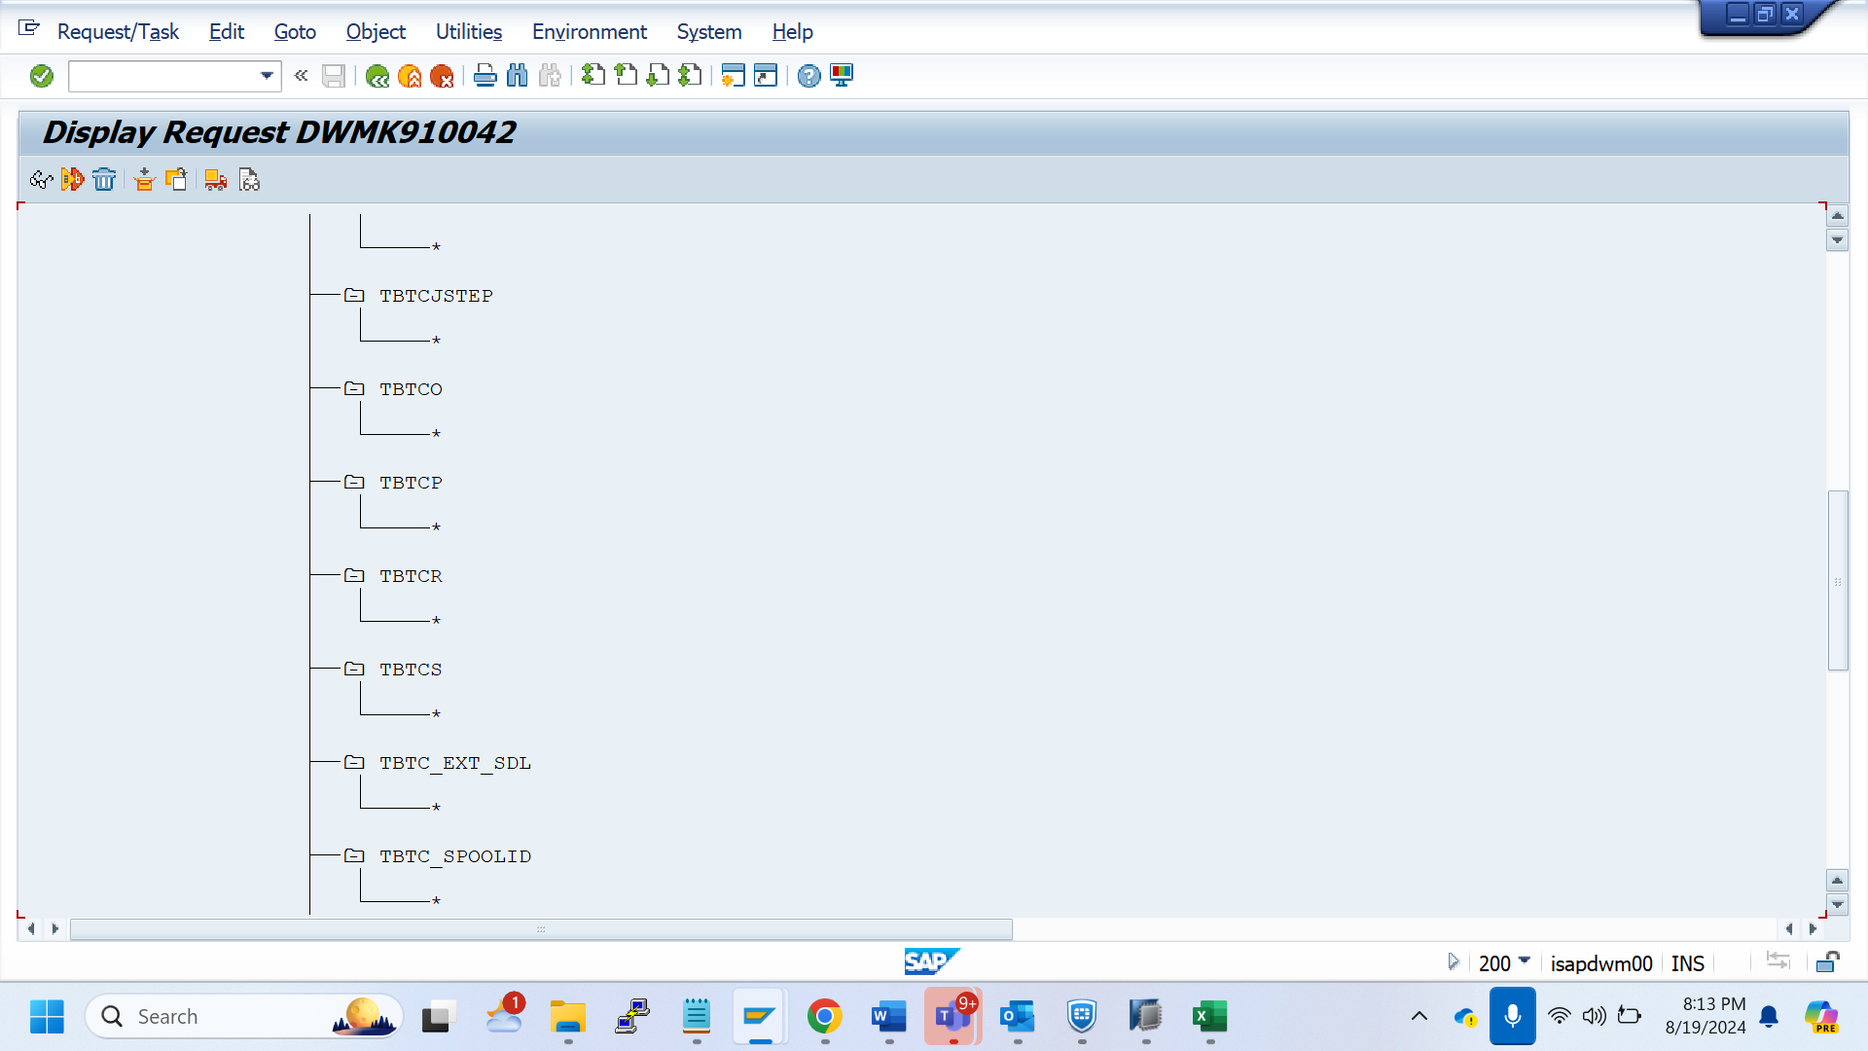

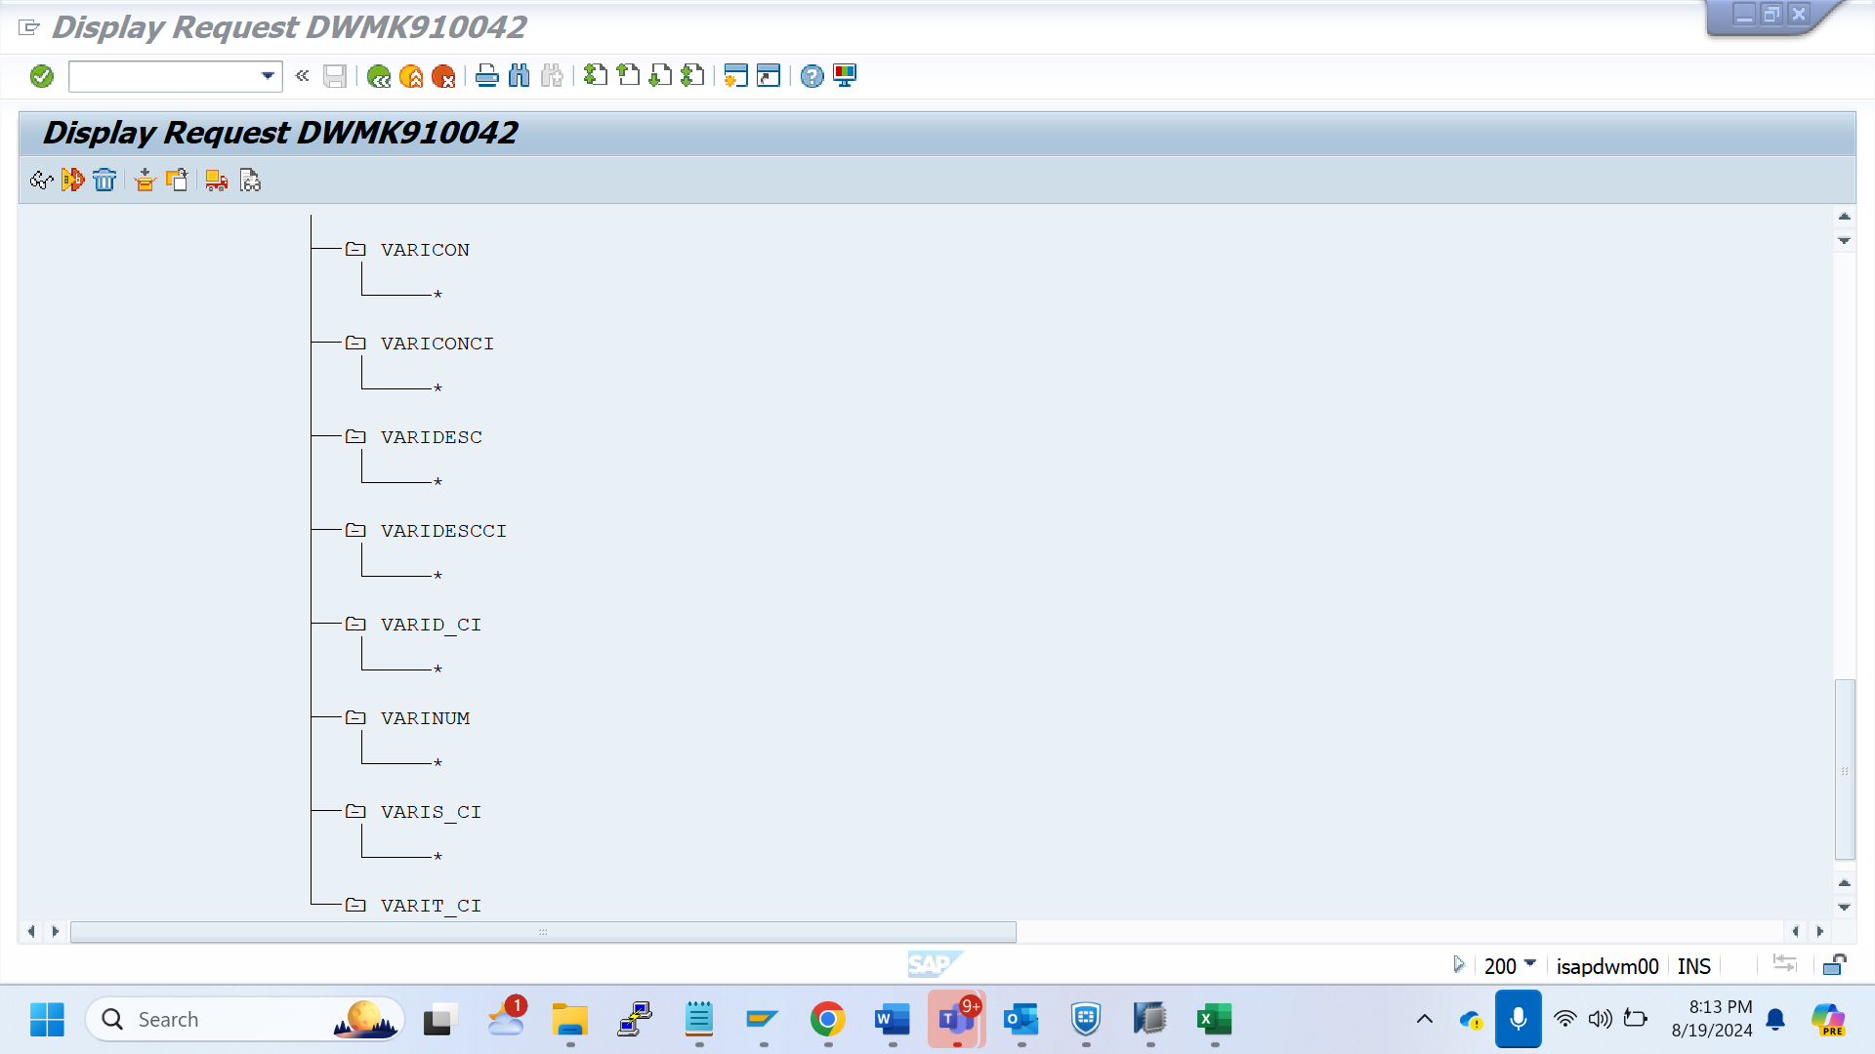

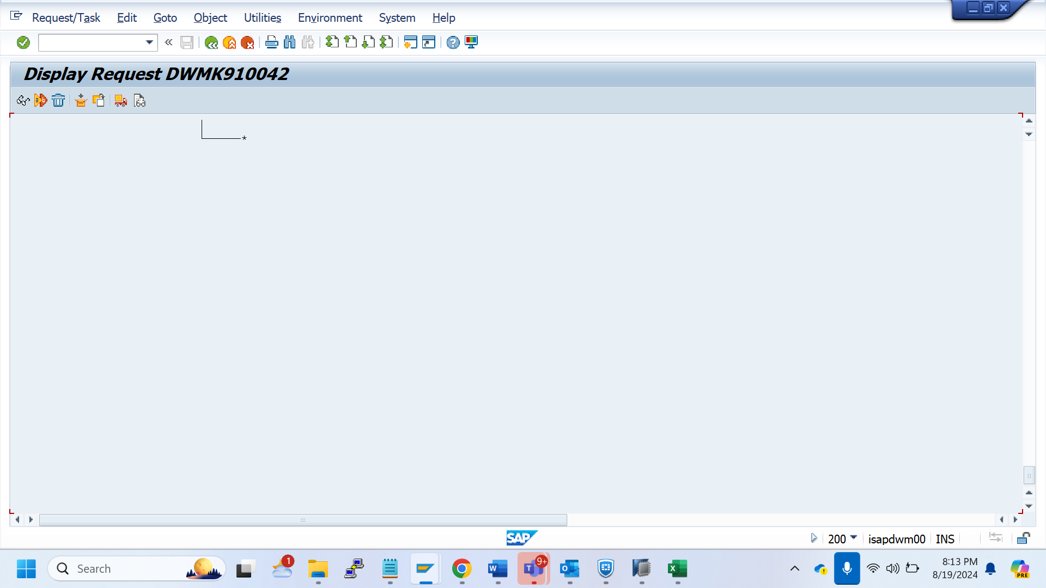

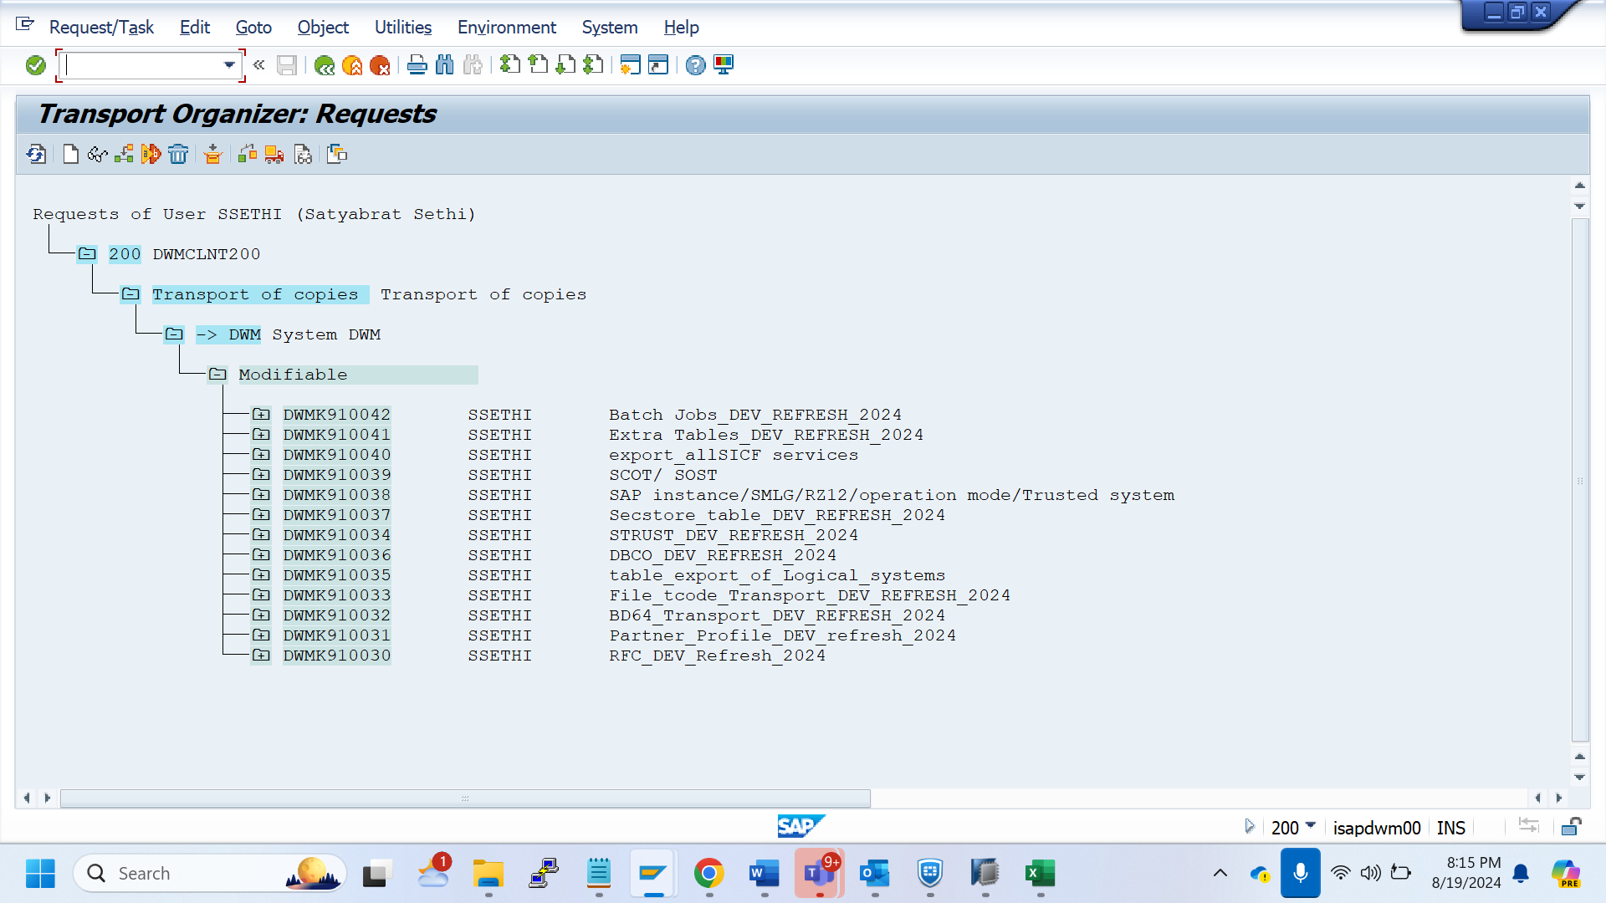

DWMK910042 SSETHI Batch Jobs_DEV_REFRESH_2024

DWMK910041 SSETHI Extra Tables_DEV_REFRESH_2024

DWMK910040 SSETHI export_allSICF services

DWMK910039 SSETHI SCOT/ SOST

DWMK910038 SSETHI SAP instance/SMLG/RZ12/operation mode/Trusted system

DWMK910037 SSETHI Secstore_table_DEV_REFRESH_2024

DWMK910034 SSETHI STRUST_DEV_REFRESH_2024

DWMK910036 SSETHI DBCO_DEV_REFRESH_2024

DWMK910035 SSETHI table_export_of_Logical_systems

DWMK910033 SSETHI File_tcode_Transport_DEV_REFRESH_2024

DWMK910032 SSETHI BD64_Transport_DEV_REFRESH_2024

DWMK910031 SSETHI Partner_Profile_DEV_refresh_2024

DWMK910030 SSETHI RFC_DEV_Refresh_2024

USER MASTER EXPORT

SCC8

Client 100

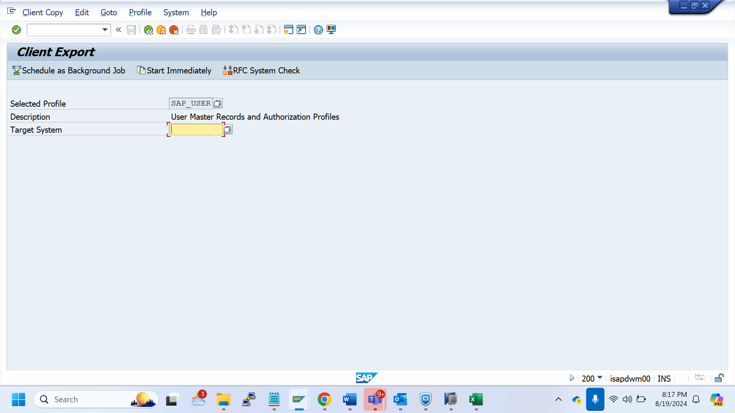

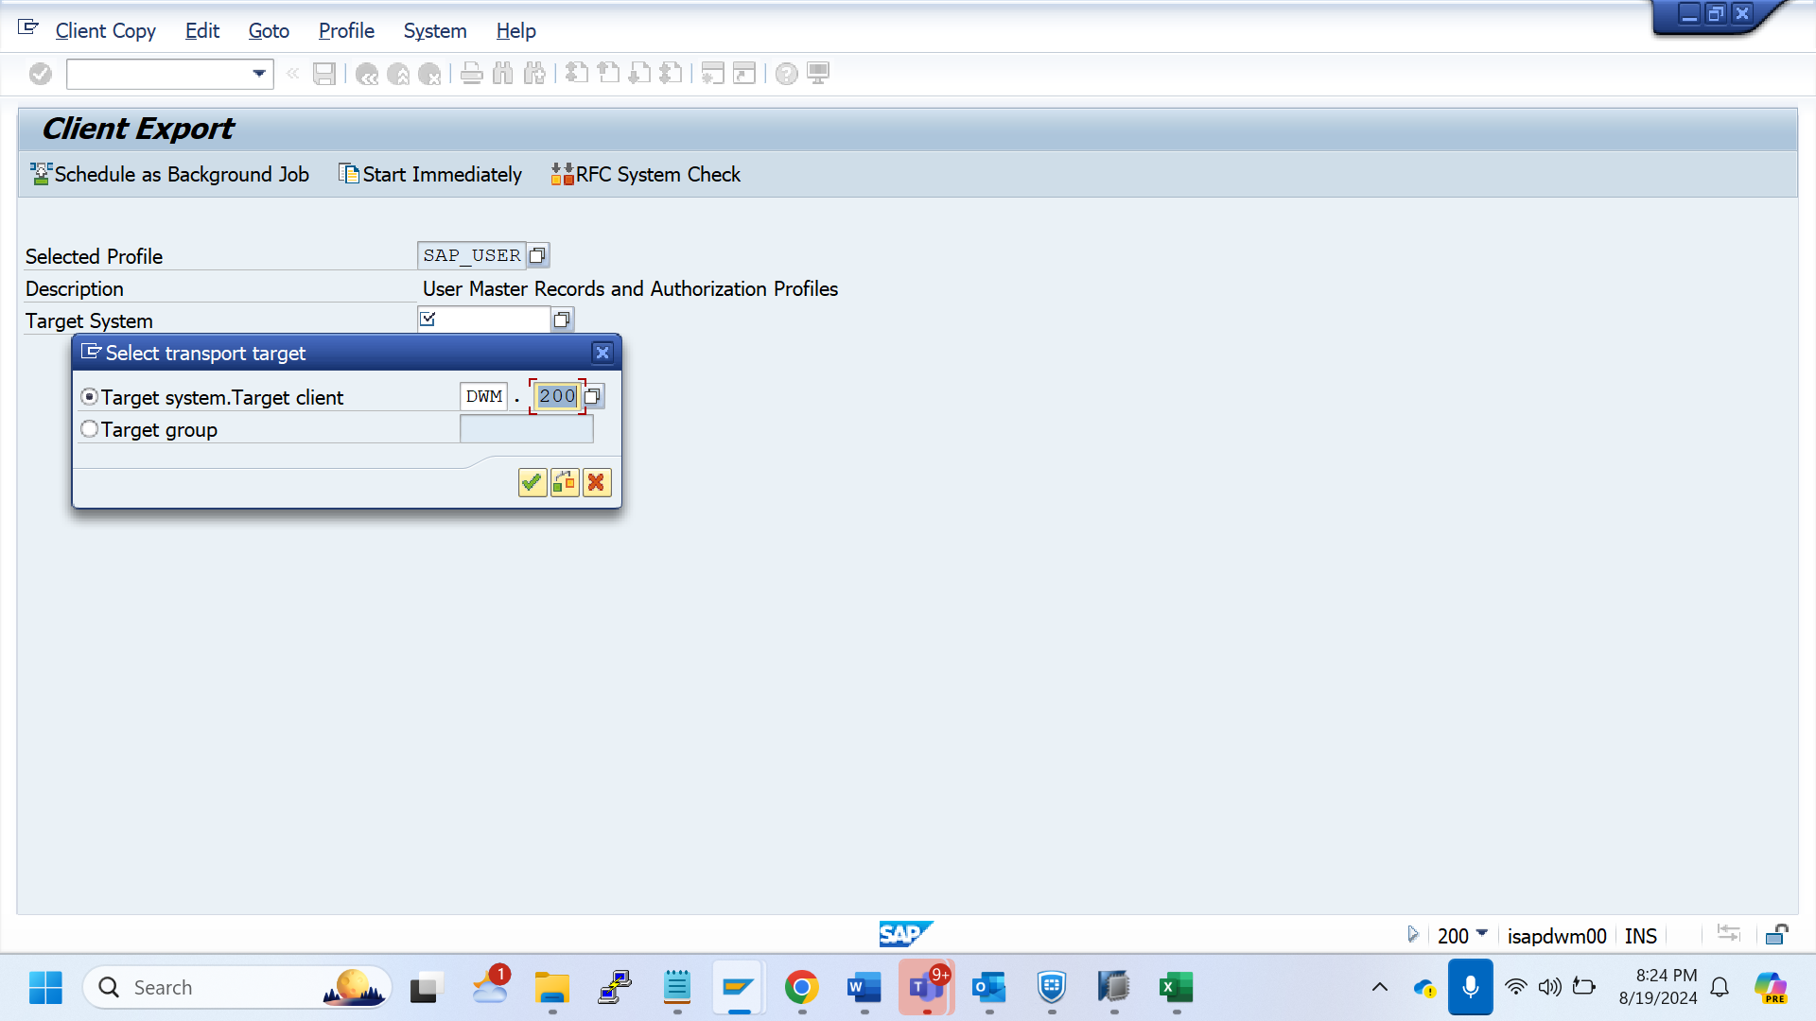

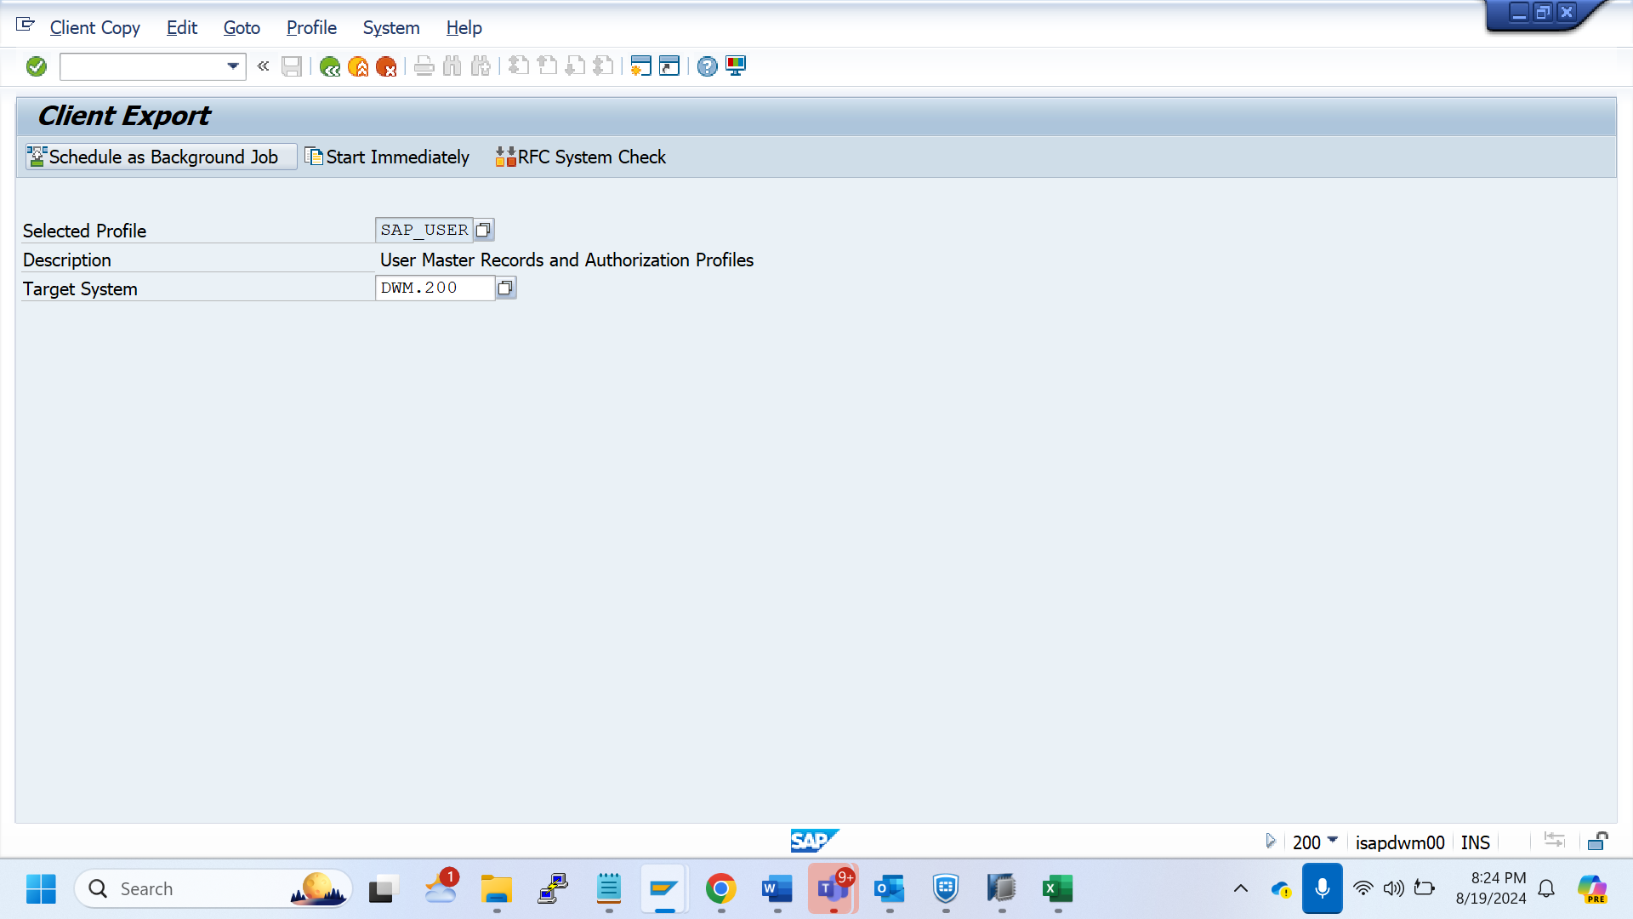

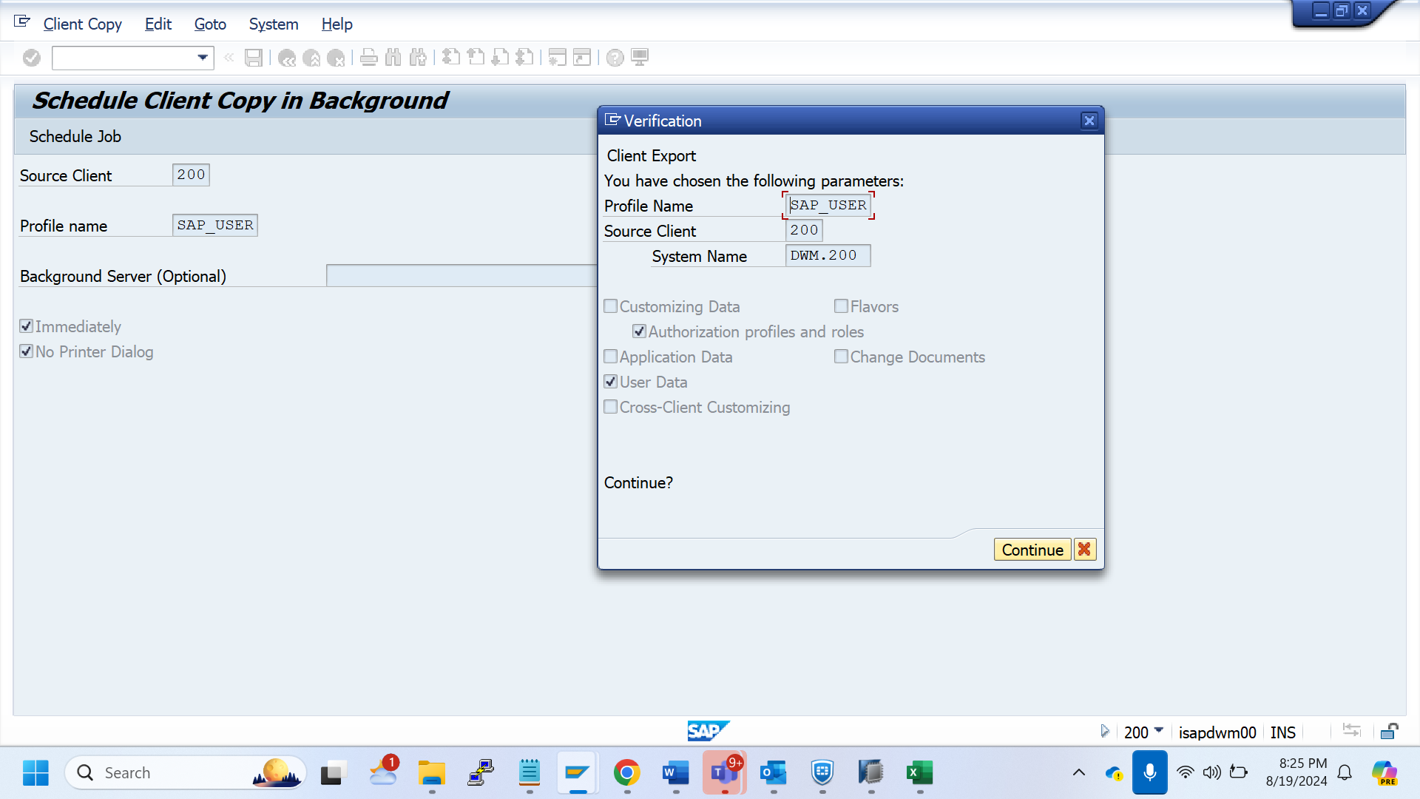

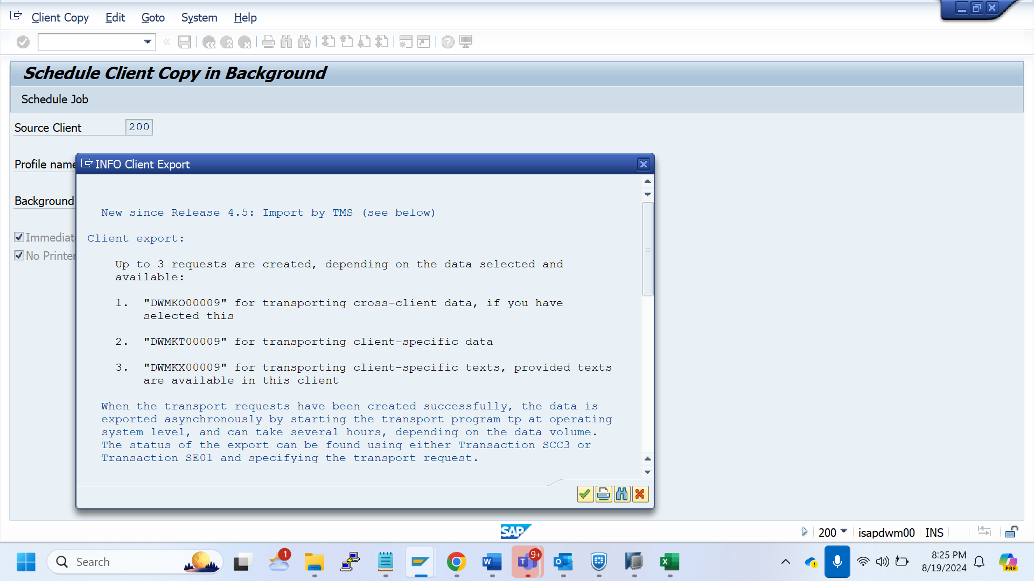

New since Release 4.5: Import by TMS (see below)

Client export:

Up to 3 requests are created, depending on the data selected and

available:

1. "DWMKO00009" for transporting cross-client data, if you have

selected this

2. "DWMKT00009" for transporting client-specific data

3. "DWMKX00009" for transporting client-specific texts, provided texts

are available in this client

When the transport requests have been created successfully, the data is

exported asynchronously by starting the transport program tp at operating

system level, and can take several hours, depending on the data volume.

The status of the export can be found using either Transaction SCC3 or

Transaction SE01 and specifying the transport request.

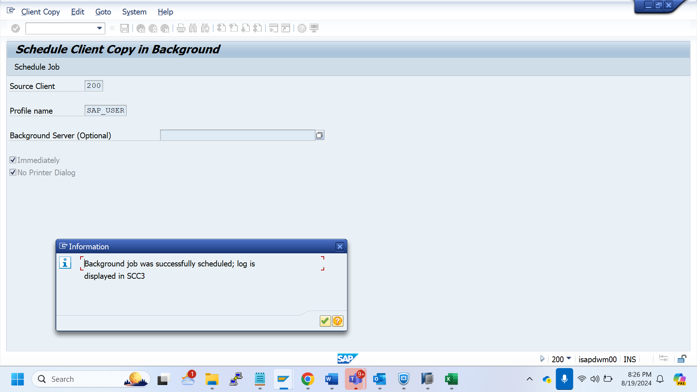

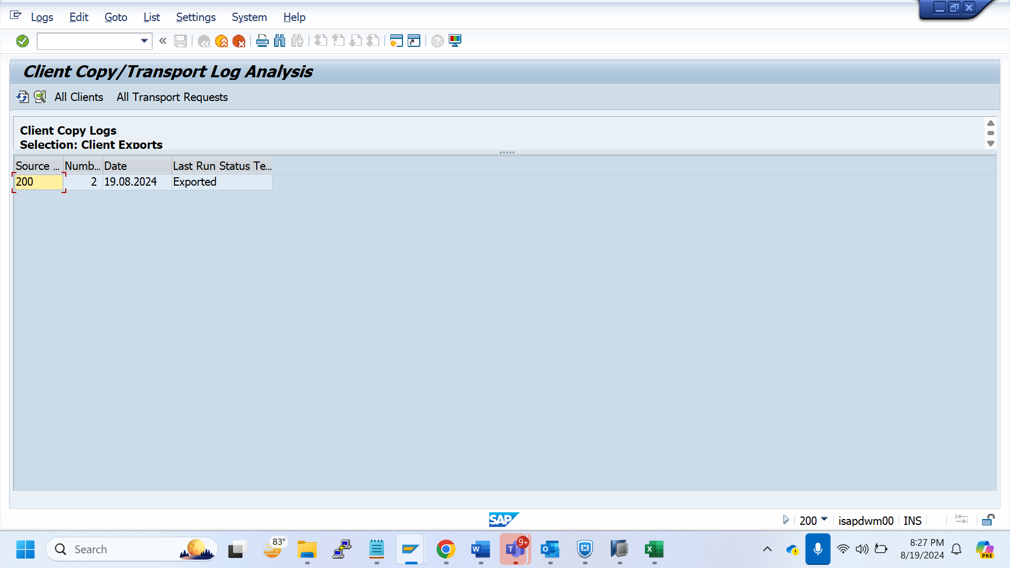

Client 000

Scc8

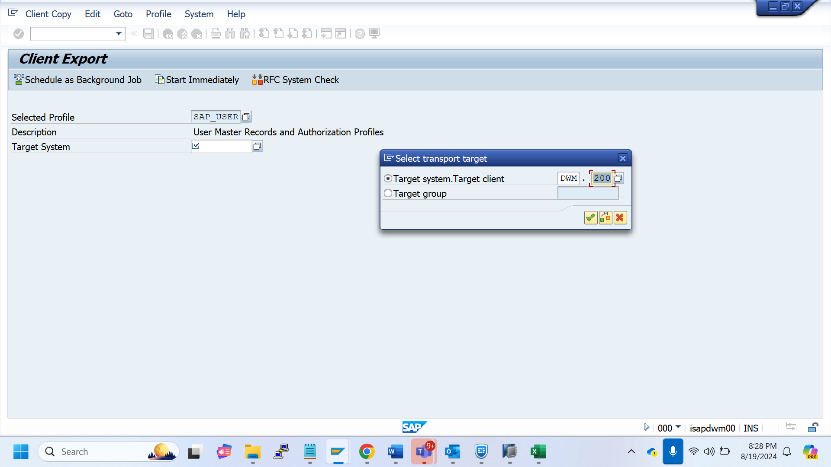

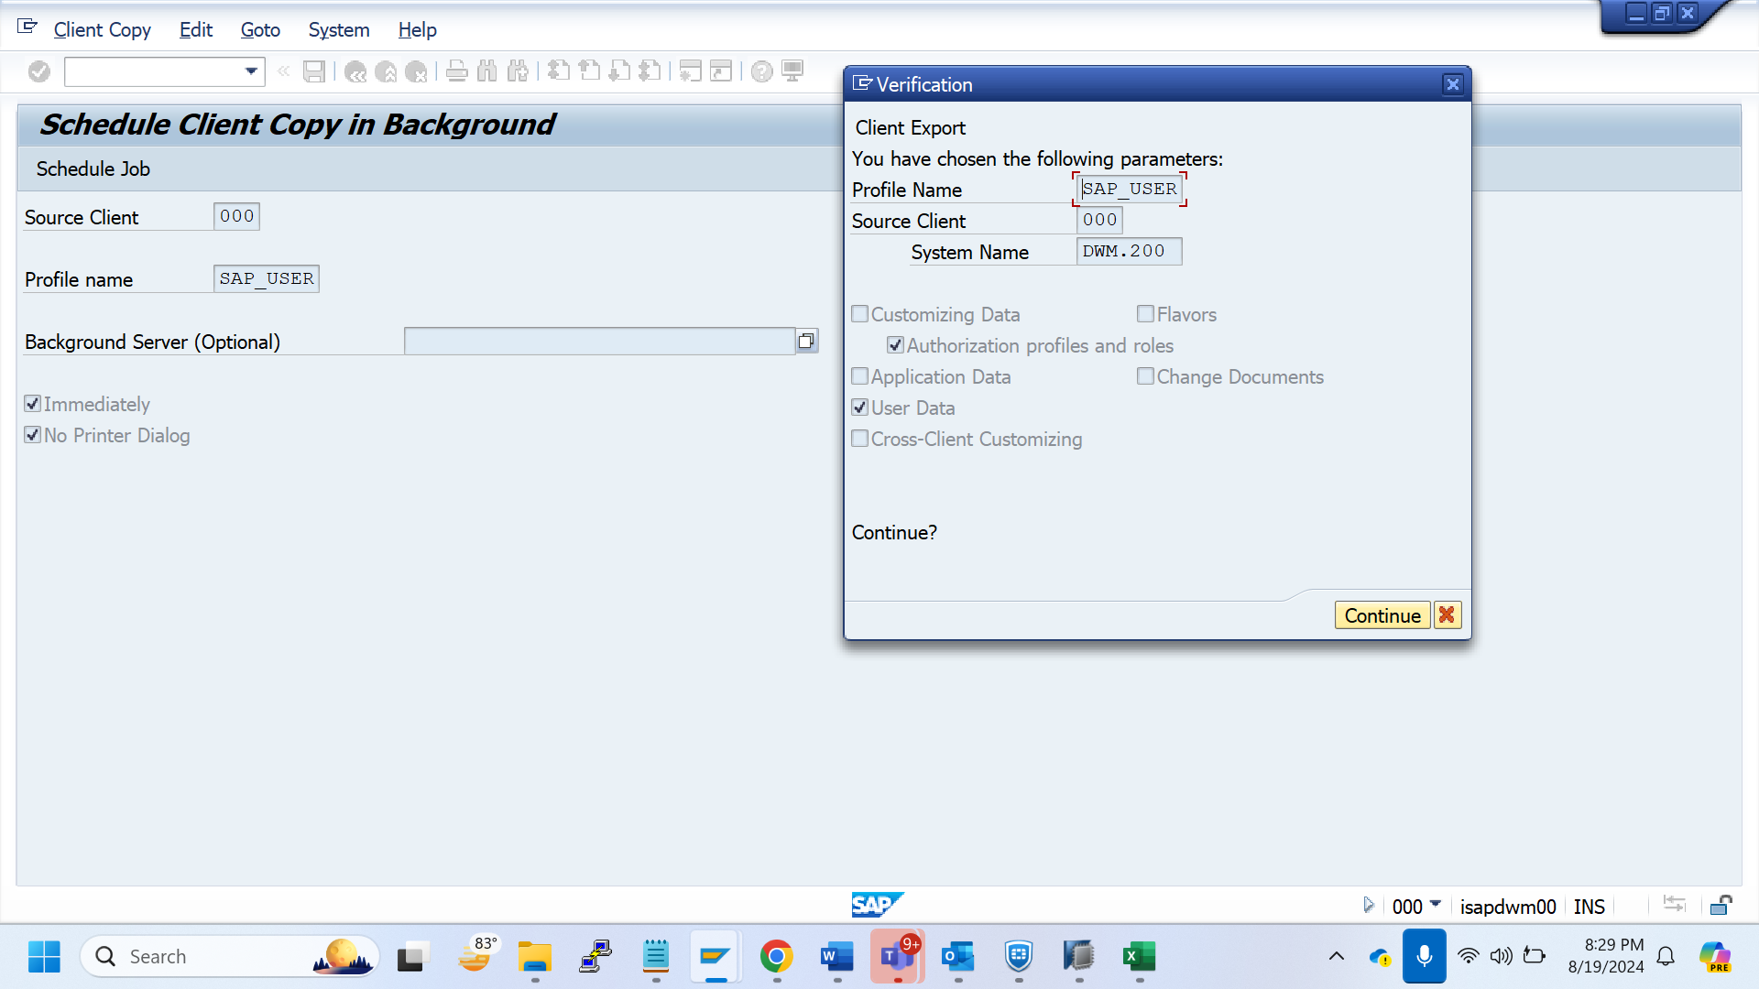

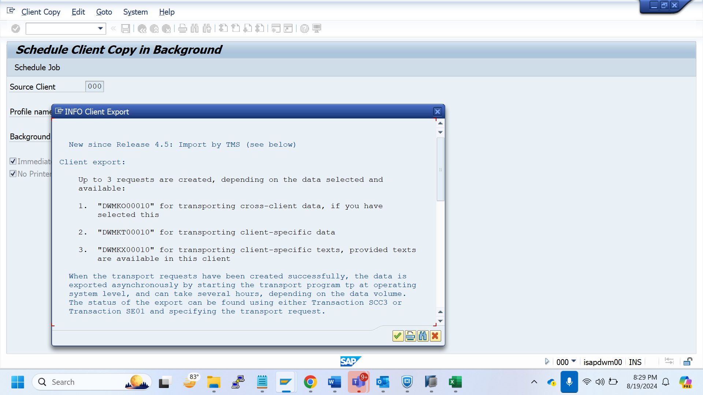

New since Release 4.5: Import by TMS (see below)

Client export:

Up to 3 requests are created, depending on the data selected and

available:

1. "DWMKO00010" for transporting cross-client data, if you have

selected this

2. "DWMKT00010" for transporting client-specific data

3. "DWMKX00010" for transporting client-specific texts, provided texts

are available in this client

When the transport requests have been created successfully, the data is

exported asynchronously by starting the transport program tp at operating

system level, and can take several hours, depending on the data volume.

The status of the export can be found using either Transaction SCC3 or

Transaction SE01 and specifying the transport request.

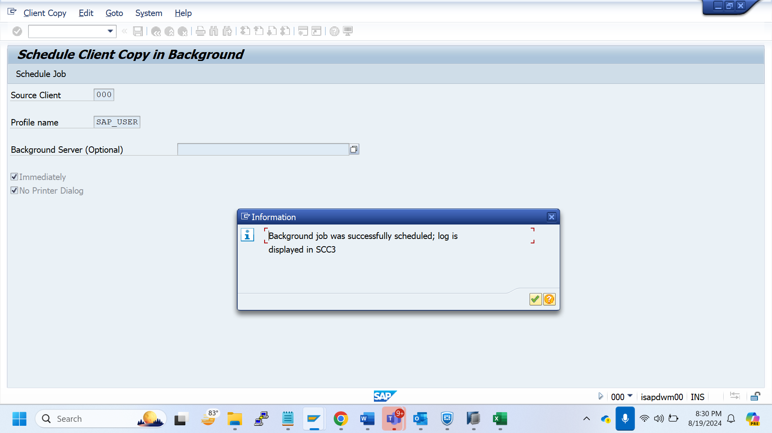

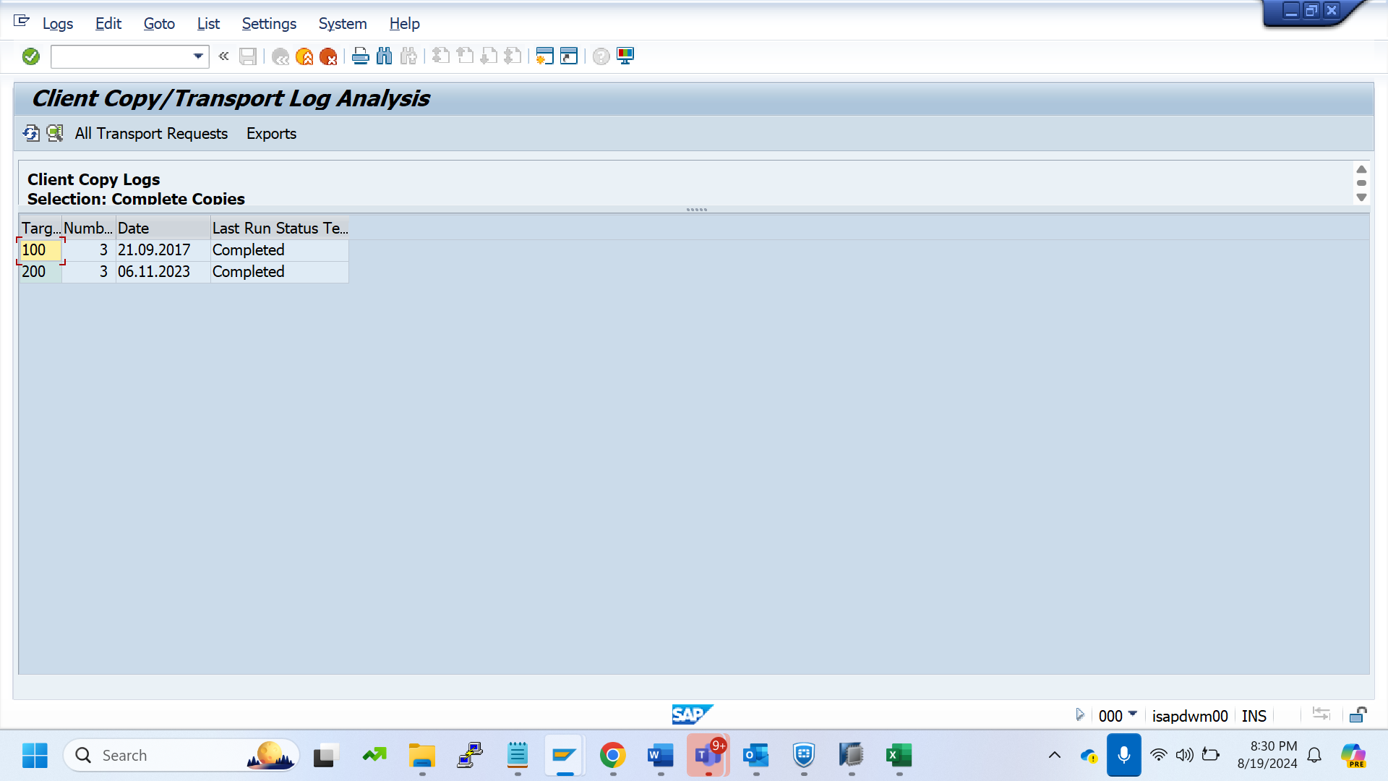

Stms

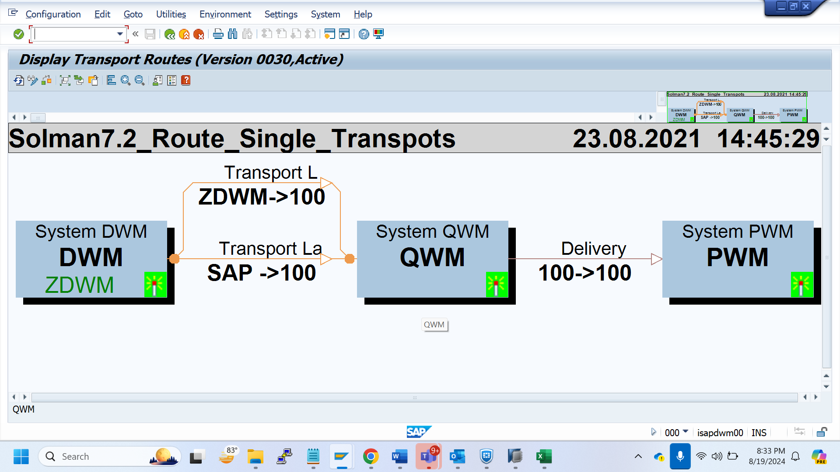

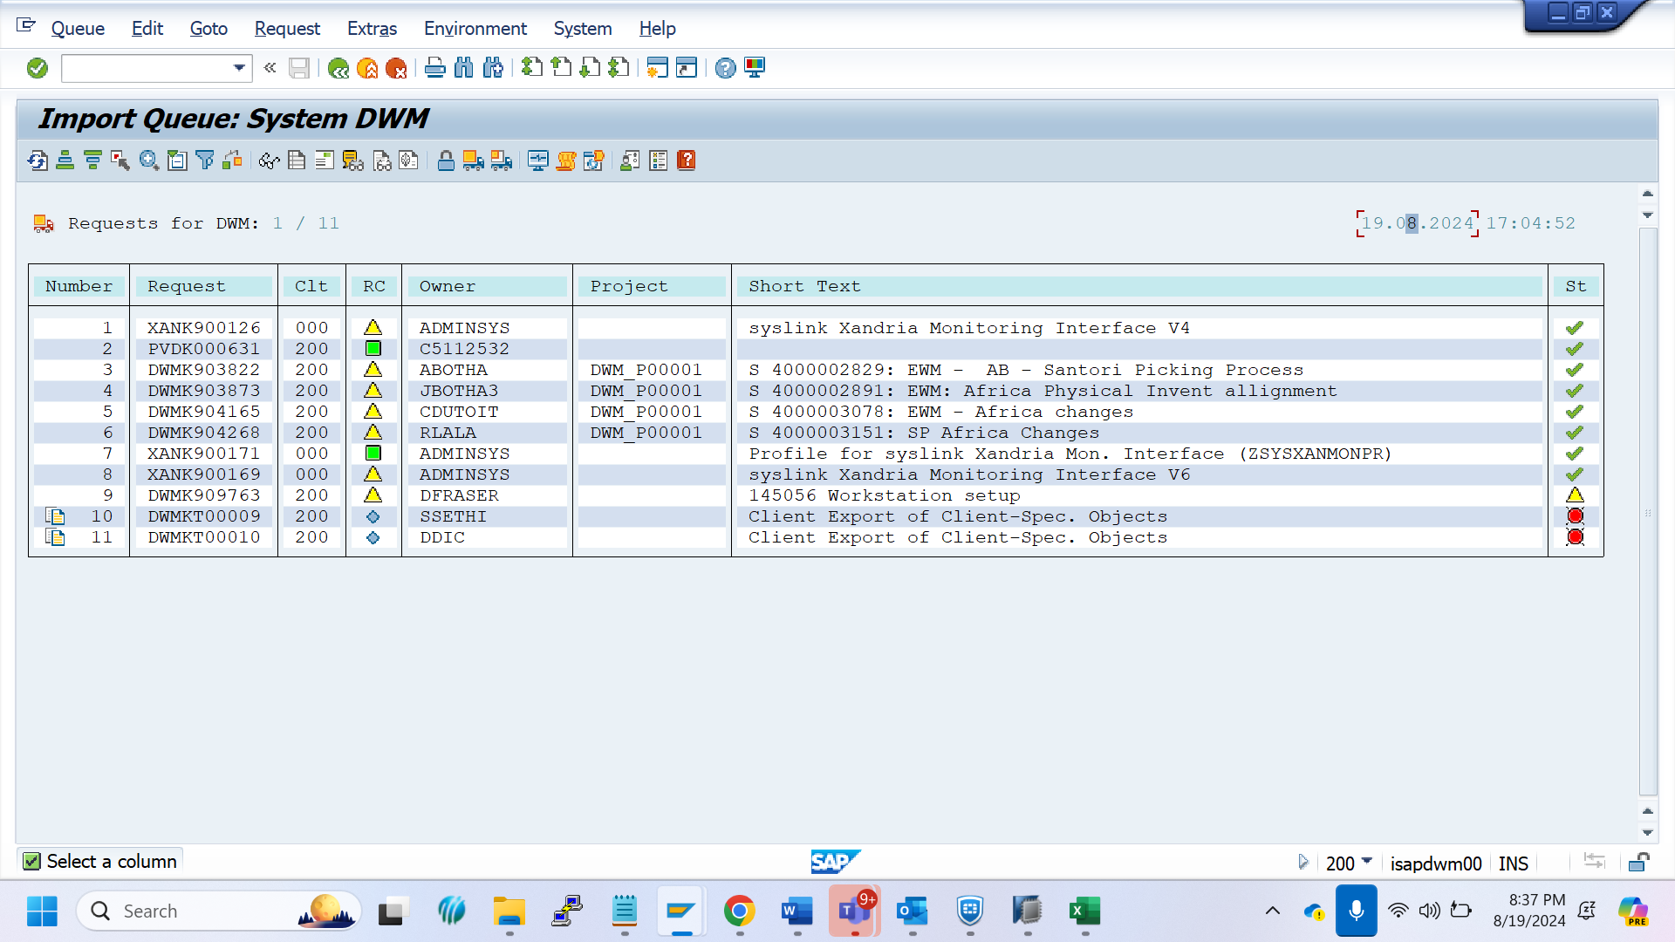

HANA Studio

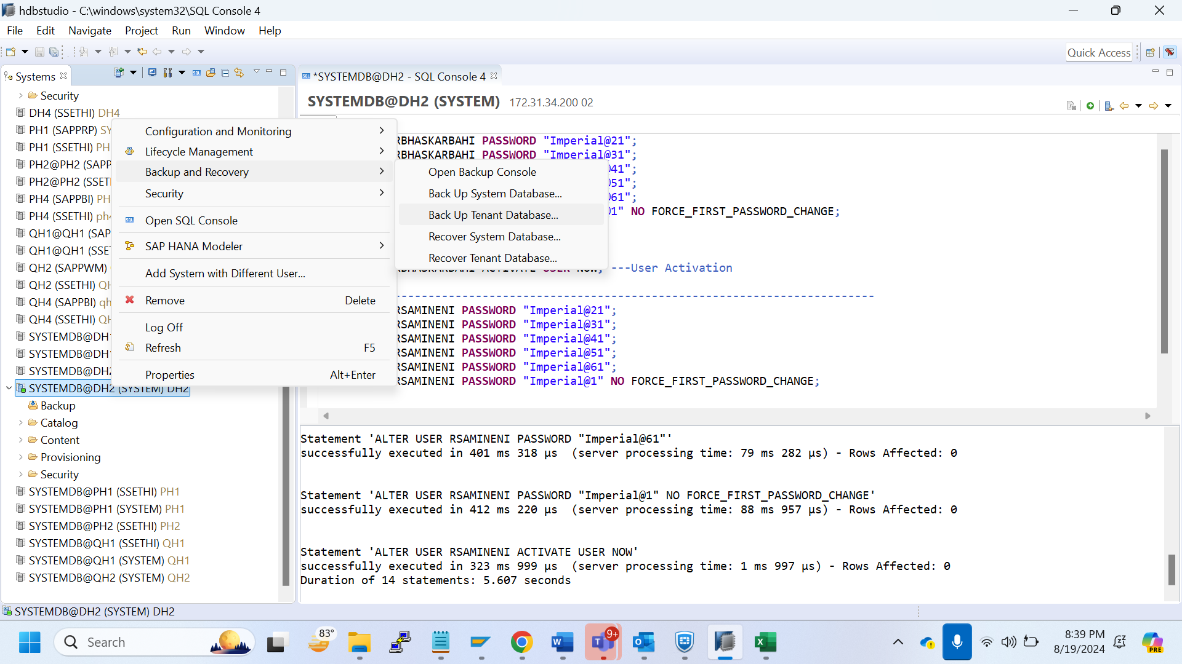

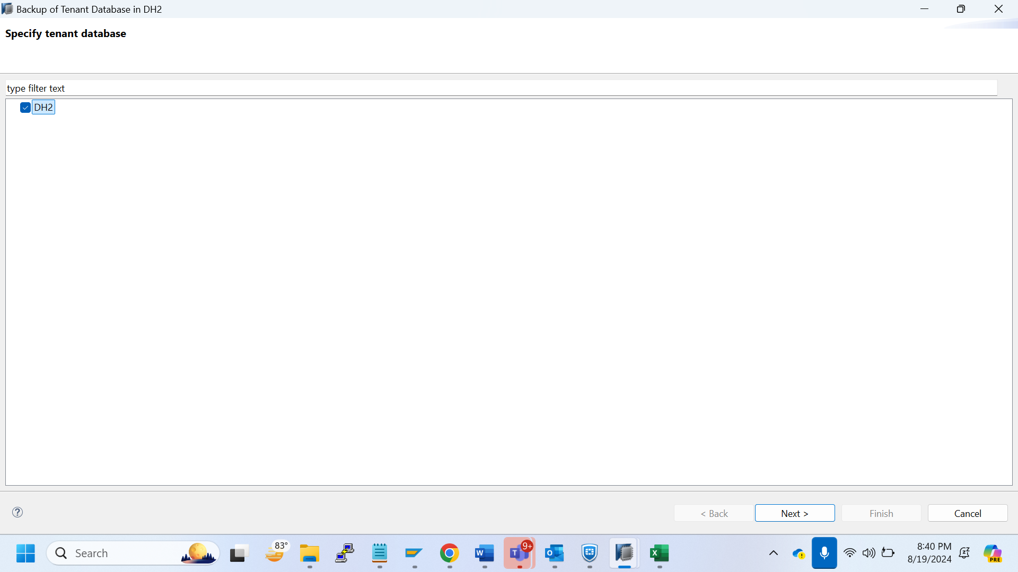

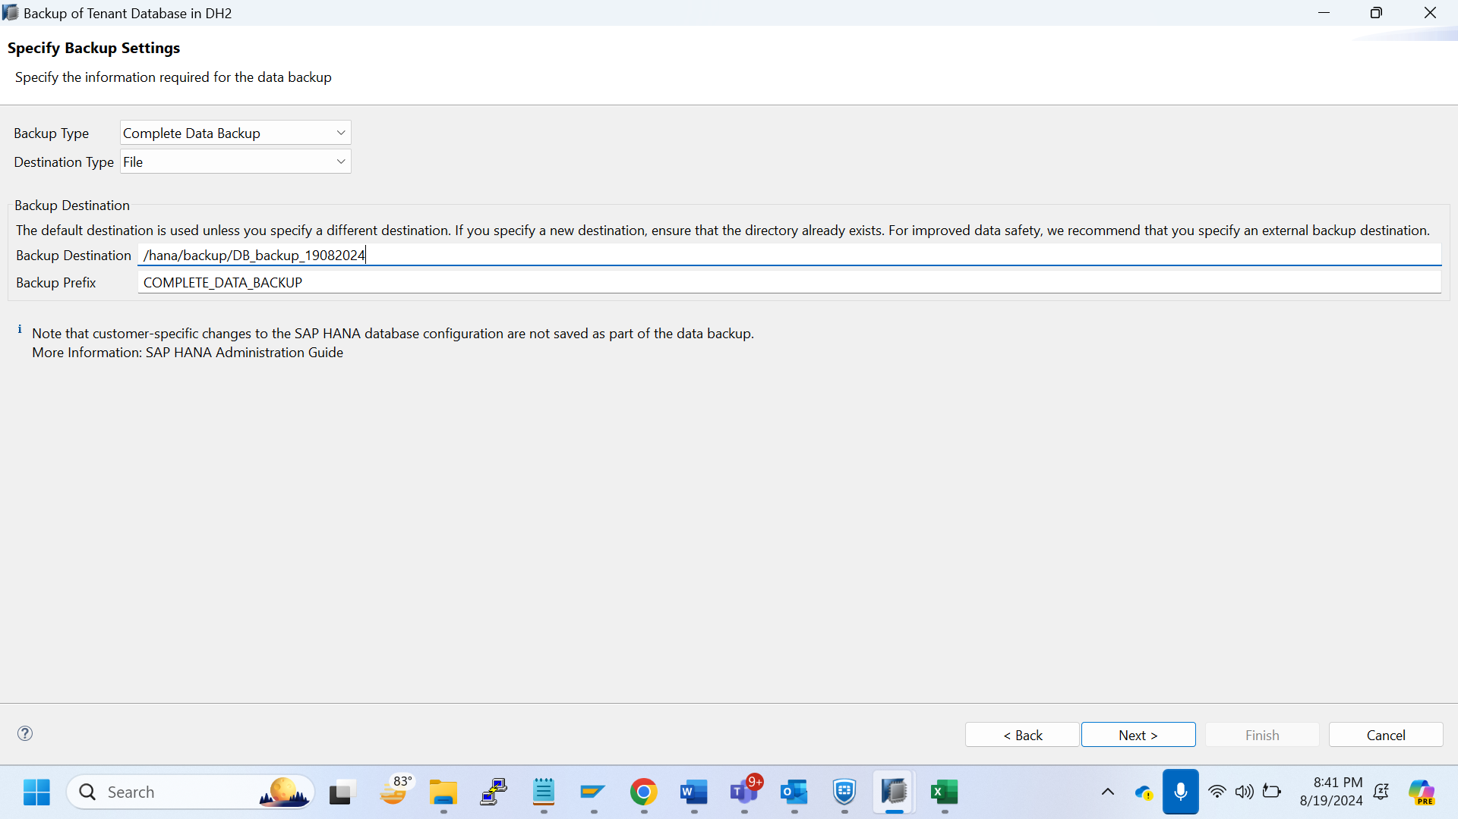

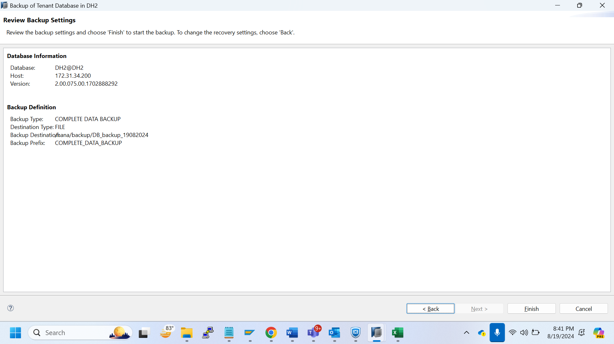

Finish

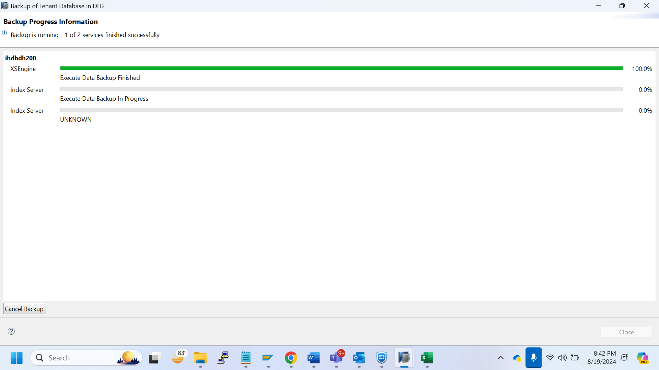

Release the toc

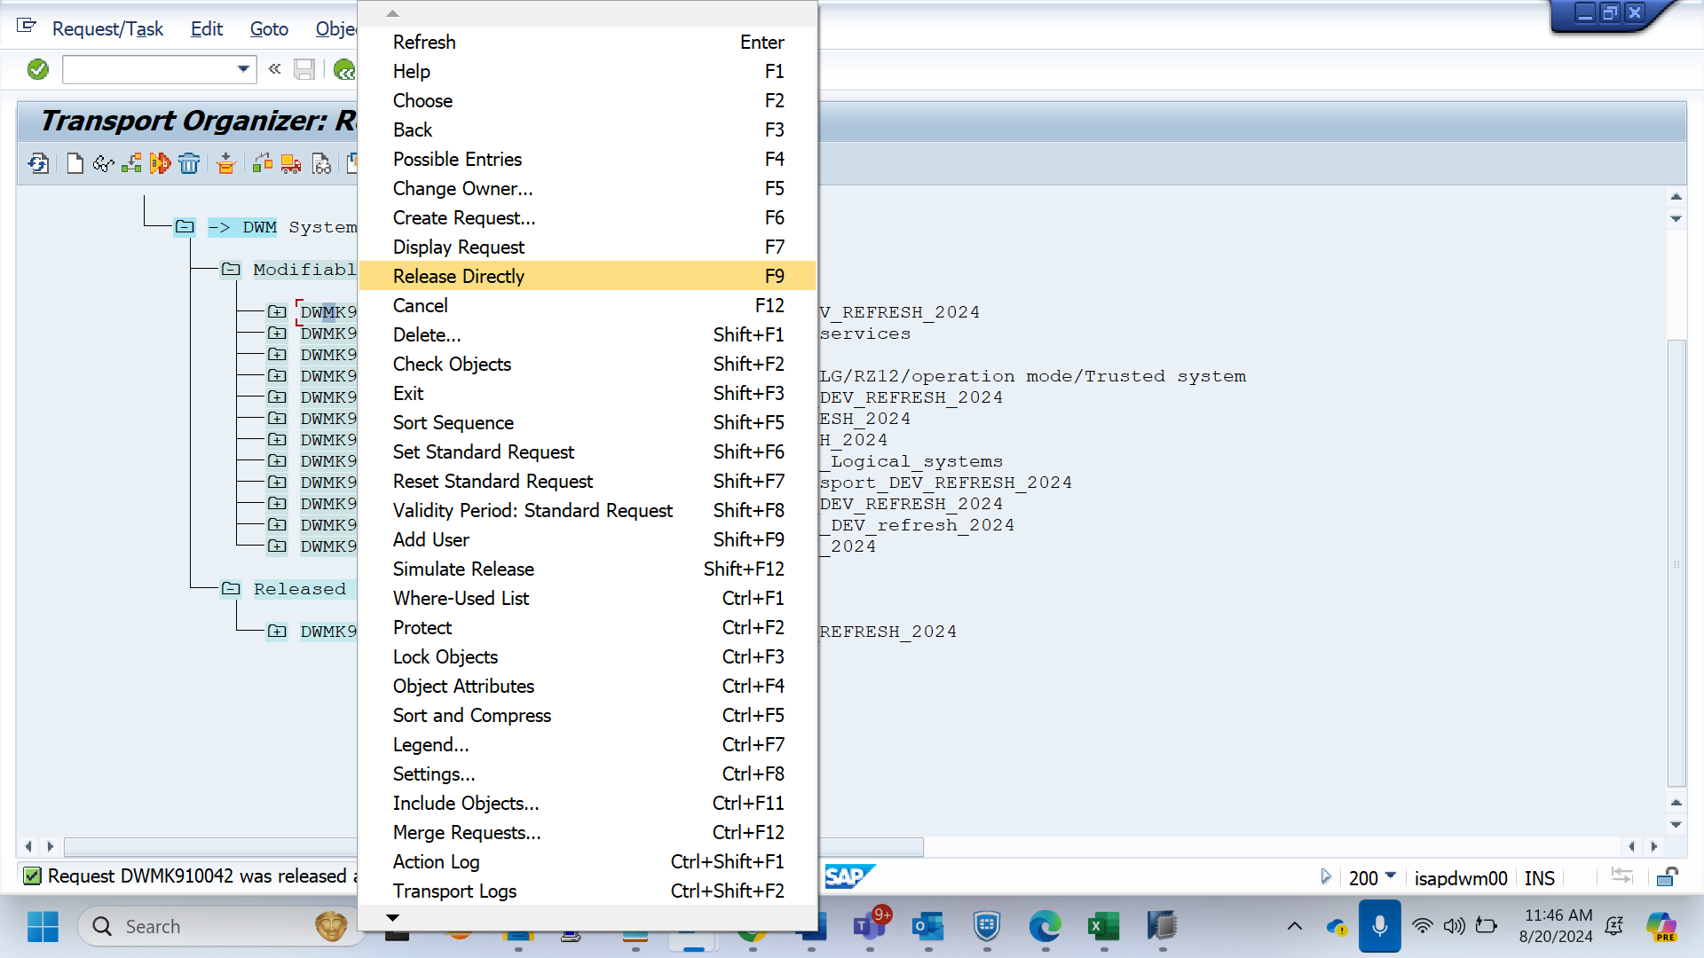

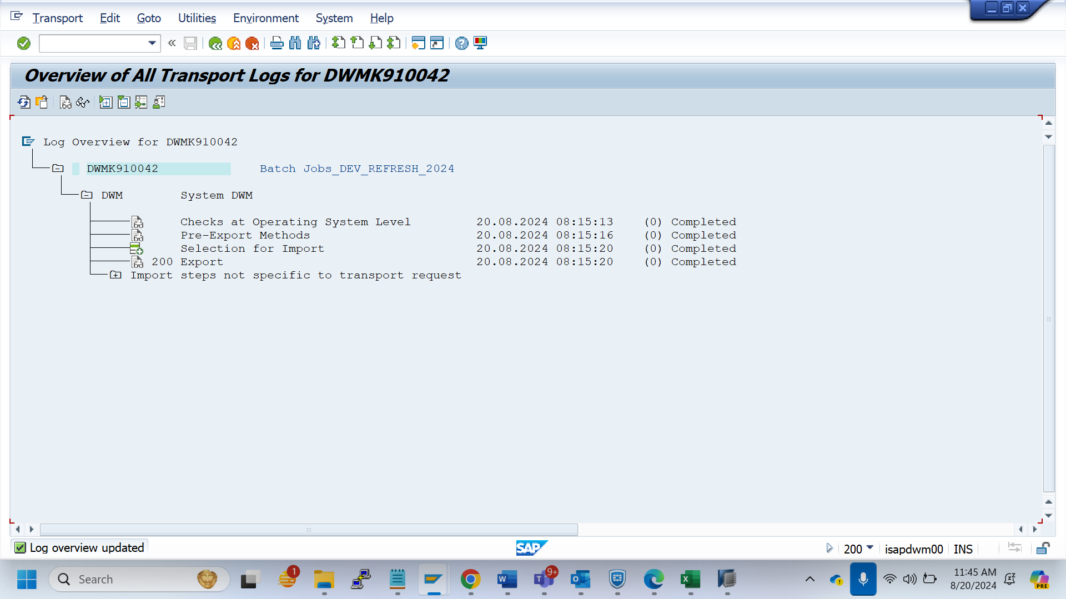

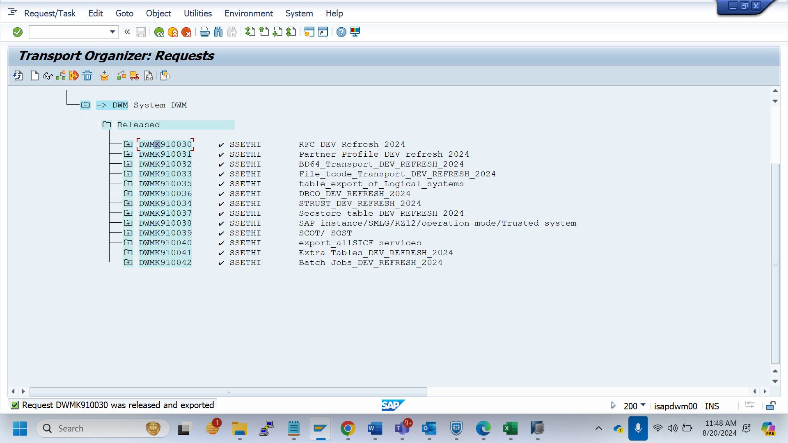

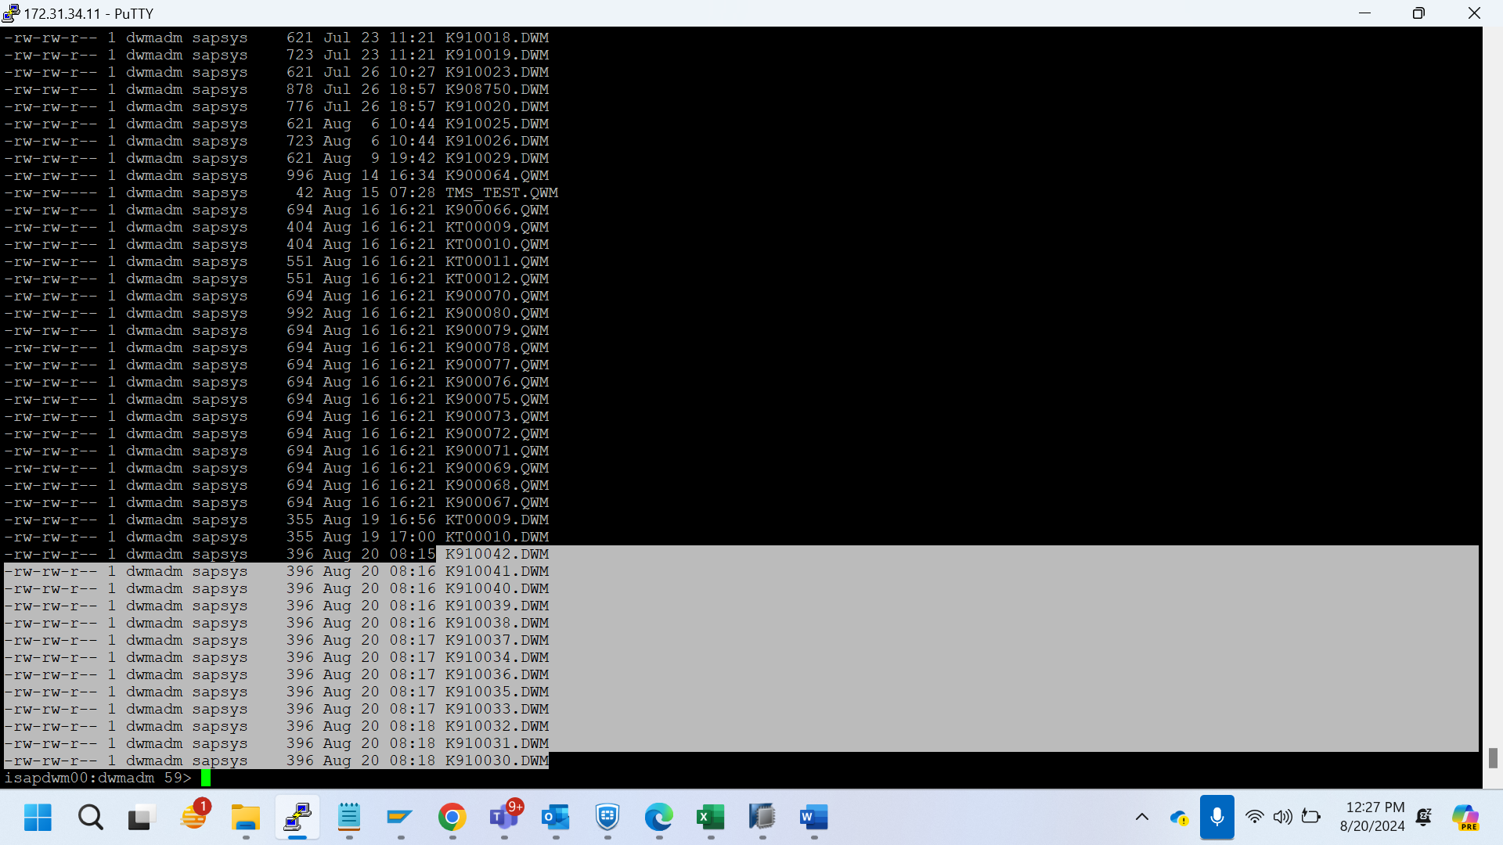

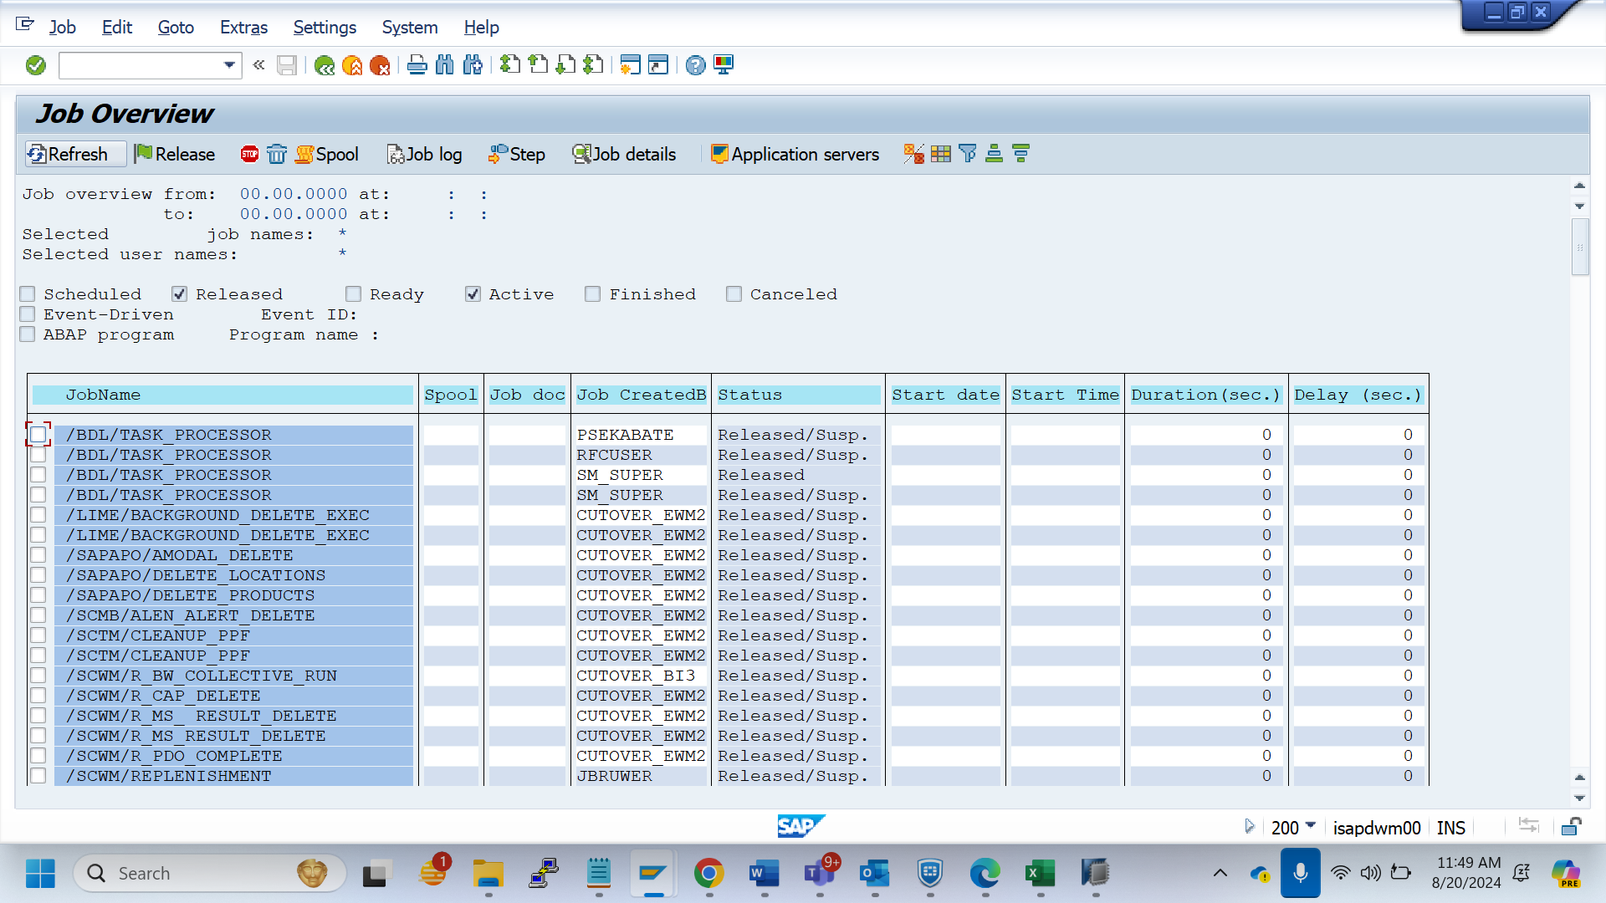

Se38 - BTCTRNS1 (to schdl the jobs)

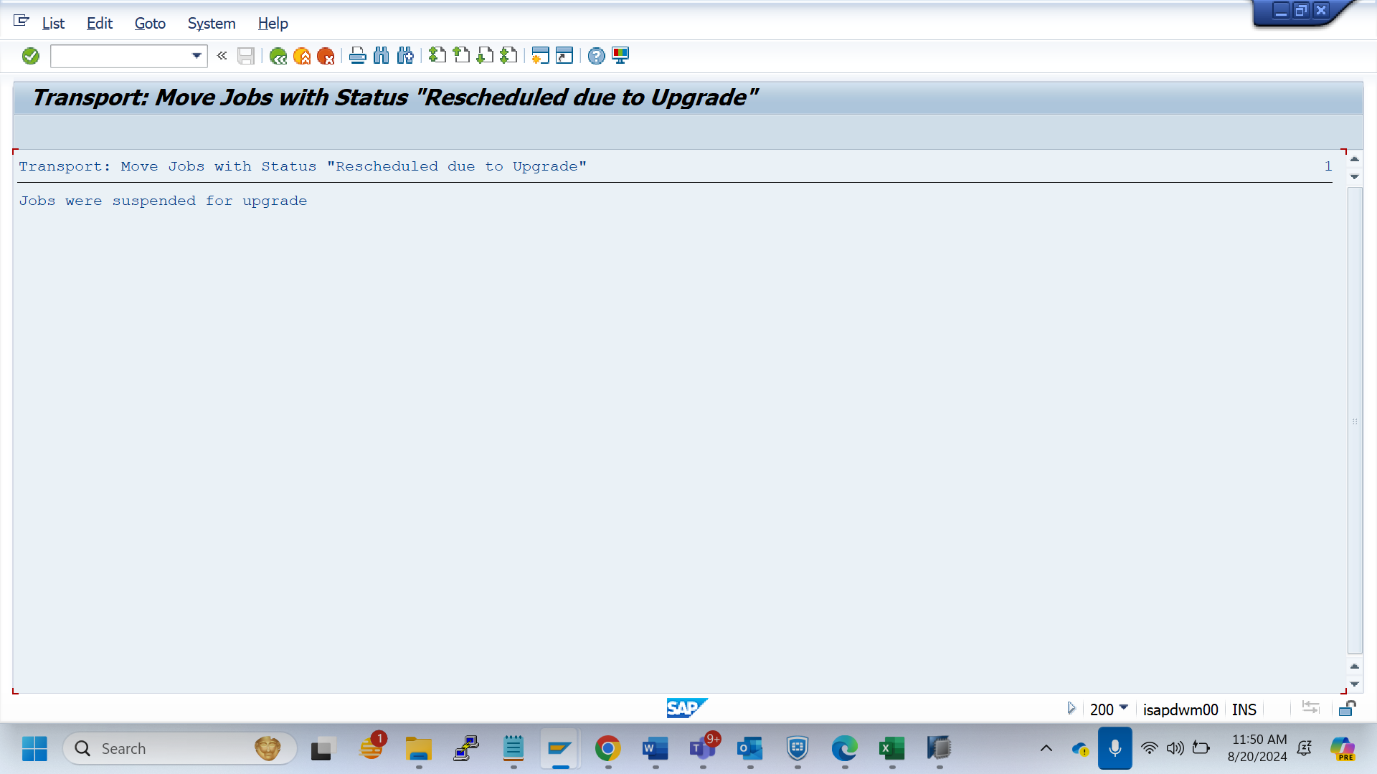

Sm37

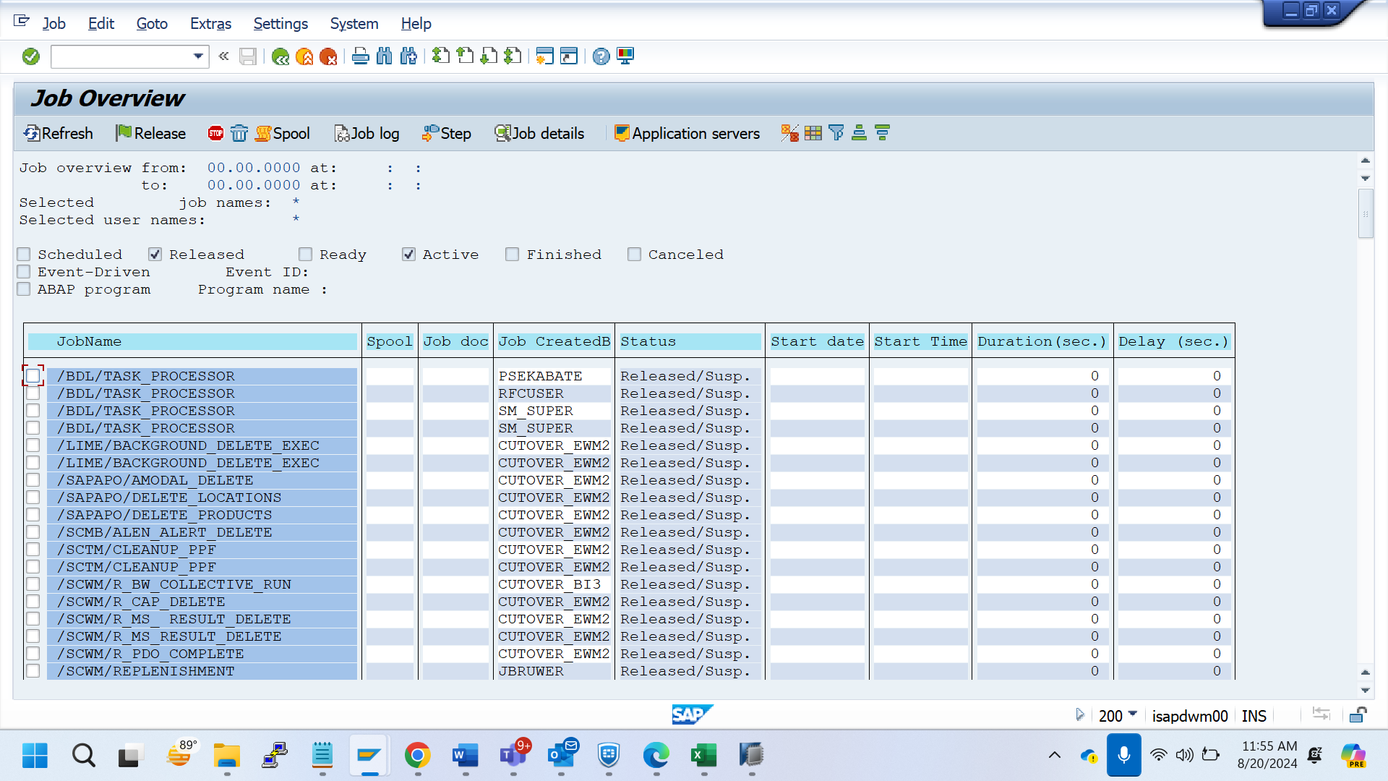

Scc8_QWM

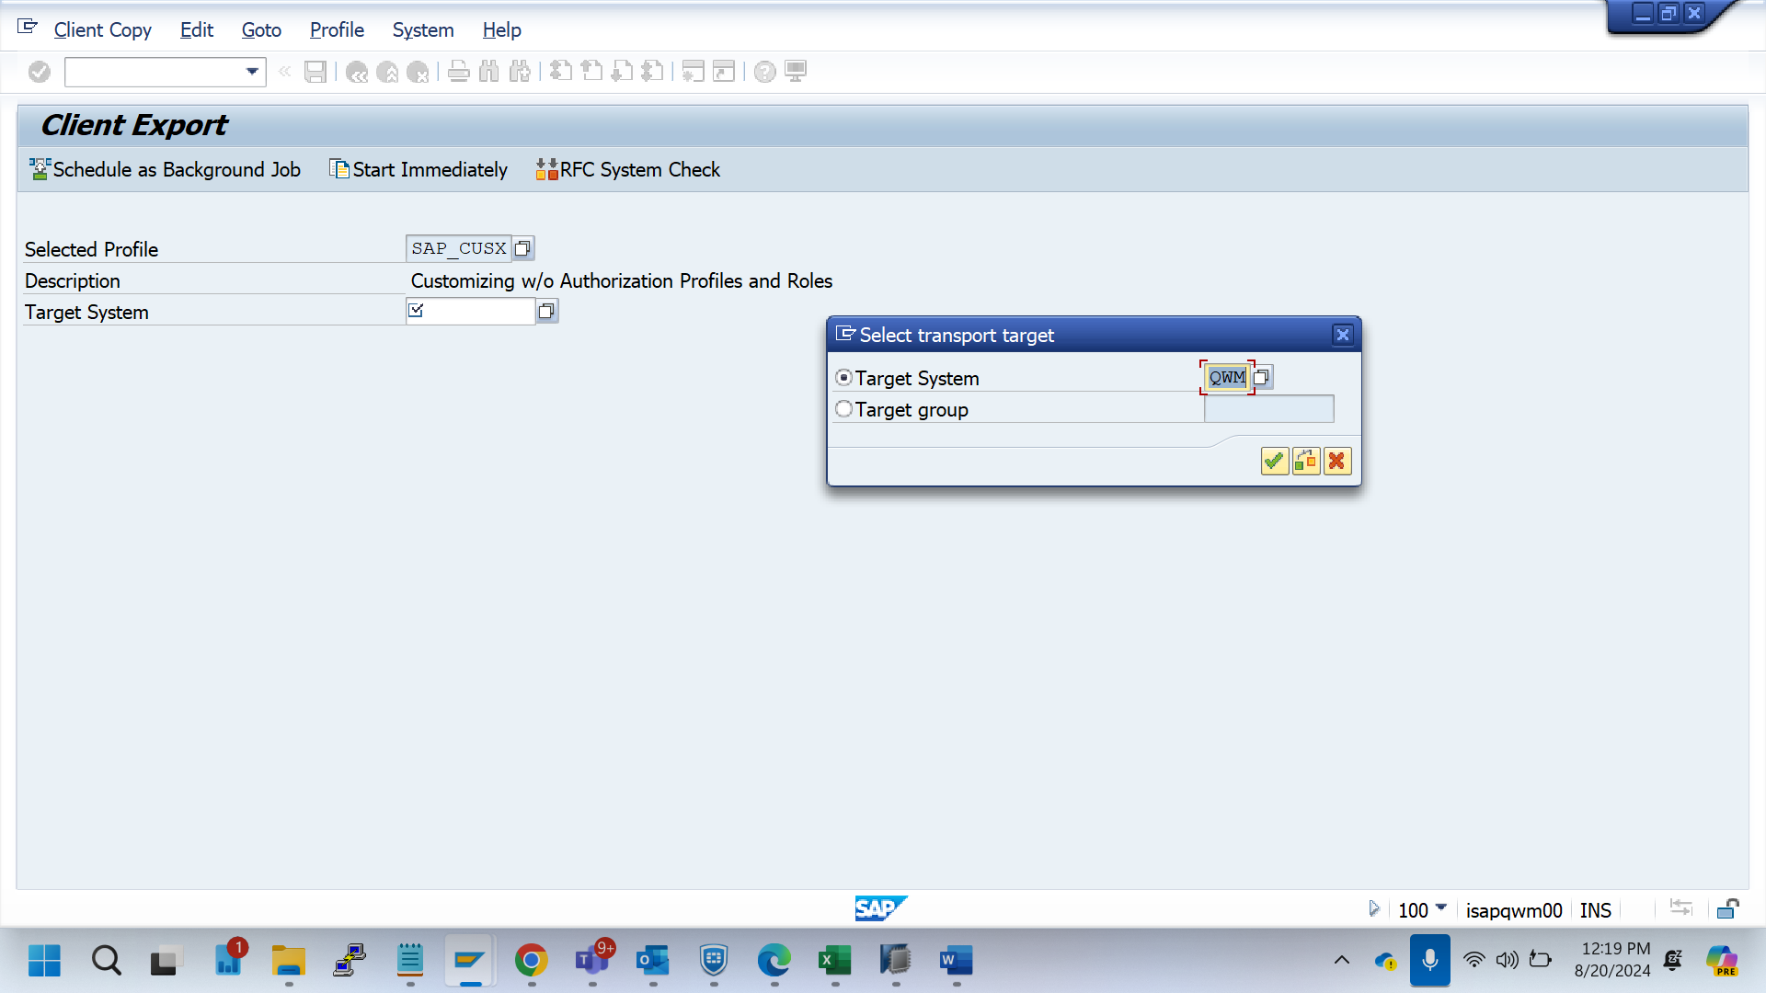

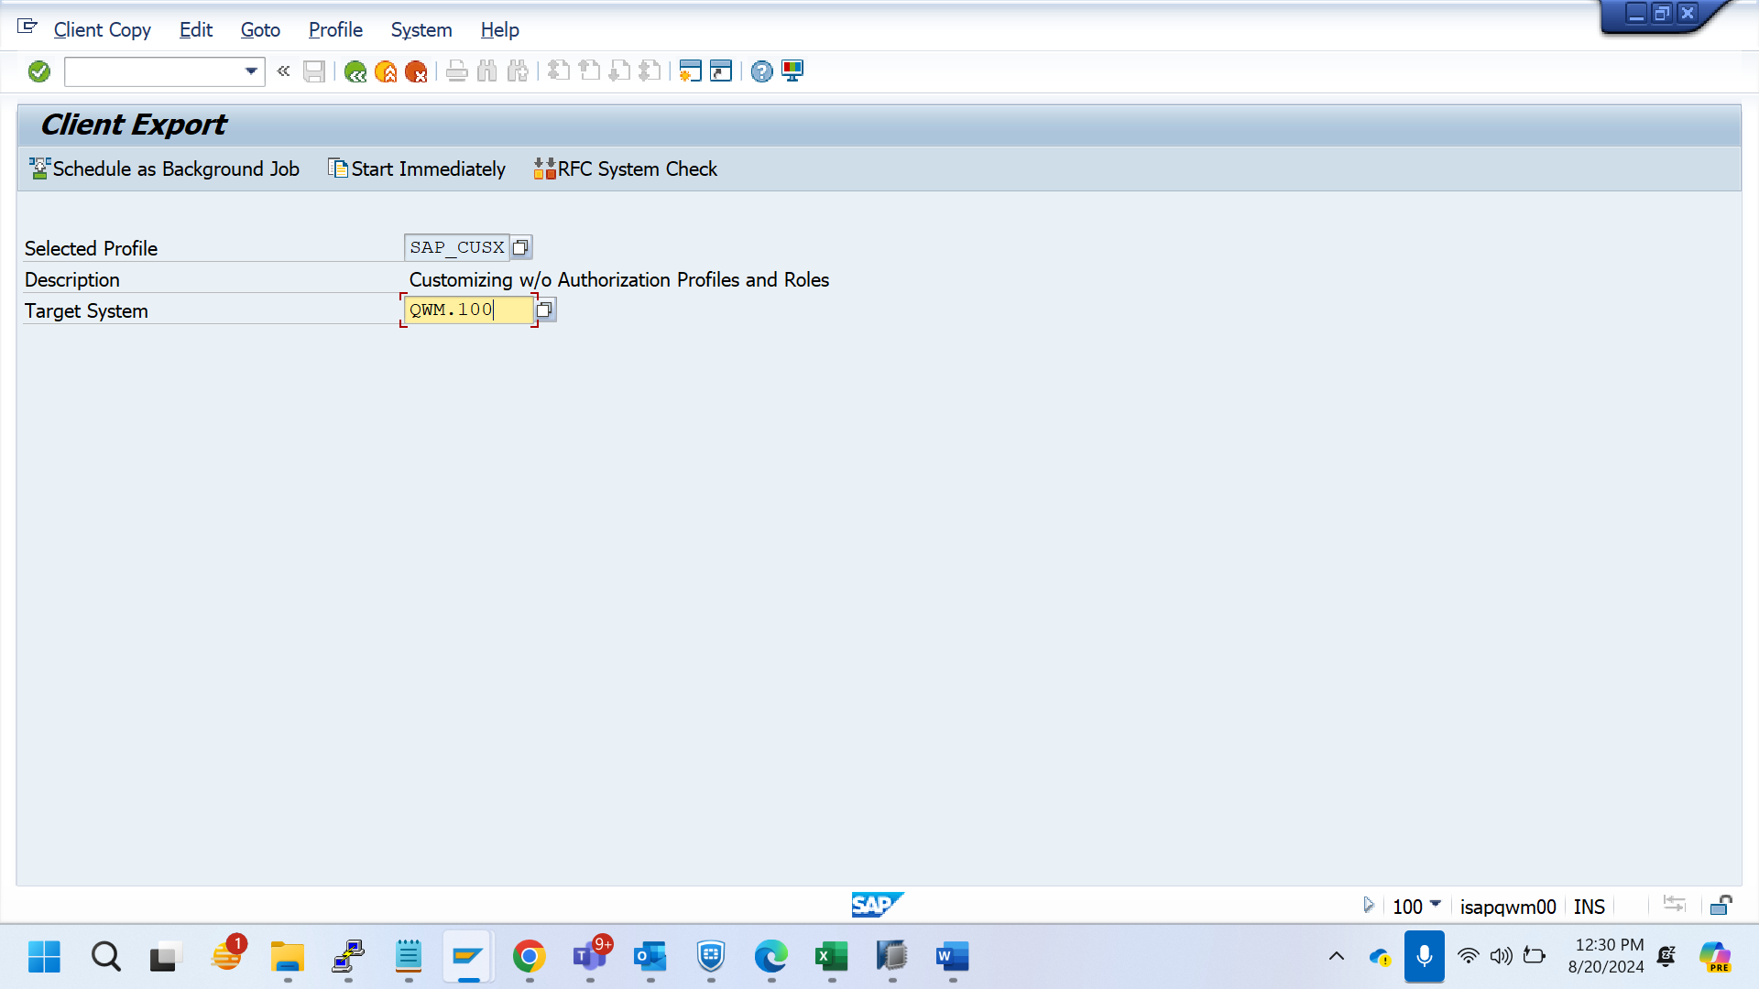

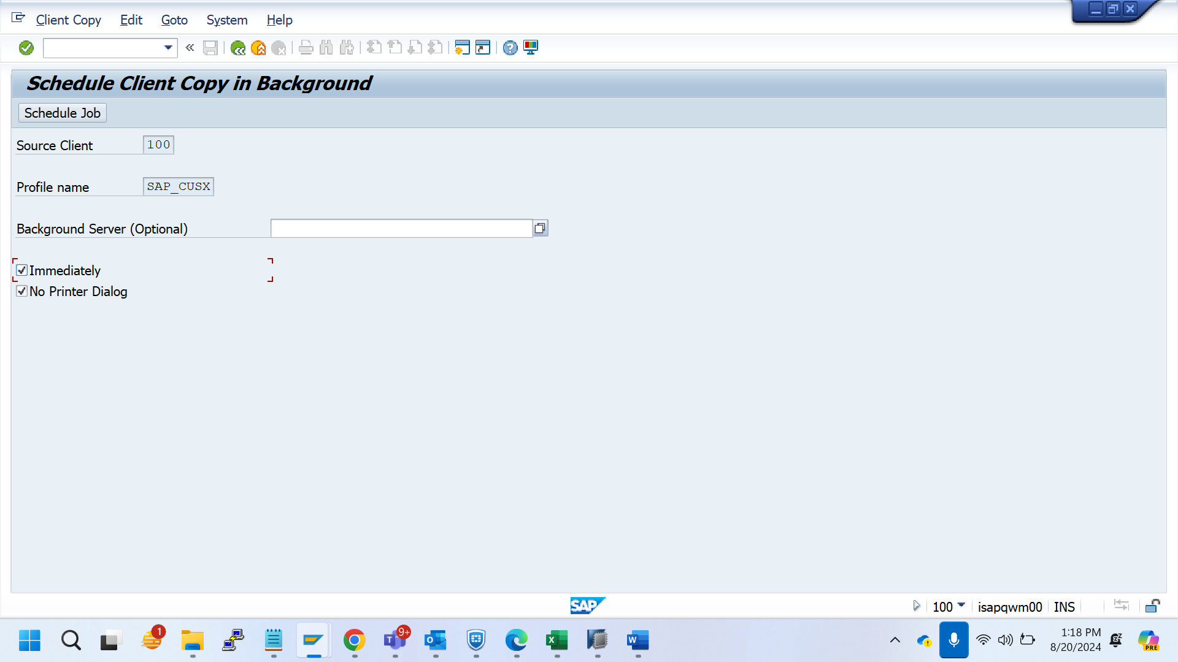

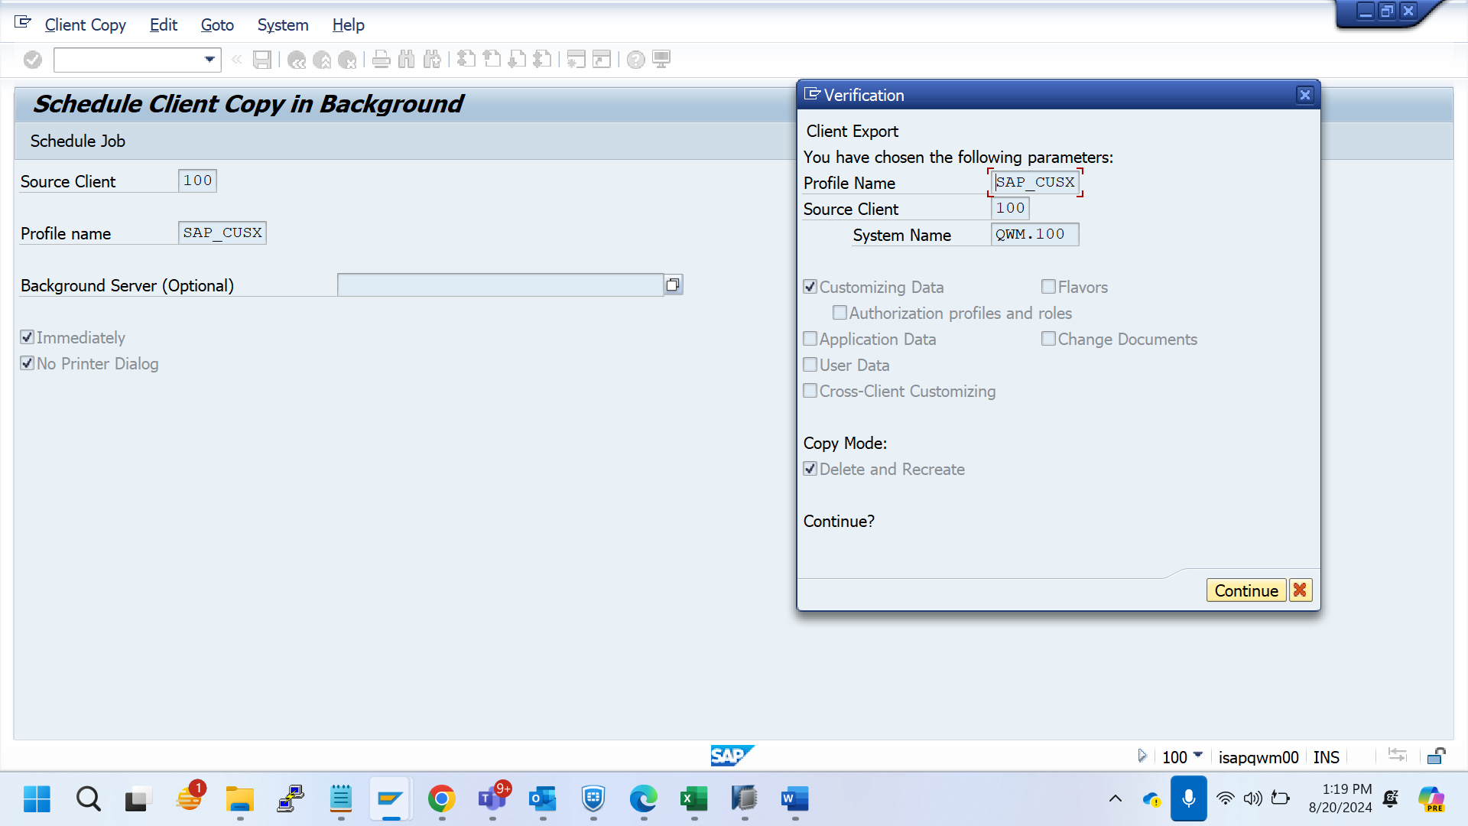

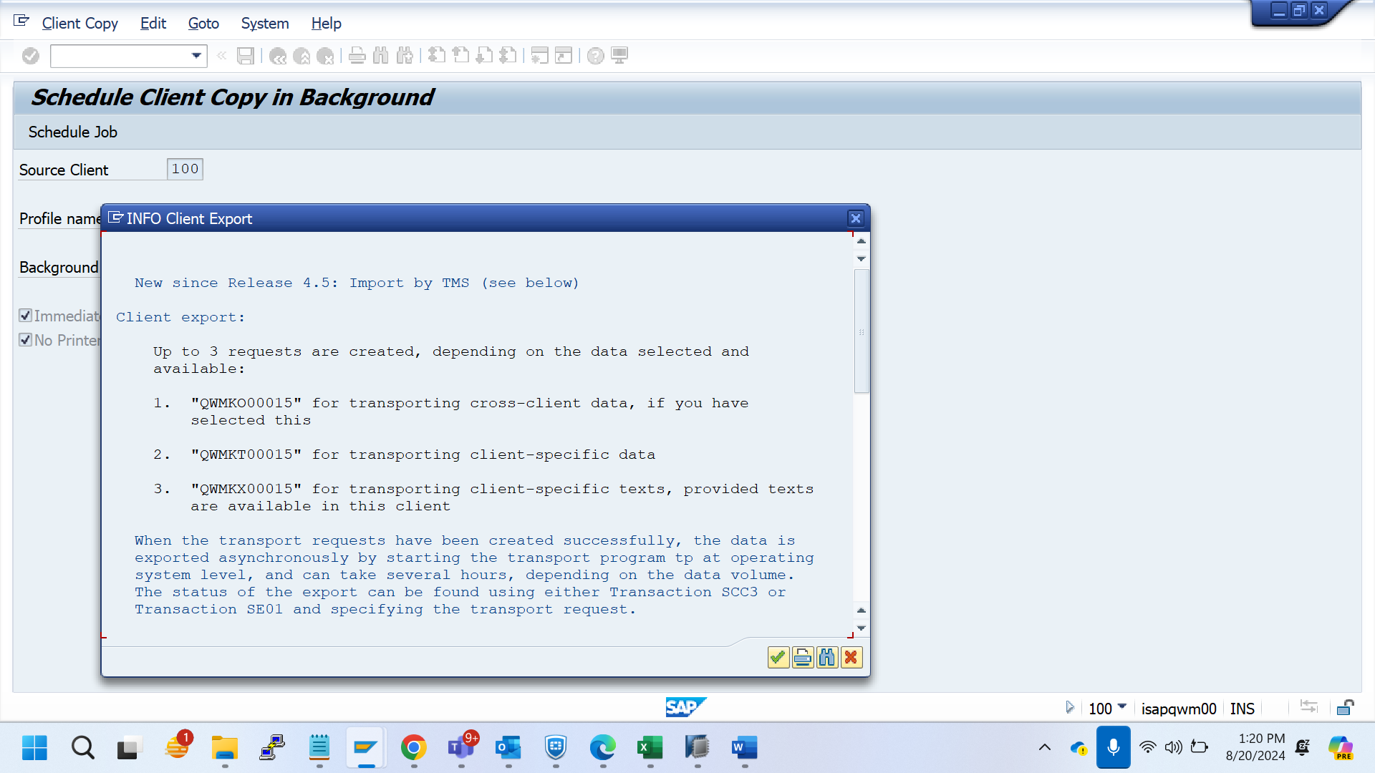

New since Release 4.5: Import by TMS (see below)

Client export:

Up to 3 requests are created, depending on the data selected and

available:

1. "QWMKO00015" for transporting cross-client data, if you have

selected this

2. "QWMKT00015" for transporting client-specific data

3. "QWMKX00015" for transporting client-specific texts, provided texts

are available in this client

When the transport requests have been created successfully, the data is

exported asynchronously by starting the transport program tp at operating

system level, and can take several hours, depending on the data volume.

The status of the export can be found using either Transaction SCC3 or

Transaction SE01 and specifying the transport request.

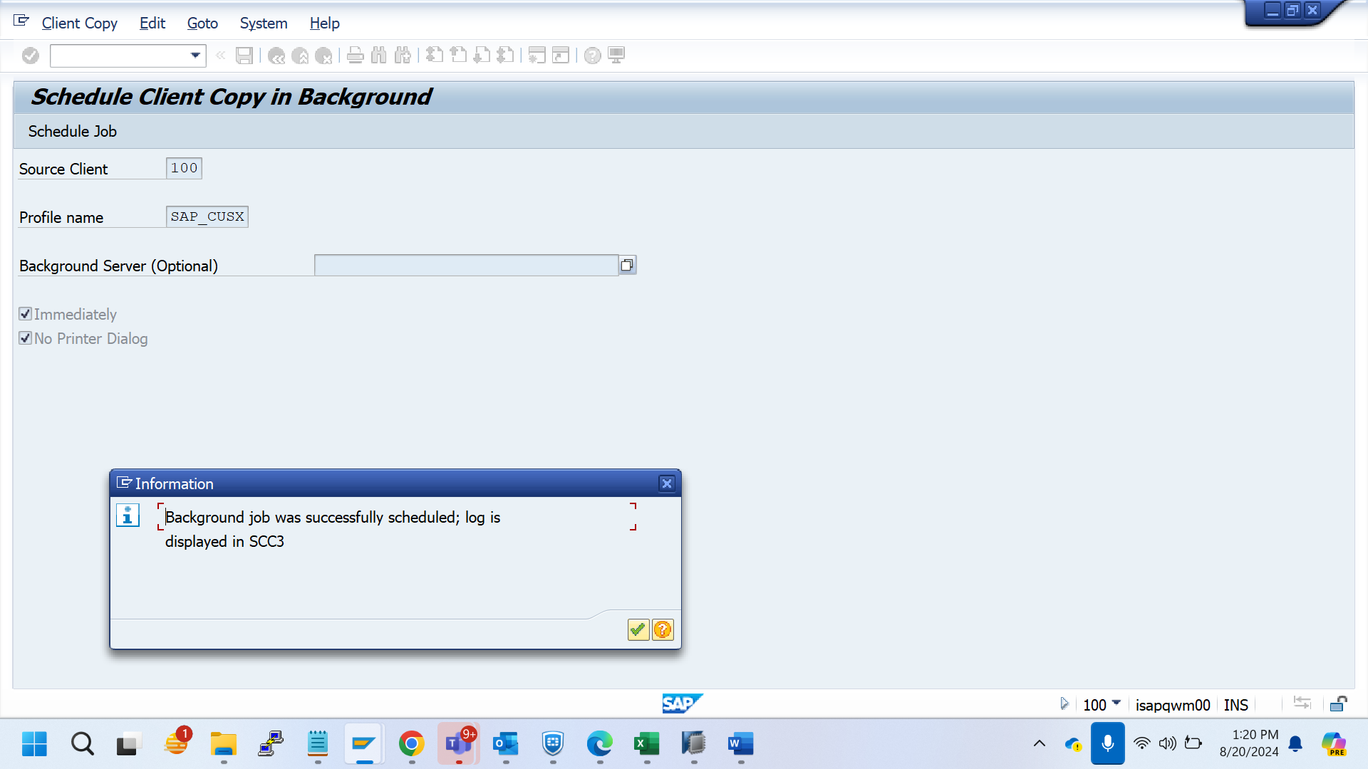

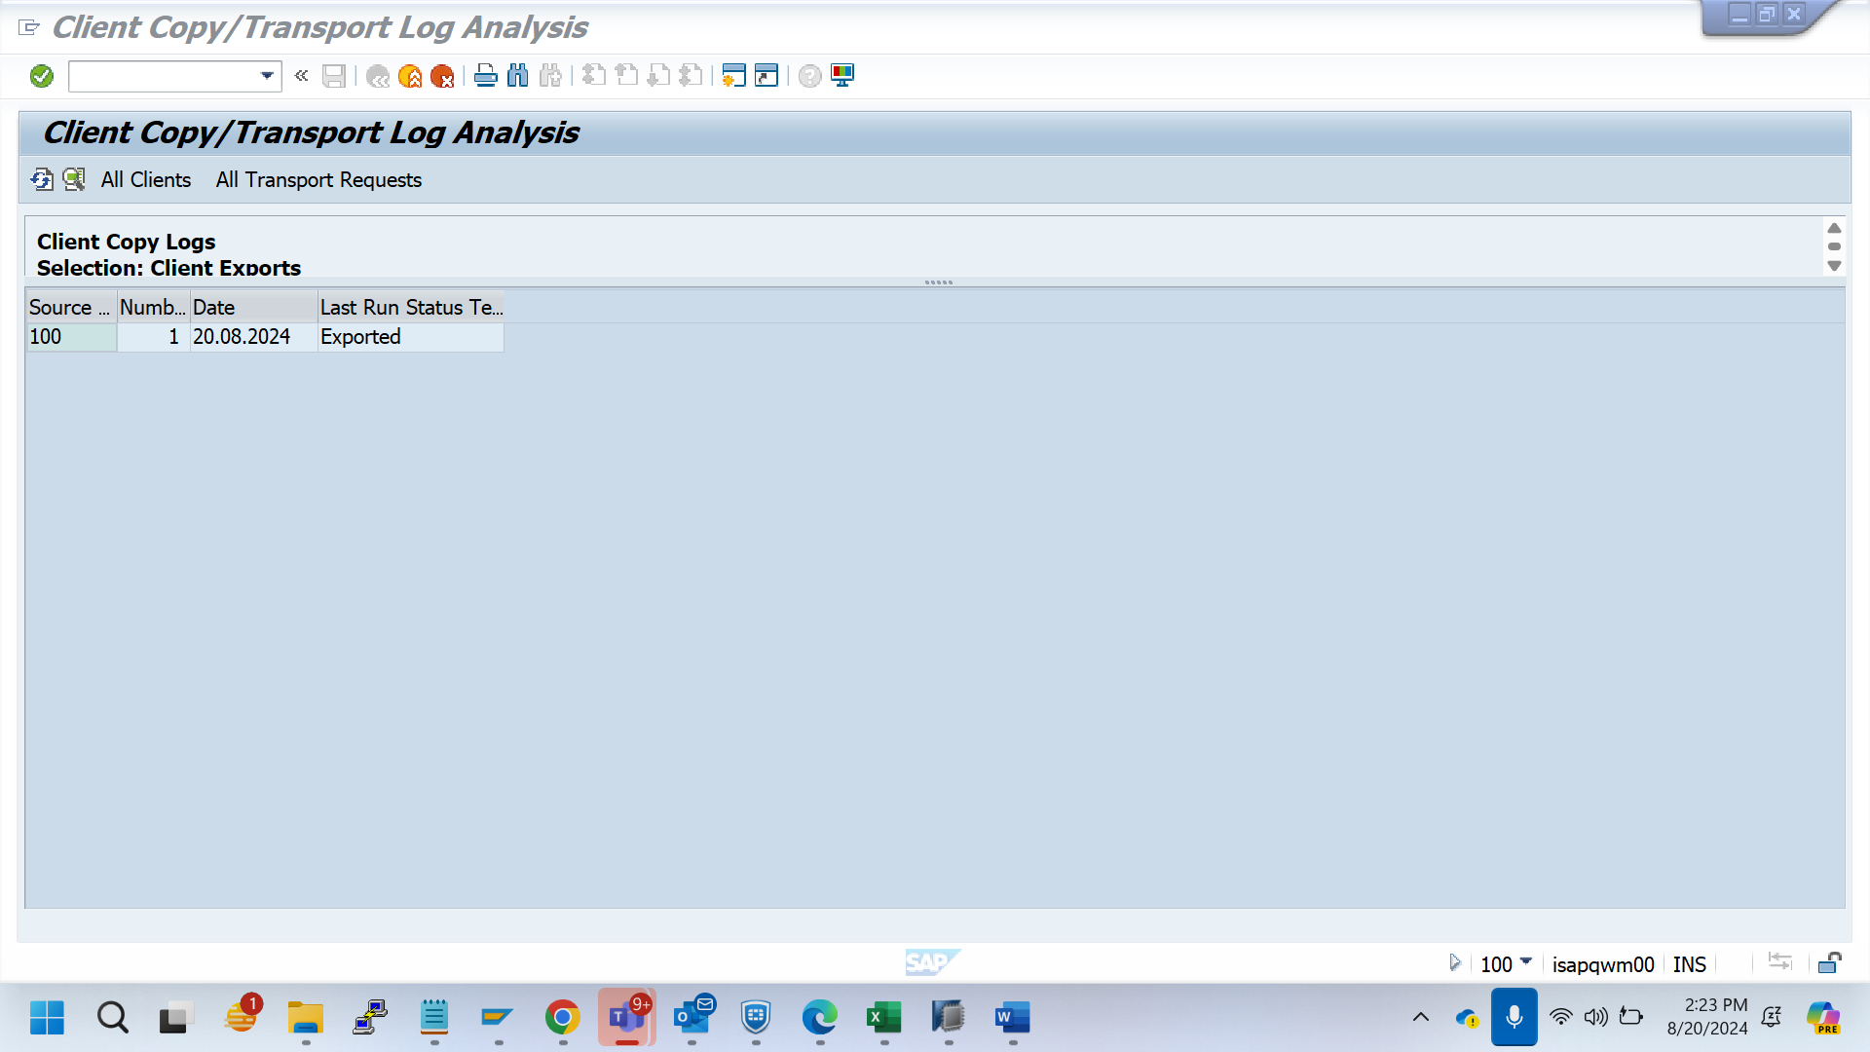

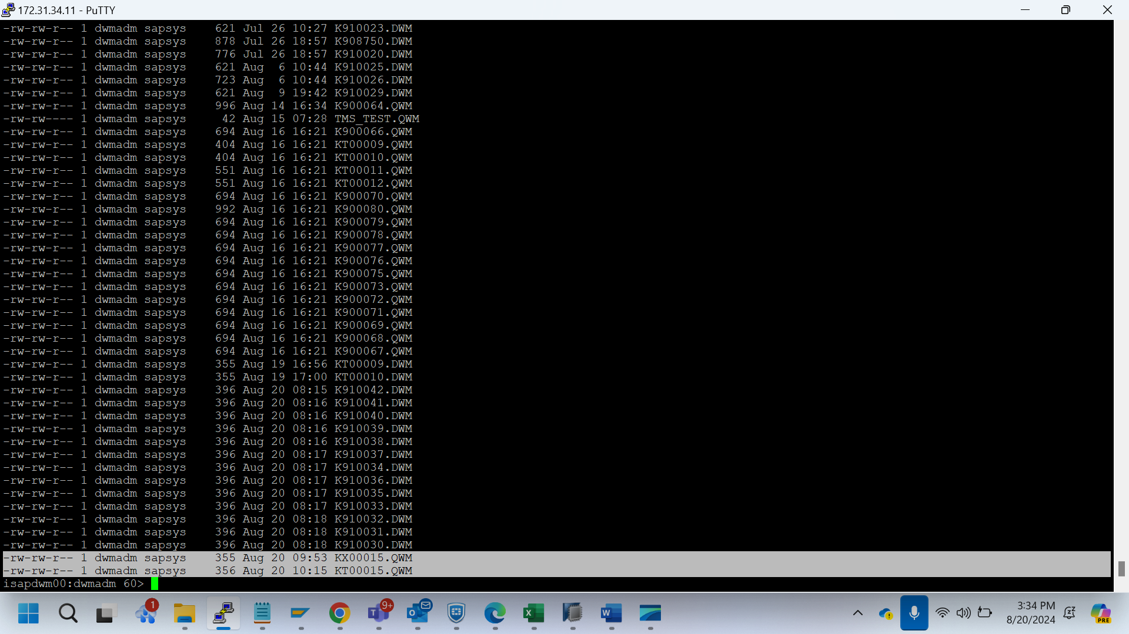

Usr/sap/trans/cofile

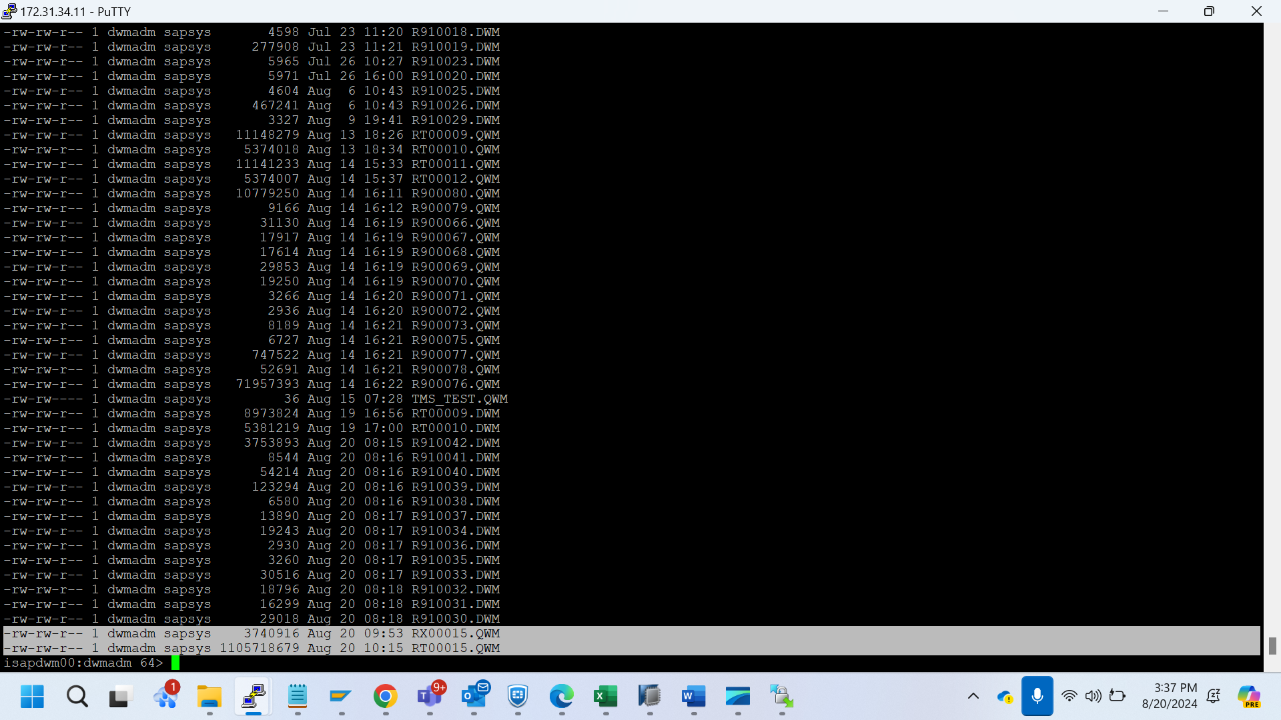

Usr/sap/trans/data

QWM

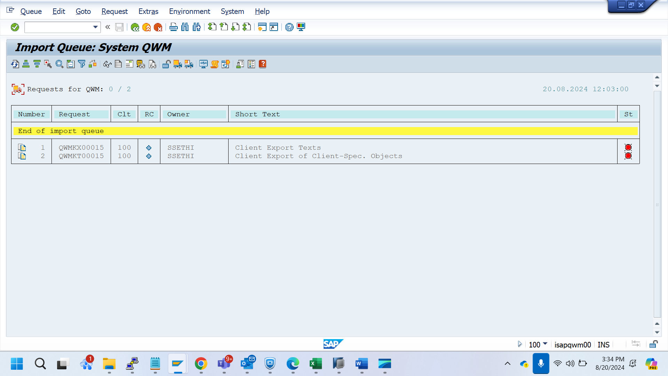

Qwm

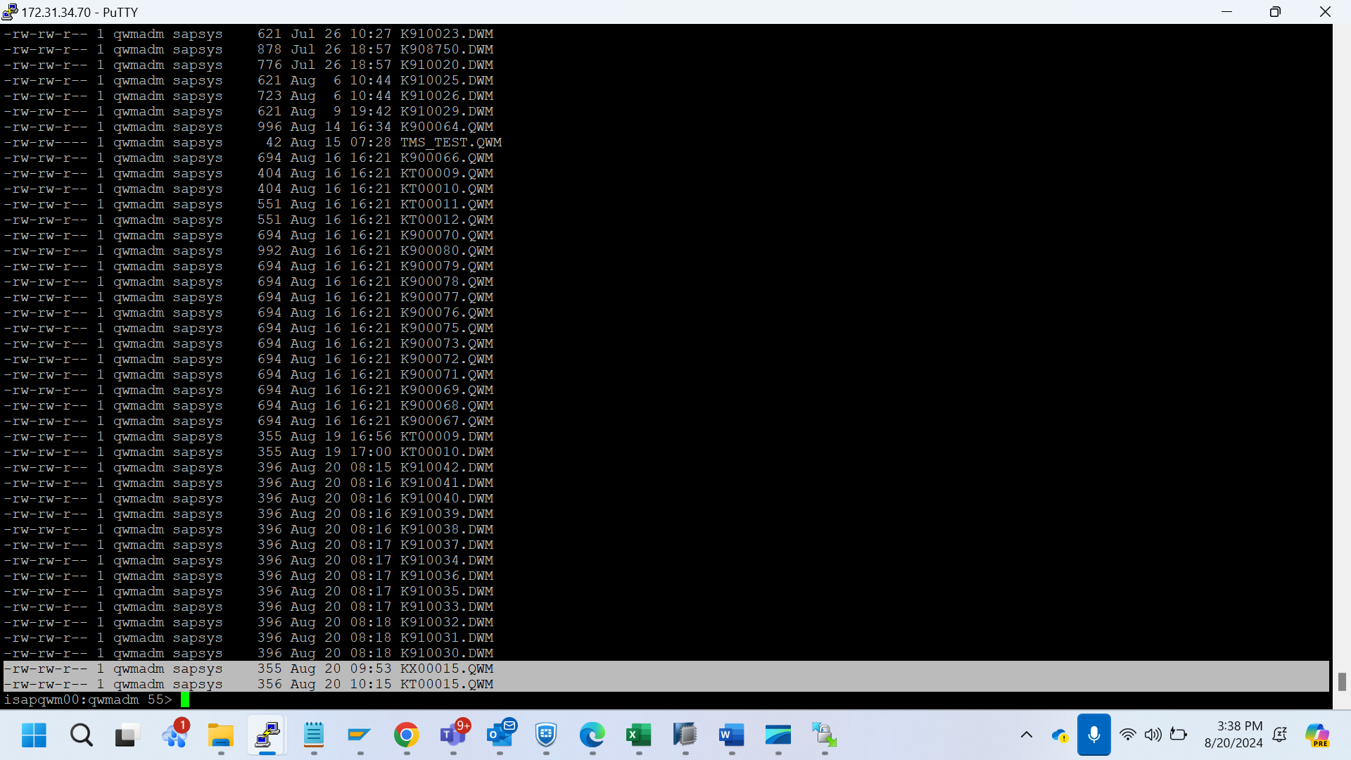

/usr/sap/trans/cofiles

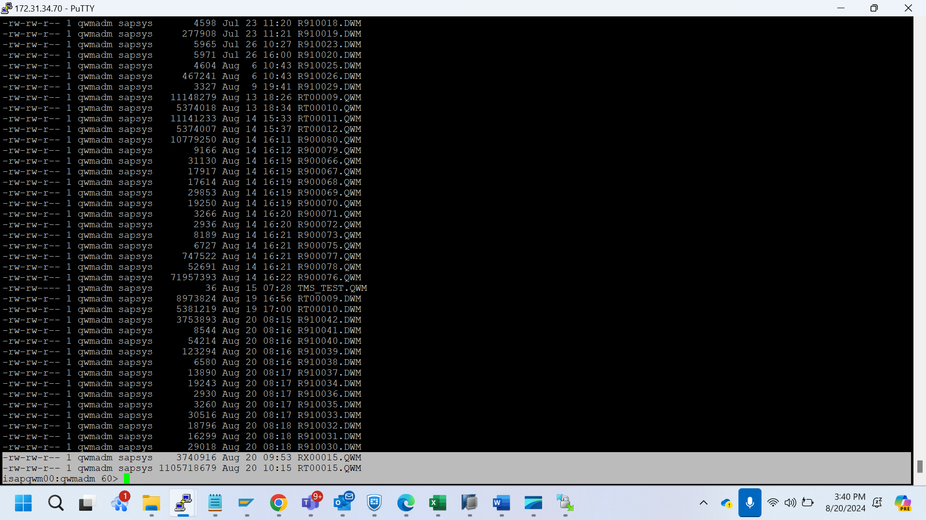

/usr/sap/trans/data

